Ancient traditions, contemporary realities
A Meeting of Israel-Asia Faith Leaders
כנס מנהיגי דתות ישראל - אסיה

11 – 15 September 2016
Jerusalem, Israel

Table of Contents
Program 3
Special Messages 7
Message the President of the State of Israel, Reuven Ruvi Rivlin 7
Message from the Prime Minister of the State of Israel, Benjamin Netanyahu 11
Final Meeting Statement 16
Greetings and Messages by Conference Co-Organizers 17
Ambassador Mark Sofer, Deputy Director General, Asia and the Pacific Division, MFA 18
Akiva Tor, Head, Bureau for World Jewish Affairs and World Religions, MFA 18
Rabbi David Rosen, International Director of Interreligious Affairs, American Jewish Committee 19
Bawa Jain, Secretary General, World Council of Religious Leaders 21
Prayer and Meditation Offered by Leaders 23
Rabbi Yakov Nagen, Lecturer at the Otniel Yeshiva 24
H.H Ven. Master Lu Wenrong, Vice President, International Taoist Association, China 25
H.H Acharya Chandna ji, Spiritual Head, Veerayatan, India 27
H.H Dastur Kobad Zoralia, High Priest, Zoroastrian, Canada 28
H.H Ven. Master Misan, Director of Sangdo Meditation Center, Jogye Order of Korean Buddhism, South Korea 29
H.H Most Ven. Ashin Nyanissara, Rector, Sitagu University, Myanmar 30
H.H Swami Parmatmananda Sawaswati, Convener, Hindu Dharma Acharya Sabha, India 31
H.H Giani Gurbachan Singh, Jathedar, Akal Takht, India 32
H.H Most Ven. Xue Cheng, President, Buddhist Association of China 33
H.H Most Ven. Hsin Bao, Abbot, Go Guang Shan, Taiwan 34
H.H Rev. Tanenori Terai, Chief Priest, Tenmangu Shrine, Japan 35
H.H Acharya Mahamandaleshwar Swami Avdeshanand Giri, Managing Trustee, Hindu Dharma Acharya Sabha, India 36
Rabbi Shlomo Dov Rosen, Communal Rabbi of Yakar Synagogue 37
The Purpose and Place of Religion 39
Session Summary by Bawa Jain, World Council of Religious Leaders 40
H.H Acharya Mahamandaleshwar Swami Avdeshanand Giri, Managing Trustee, Hindu Dharma Acharya Sabha, India 42
H.H Giani Gurbachan Singh, Jathedar, Akal Takht, India 43
H.H Most Ven. Xue Cheng, President, Buddhist Association of China 45
Rabbi Professor Daniel Sperber, President, Bar-Ilan University Institute of Advanced Torah Studies 46
Rabbi Naamah Kelman, Dean of the Hebrew Union College, Jerusalem 47
H.H Ven. Master Misan, Director of Sangdo Meditation Center, Jogye Order of Korean Buddhism, South Korea 49
H.H Most Ven. Hsin Bao, Abbot, Fo Guang Shan, Taiwan 51
H.H Most Ven. Ashin Nyanissara, Rector, Sitagu University, Myanmar 53
Rabbi Avi Gisser, Rabbi of the Community of Ofra 55
Religion and Responsibility: The Vision of a Just Society 56
Session Summary by Akiva Tor, Head, Bureau for World Jewish Affairs and World Religions, MFA 57
H.H Tanenori Terai, Chief Priest, Tenmangu Shrine, Japan 59
Rabbi Yuval Cherlow, Head of the Amit Orot Shaul Yeshiva 61
Rabbi Dr. Alon Goshen-Gottstein, Director of the Elijah Interfaith Institute 62
H.H Acharya Chandna ji, Spiritual Head, Veerayatan, India 63
H.H Most Ven. Lu Wenrong, Vice President, Taoist Association of China 65
H.H Dastur Kobad Zoralia, High Priest, Zoroastrian, Canada 67
H.H Swami Parmatmananda Saraswati, Convener, Hindu Dharma Acharya Sabha, India 69
Safeguarding the Garden: The Ecology of Planet Earth in an Industrial Age 71
Session Summary by Phil Harrison, World Council of Religions 72
Position Statement from Rabbi Dr. Michael Cohen 73
Repairing the World: The Role of Religious Leadership in Peace Making 75
Session Summary by Professor Menahem Blondheim, Head, Hebrew University Harry S. Truman Institute for the Advancement of Peace 76
Position Statement Rabbi Melchior, President of Mosaica, the Middle East Religious Peace Initiative 77
Special Moments 79
Address in Memory of Swami Dayananda: Swami Parmatmananda Saraswati 81
Tour of the Old City of Jerusalem 83
Photos the President of the State of Israel, Reuven Ruvi Rivlin 83
Photos with the Prime Minister of the State of Israel, Benjamin Netanyahu 88
Breakfast with the Mayor of the City of Haifa, Mr. Yona Yahav 85
Tour and Visit of the Baha'i Gardens and the Baha'i World Center 87
Meeting with the Council of Religious Leaders of Israel, Rabbi David Rosen 88
Visit to the Dead Sea 89
List of Attendees 90

Program
September 11th-15th, Jerusalem

September 11th
Welcome Dinner at the Israel Ministry of Foreign Affairs, hosted by Minister Tzachi Hanegbi

September 12th
Residence of the President of the State of Israel, Reuven Ruvi Rivlin
Welcome and Opening of the Conference

Israel Ministry of Foreign Affairs
11:30 Prayer and Meditation
- Rabbi Yakov Nagen, Lecturer at the Otniel Yeshiva
- H.H Acharya Chandna ji, Spiritual Head, Veerayatan, India
- H.H Ven. Master Lu Wenrong, Vice President, International Taoist Association, China
- H.H. Dastur Kobad Zoralia, High Priest, Zoroastrian, Canada
- H.H Ven. Master Misan, Director of Sangdo Meditation Center, Jogye Order of Korean Buddhism, South Korea
- H.H. Most Ven. Ashin Nyanissara, Rector, Sitagu University, Myanmar
- H.H. Swami Parmatmananda Saraswati, Convener, Hindu Dharma Acharya Sabha, India

12:30 Meeting with the Prime Minister of the State of Israel, Benjamin Netanyahu

Lunch

14:30 the Purpose and Place of Religion in our Societies
This session provides the opportunity for participants to present and discuss some of the fundamental principles and values that underlie our traditions, both those which unite and those which make us distinctive. How do our religions see their role in relation to their societies? What insights can we provide each other regarding the challenges presented by the many facets of secularization in contemporary life, and the ways in which religions can remain relevant, vibrant and rooted?
Moderators: Bawa Jain, World Council of Religious Leaders / Rabbi David Rosen, AJC
Opening Speakers:
- H.H Acharya Mahamandaleshwar Swami Avdeshanand Giri, Managing Trustee, Hindu Dharma Acharya Sabha, India
- H.H Most Ven. Xue Cheng, President, Buddhist Association of China
- H.H Giani Gurbachan Singh, Jathedar, Akal Takht, India
- Rabbi Professor Daniel Sperber, President, Bar-Ilan University Institute of Advanced Torah Studies
- Rabbi Naamah Kelman, Dean of the Hebrew Union College, Jerusalem
- H.H Ven. Master Misan, Director of Sangdo Meditation Center, Jogye Order of Korean Buddhism, South Korea
- H.H Most Ven. Hsin Bao, Abbot, Fo Guang Shan, Taiwan
- H.H. Most Ven. Ashin Nyanissara, Rector, Sitagu University, Myanmar
- Rabbi Avi Gisser, Rabbi of the Community of Ofra

Coffee break

16:45 Religion and Responsibility: The Vision of a Just Society
Moving from the more general to the specific, this session explores the various perspectives of the religions on questions of human dignity and rights. The religious traditions see themselves as working to improve the human condition, while contemporary society often sees them as a non-liberal force restraining human empowerment. What can we learn from each other to ensure that our religions live up their most sublime social ideals? How can faith leadership better utilize the deep resources of our traditions to provide answers and vision?
Moderator: Professor Tova Hartman, Dean of Humanities at Ono Academic College
Opening Speakers:
- Rabbi Yuval Cherlow, Head of the Amit Orot Shaul Yeshiva
- H.H. Tanenori Terai, Chief Priest, Tenmangu Shrine, Japan
- H.H. Acharya Chandna ji, Spiritual Head, Veerayatan, India
- H.H. Most Ven. Lu Wenrong, Vice President, Taoist Association of China
- H.H. Dastur Kobad Zoralia, High Priest, Zoroastrian, Canada
- H.H. Swami Parmatmananda Saraswati, Convener, Hindu Dharma Acharya Sabha, India
- Rabbi Dr. Alon Goshen-Gottstein, Director of the Elijah Interfaith Institute

Dinner
September 13th
Truman Institute for the Advancement of Peace, The Hebrew University of Jerusalem

09:00 Prayer and Meditation
- H.H Most Ven. Xue Cheng, President, Buddhist Association of China
- H.H Giani Gurbachan Singh, Jathedar, Akal Takht, India
- H.H Most Ven. Hsin Bao, Abbot, Fo Guang Shan, Taiwan
- H.H Rev. Tanenori Terai, Chief Priest, Tenmangu Shrine, Japan
- H.H Acharya Mahamandaleshwar Swami Avdeshanand Giri, Managing Trustee, Hindu Dharma Acharya Sabha, India
- Rabbi Shlomo Dov Rosen, Communal Rabbi of Yakar Synagogue

09:30 Safeguarding the Garden: The Ecology of Planet Earth in an Industrial Age
At the heart of our traditions lie the veneration of life and the imperative to safeguard the balance of nature. This session explores how values of sustainability are reflected in our traditions and practice; and how faith leadership can help better protect our planet and conserve its resources.
Presentation: Let There Be Light: Diversity as a Biblical Message Rabbi Michael Cohen, Arava Institute for Environmental Studies
Responses and discussion led by Dr. Deborah Weissman, Educationist and lecturer in Jewish thought

Lunch

13:30 Repairing the World: The Role of Religious Leadership in Peace Making
What is required of religious leadership to increase peace in the world? Do our faith traditions mandate us to seek proactively "to repair the world"? How can we pursue global betterment as a religious imperative without falling prey to hubris?
Presentation: Religion as a Vehicle for Peace and Reconciliation Rabbi Michael Melchior
Responses and discussion led by Professor Menahem Blondheim, Head, Hebrew University Harry S. Truman Institute for the Advancement of Peace, followed by concluding statements and proposals.

17:00 Address in Memory of Swami Dayananda (open to the General Public)
Hebrew Union College - Jewish Institute of Religion, 13 King David Street

Introductory Remarks:
Acharya Mahamandaleshwar Swami Avdheshanand Giri Managing Trustee, Hindu Dharma Acharya Sabha

Address:
Swami Parmatmananda Saraswati
Secretary General, Hindu Dharma Acharya Sabha

Dinner King David Hotel, Jerusalem

September 14th

Morning
Tour of the Old City of Jerusalem, visit some major faith sights
Visit to the Library of Professor Daniel Sperber

Lunch Eucalyptus Restaurant

Afternoon
Embark to the north of Israel, for two days of meetings with Israel's non-Jewish religious leaders

Dinner with Religious Leaders from Northern Israel

September 15th

Breakfast with the Mayor of the City of Haifa, Mr. Yona Yahav

Tour and visit of the Bahai Gardens and the Bahai World Center, Acre

Meeting with the Council of Religious Leaders of Israel

Lunch

Visit the Dead Sea at sunset

Transfer to Jerusalem or to the Airport for departures

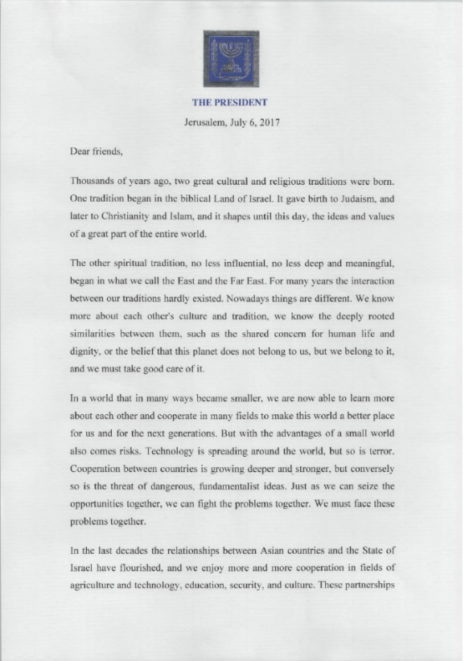
Message from the President of the State of Israel, Reuven Ruvi Rivlin

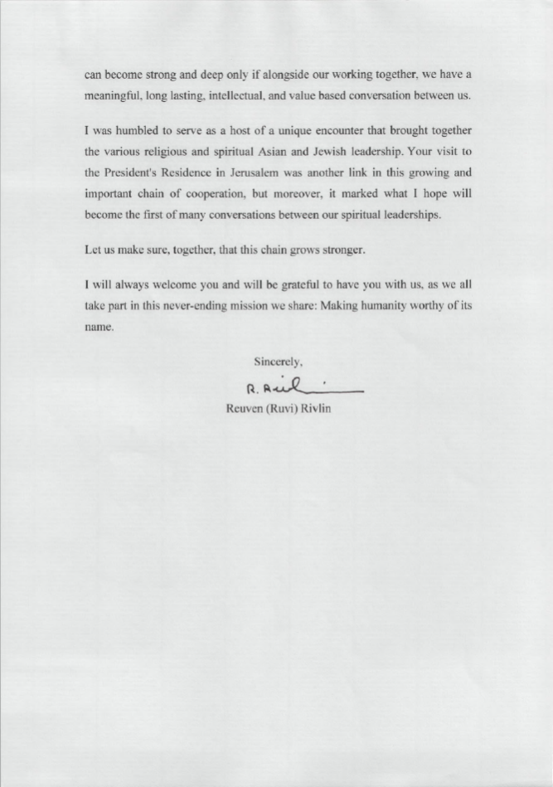

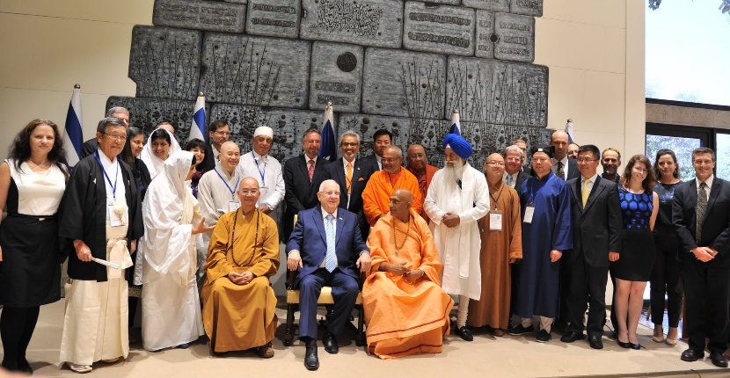

With the President of the State of Israel, Reuven Ruvi Rivlin, at his official residence

Prime Minister of the State of Israel, Benjamin Netanyahu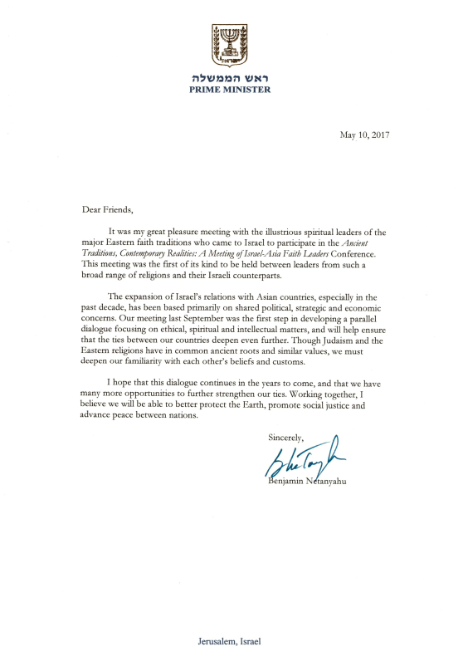

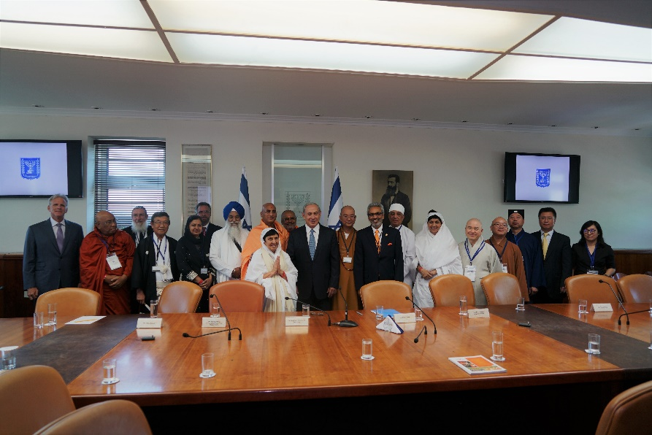

With the Prime Minister of the State of Israel, Benjamin Netanyahu, at the Prime Minister's Office

Final Meeting Statement

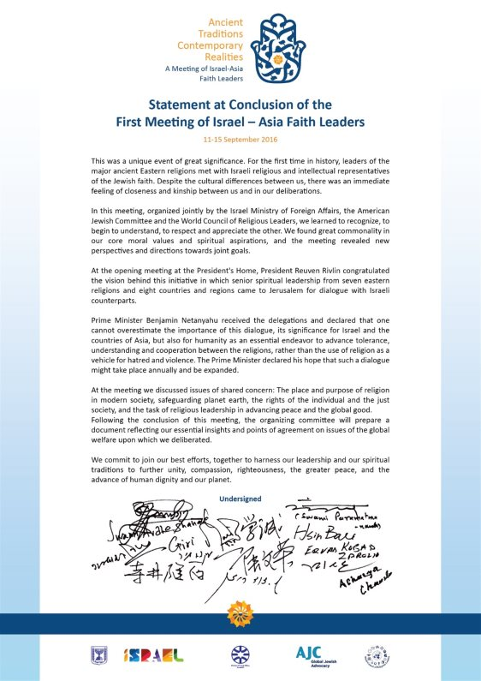

Greetings and Messages by Conference Co-Organizers:


Ambassador Mark Sofer, Deputy Director General, Asia and the Pacific Division, MFA
Akiva Tor, Head, Bureau for World Jewish Affairs and World Religions, MFA

Dear Friends,

In this book we present the essential proceedings of a most unusual gathering which took place in Jerusalem in September 2016. This was a meeting in which the spiritual leaders of the major Eastern faith traditions engaged in dialogue with Israel's religious, intellectual and political leaders on matters of concern for the world today.

At first glance, it would seem unusual for a foreign ministry to participate in a gathering of this kind. But when one considers the dynamism in the Israel – Asia relationship, it was obvious to us that we require a substantive dialogue of civilizations; one which would support the growing strategic, political and economic connections with a greater cultural and spiritual mutual comprehension.

The gathering was an opportunity for creating a better understanding in Asia of the living reality of the State of Israel and its meaning for the Jewish people. It presented an important occasion for Israel's thinkers to better apprehend the values and traditions underlying Eastern civilizations and what these mean for the current and future Israel – Asia relationship.

We would like to thank our partners in this unique project - Rabbi David Rosen of the American Jewish Committee, Bawa Jain of the World Council of Religious Leaders and our colleague at the Ministry of Foreign Affairs, Simona Halperin, who was the conference coordinator and is currently serving as Israel's Ambassador to Singapore.

It is our hope that this gathering will mark the beginning of an ongoing conversation that will deepen and grow.

Best wishes,

Mark Sofer Akiva Tor
Deputy Director General Head of Bureau
Asia and Pacific Division World Jewish Affairs and World Religions


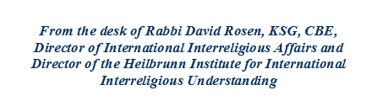


Rabbi David Rosen

While interreligious understanding and cooperation has become a widespread global endeavor in our times, AJC was the first representative Jewish organization to engage institutionally in this field more than a century ago.

The leaders of this agency fully appreciated that if religion had been and often still is part of the problem of prejudice and bigotry from which Jews have suffered historically so disproportionately; religion also has the greatest potential to be part of the solution, and that it is essential to engage with other religious communities to this end.

Indeed, Jewish historical experience makes it clear that as a rule it is unfamiliarity which allows contempt to flourish, and not the other way round. Pursuant to its pioneering work in promoting Jewish-Christian relations in the US, AJC played a central role in the historical transformation of the approach of the Catholic Church towards the Jewish people that was ushered in with the Second Vatican Ecumenical Council convened by Pope John XXIII.

However, it was well understood that beyond the critically important function of combatting prejudice and bigotry, interreligious relations provide a firm basis for cooperation and collaboration in the pursuit of shared values and aspirations. Not least of all it offers a unique framework within which to convey and advocate for respective interests. Understanding the centrality and wellbeing of the State of Israel for contemporary Jewish identity has inevitably been a central focus for AJC in this endeavor.

Our modern world has “shrunk” in terms of the cross-cultural encounters that are now available to us, and today both in the US and globally we encounter religious communities that we had not really known in the past. This is particularly the case for the Jewish encounter with the Dharma religions from societies where there had barely ever been a Jewish presence if at all.
In addition to overcoming our ignorance about one another (and often mistaken stereotypes as well as theological fallacies) these encounters reveal the profound values that we share and the moral imperative to work together to be greater than the sum of our different parts. We discover common agendas and issues of shared concern on which we can and should cooperate. Not least of all in this regard for the Jewish community, is an understanding of what Israel is in itself and for the Jewish People as a whole as well as revealing Israel’s remarkable resources that can and should be a blessing for all humankind.

Politicians and diplomats come and go, but if relationships between societies can be based upon connections between their foundational spiritual values and identities, then bilateral and multilateral relations can flourish in a most unique and profound way.

It was this recognition that led to the three Hindu-Jewish summits in which AJC collaborated with Israel’s MFA, the WCORL and the All India Dharma Acharya Sabha. This latest encounter between Israeli Jewish religious leaders and representatives of “Eastern Religions” was in many ways a further extension of these initiatives and substantially deepened the growing links between Israel and Asia (in parallel to the links AJC promotes with US communities of Asian origin in the US.)

It was a privilege for AJC to co-host this seminar with the Israeli MFA and the WCORL and we are confident that not only did it serve as a milestone on the road of greater understanding and cooperation between the religious representatives involved, but also in promoting greater understanding and cooperation among our respective nations.

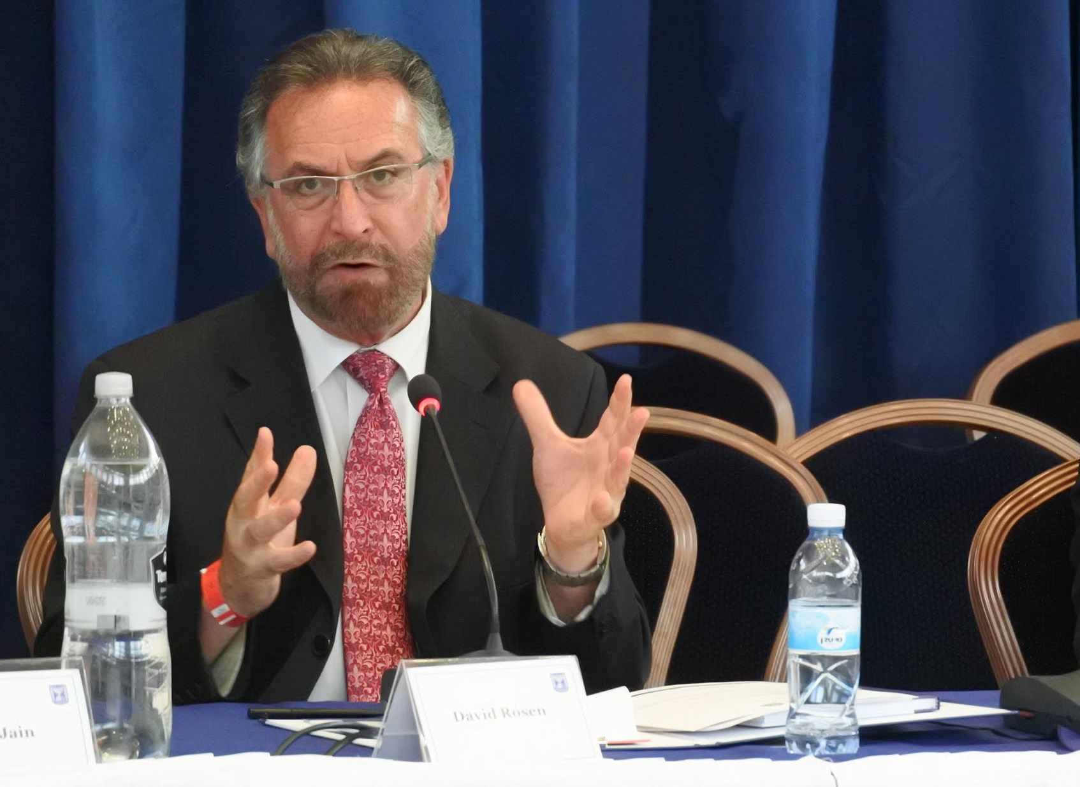

__________________________________________________________________________________________
Beit Moses, 11 Mesilat Yesharim St., P.O. Box 37068 Jerusalem 9137001, ISRAEL
Tel: 972 2 625 5281; Fax: 972 2 625 6527; email: rosend@ajc.org
Head Office: The Jacob Blaustein Building, 165 E.56 St., NY, NY 10022-2746; Tel: 212-751-4000; Fax: 212-891-4555
World Council of Religious Leaders

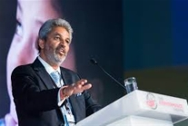

Bawa Jain is the founding Secretary- General of The World Council of Religious Leaders (WCORL).

The organization is the direct outcome of the Historic Millennium World Peace Summit, United Nations in 2000. The leadership Council is charged with being a strong resource and a collaborator with the United Nations and other international and national organizations whose purposes include promoting peace, harmony, tolerance, and mutual respect among human beings and the evolution of world social and economic justice.

Practical WCORL work is focused on “Religious Diplomacy” forging new and reinvigorating existing strategic alliances, set against new geo-political landscapes of rapidly changing global scenarios. Trends are monitored and from these intelligence opportunities are identified. An example being the significant potential to strategically build/promote Israel - South Asia alliances through the engagement of Religious Leaders. For WCORL this is one particularly important area of focus.

In 2001, Bawa Jain was asked by The World Economic Forum to help integrate a religious dimension into the Forum's activities by bringing a delegation of religious leaders to their meeting in Davos, Switzerland. The strategic partnership that was formed between The World Economic Forum and The Millennium World Peace Summit resulted in the launching of the Forum's Religious Initiative. He continues to develop an integrated framework for world religions, business, and government communities to address world problems collectively.

WCORL’s launched the “Religion One on One”, initiative which brought together two of the world's oldest religions, Jews and Hindus which resulted in a signed “Declaration of Mutual Understanding and Cooperation” and the creation of a "Standing Committee” for Hindu-Jewish Relations for ongoing bilateral relations.

Bawa Jain, Secretary General, World Council of Religious Leaders

This was a historic meeting. Never before have the Religious Leaders from the Jewish, Dharmic and Oriental Faith Traditions met exclusively amongst themselves.

The World Council of Religious Leaders applauds the far sightedness and strategic decision of the Government of Israel. We, with the Foreign Ministry, are honored to be a part of the organizing trio convening this meeting together with the American Jewish Committee.

Increasingly, we see energy and emphasis on “the Asian juggernaut." This meeting was a seminal moment to foster closer cooperation amongst the peoples of faith from Israel and Asian countries. Times to come will remember this moment as the time when the great Asian and Jewish Religions forged closer relations that led to even closer relations between the political leadership of their countries guided by their religious leaders.

This approach where religion is intrinsic to all aspects of life; deeply inter-twined in cultural, political and civic life, where state and religion cannot be separated. That is a way of life millennia old. One that has worked to enable societies to live harmoniously together, where core values derived from the great religions and faith traditions are the foundational principles that guide daily life.

The World Council of Religious Leaders builds an “Integrated Framework for Peace”. We engage in “Religious Diplomacy”, to complement political diplomacy by working closely with the world’s political, religious and business/civic leaders, the three most important sectors of society. We seek to monitor trends and build strategies with the re-alignment of global geo-politics by harnessing the power of religion. After all, more than 90% of the world follows or adheres to one of the great religious traditions.

In Asia, the percentage is even higher; the influence of religion is immense and forms the very basic way of life. In countries like China, it is their culture and they seek to build a harmonious society through the profound teaching of Buddhism, Taoism and Confucianism.

This initiative, involving Israel, India and China and in turn with Japan, South Korea and other Asian countries will shape the times to come (as we envisioned when we convened the Historic Hindu-Jewish Summits). We seek to build closer relations between Israel and India and in turn, Israel, India and the USA. This alignment will be a major influencer that positively shapes and guides global interests.

We are profoundly thankful to all the eminent faith leaders for their commitment and active participation in the entire process in Israel and all that is envisioned as the follow up to this conference. In addition we are deeply grateful to the Government of Israel, the President, the PM, especially Ambassador Yuval Rotem, Ambassador Mark Sofer, Ambassador Akiva Tor, Ambassador Simona Halperin and her team at the Ministry of Foreign Affairs of Israel and my dearest brother and friend Sir Rabbi David Rosen, his assistant Avril Promislow from the American Jewish Committee and to my colleague at The World Council of Religious Leaders, Phil Harrison for a job well done – many more such initiatives to follow, we pray!

Prayer and Meditation Offered by Leaders

Rabbi Yakov Nagen
Lecturer at the Otniel Yeshiva
Judaism
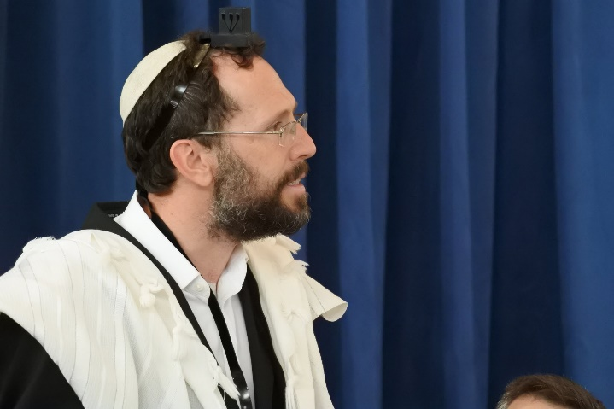

שְׁמַע, יִשְׂרָאֵל:  ה' אֱלוהֵינוּ,  ה' אֶחָד | The prayer Shema Yisrael reflects the essence of Jewish faith in God. These words are written in parchment on the tefillin on my head to bind them to my consciousness and to the tefillin on my arm to bind them to my actions.  The six words that I will recite reflect the six directions of the universe: above, below, east, west, north, south.  The first word is 'Shema' which means listen, teaching us that we connect to God through listening. The second word, 'Yisrael', means Israel, the Jewish people, which reflects our belief that not only as individuals, but as a community in whole we connect to God.  And then, 'Adonai Eloheinu', God is our God. The Jewish belief in a personal God who which we can have a relationship. And finally, 'Adonai Echad', God is one, which on a simple level is belief in monotheism, meaning one God not two, but in Jewish mysticism the oneness of God expresses that all is one, and all is God. We close our eyes when we say these words because in the Shema we link to God not through the eyes but through the ears and the heart. Shema Yisrael, Adonai Eloheinu, Adonai Ehad.
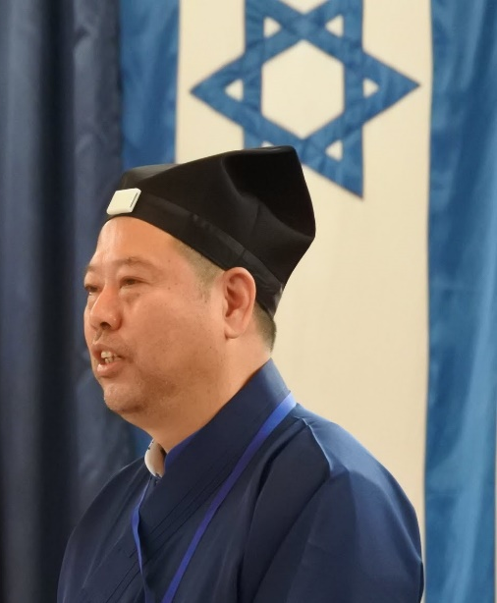
H.H Ven. Master Lu Wenrong,
Vice President, International Taoist Association, China

Huangdi Yinfu Jing

If one observes the Way of Heaven, and maintains its doings as his own, all that he has to do is accomplished.

To Heaven there belongs to the five mutual foes, and he who sees them and understands their operation apprehends how they produce prosperity. The same five foes are in the mind of Man, and when he can set them in action after the manner of Heaven, all space and time are at his disposal, and all things receive their transformations from his person.

The nature of Heaven belongs also to Man; the mind of Man is a spring of power. When the Way of Heaven is established, the course of Man is thereby determined.

When Heaven puts forth its power of putting to death, the stars and constellations lie hidden in darkness. When Earth puts forth its power of putting to death, dragons and serpents appear on the dry ground. When Man puts forth his power of putting to death, Heaven and Earth resume their proper course. When heaven and man exert their powers in concert, all transformations have their commencements determined.

The nature of Man is here clever and there stupid; and the one of these qualities may lie hidden in the other. The abuse of the nine apertures is chiefly in the three most important, which may be now in movement and now at rest. When fire arises in wood, the evil, having once begun, is sure to go on to the destruction of the wood. When calamity arises in a state, if thereafter movement ensue, it is sure to go to ruin. When one conducts the work of culture and refining wisely we call him a Sage.

Heaven and Earth are the despoilers of all things; all things are the despoilers of Man; and Man is the despoiler of all things. When the three despoilers act as they ought to do, as the three Powers, they are at rest. Hence it is said, 'During the time of nourishment, all the members are properly regulated; when the springs of motion come into play, all transformations quietly take place.'

Men know the mysteriousness of the Spirit's action, but they do not know how what is not spiritual comes to be so. The sun and moon have their definite times, and their exact measures as large and small. The service of the sages hereupon arises, and the spiritual intelligence becomes apparent. The spring by which the despoilers are moved is invisible and unknown to all under the sky. When the superior Man has got it, he strengthens his body by it; when the small Man has got it, he makes light of his life.

The blind hear well, and the deaf see well. To derive all that is advantageous from one source is ten times better than the employment of a host; to do this thrice a day and at night is a myriad times better. The mind is quickened (to activity) by (external) things, and dies through excessive pursuit of them. The spring of the mind's activity is in the eyes. Heaven has no special feeling of kindness, but so it is that the greatest kindness comes from it. The crash of thunder and the blustering wind both come without design.

Perfect enjoyment is the overflowing satisfaction of the nature. Perfect stillness is the entire disinterestedness of it. When Heaven seems to be most wrapped up in itself, its operation is universal in its character. It is by its breath that we control whatever creature we grasp. Life is the root of death, and death is the root of life. Kindness springs from injury, and injury springs from kindness. The stupid Man by studying the phenomena and laws of Heaven and Earth becomes sage; I by studying their times and productions become intelligent. He in his stupidity is perplexed about sageness; I in my freedom from stupidity am the same. He considers his sageness as being an extraordinary attainment; I do not consider mine so.

The method of spontaneity proceeds in stillness, and so it was that heaven, earth, and all things were produced. The method of heaven and earth proceeds gently and gradually, and thus it is that the Yin and Yang overcome (each other by turns). The one takes the place of the other, and so change and transformation proceed accordingly.

Therefore, the sages, knowing that the method of spontaneity cannot be resisted, take action accordingly and regulate it for the purpose of culture. The way of perfect stillness cannot be subjected to numerical calculations; but it would seem that there is a wonderful machinery, by which all the heavenly bodies are produced, the eight diagrams, and the sexagenary cycle; spirit-like springs of power, and hidden ghostliness; the arts of the Yin and Yang in the victories of the one over the other - all these come brightly forward into visibility.

H.H Acharya Chandna ji
Spiritual Head, Veerayatan, India / Jain

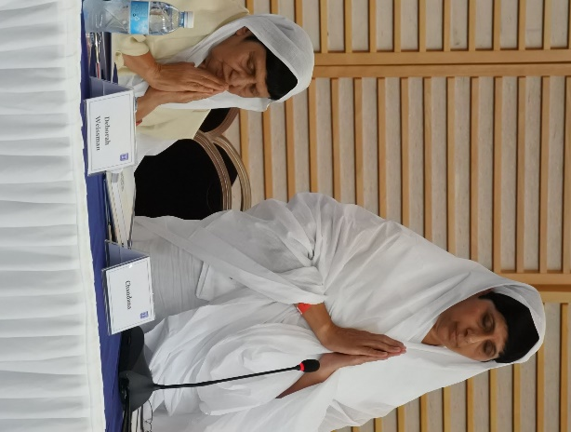

NAVKAR MANTRA, Jain Prayer

Namo Arihantanam,  Namo Siddhanam,  Namo Ayariyanam,  Namo Uvajjhayanam,  Namo Loe Savva-sahunam,  Eso Panch Namokaro,  Savva-pavappanasano,  Manglananch Savvesim,  Padhamam Havei Mangalam, | I bow down to Arihanta,  I bow down to Siddha,  I bow down to Acharya,  I bow down to Upadhyaya,  I bow down to Sadhu and Sadhvi,  These five bowings down,  Destroy all the sins,  Amongst all that is auspicious,  This Navkar Mantra is the foremost.

H.H. Dastur Kobad Zoralia
High Priest, Zoroastrian, Canada
Khordeh Avesta
Yasna 60, Verses 10 - 12 & Hoshbaam Prayer

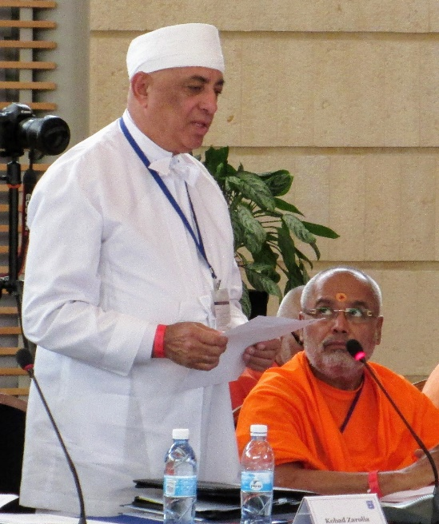

Hakhshaya azem-chit yo Zarathushtro fratemaan,  Nmaananaamcha, Visaamcha, Zantunaamcha Dakhyunaamcha, Anghaao daenayaao Anumatayaecha Anukhtayaecha, Anvarshtayaecha, Yaa Aahuirish Zarathushtrish.  Yatha no aaonghaam shaato manaao,  Vahishto urvaano khvaathravaitish,  Tanvo hento vahishto anghush;  Aakaaoschoit Aahuire Mazda jasentaam.  Asha vahishta, asha sraeshta,  Daresaama thwaa,  Pairi thwaa jamyaama,  Hamem thwaa, hakhma. | I am Zarathushtra who will guide the leaders of the house, clans, towns and lands,  to think, to speak and to act in conformity with this Religion which is of Ahura, revealed-by- Zarathushtra,  So that our minds be full of joy  And our souls attain the best,  Our bodies be full of heavenly glory,  May we be fit for the best world (Heaven) O Ahura Mazda!  May all these good wishes reach us!  Through the best righteousness,  Through the excellent righteousness,  (Oh Ahura Mazda!)  May we see Thee,  May we surround Thee  And may we become one unto Thee!

H.H Ven. Master Misan
Director of Sangdo Meditation Center
Jogye Order of Korean Buddhism
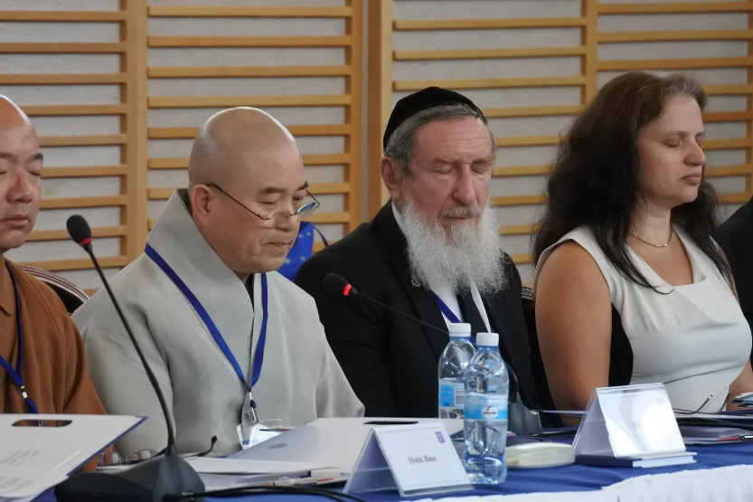
South Korea

Prayer for Peace

Lord Buddha of Light,
Who permeates all corners of the universe,
And who takes care of all things with equanimity!
May your blessings fill the universe with peace and reconciliation!
May all beings be calm and at ease as they are, just the way they are!
May all beings be pure and fragrant as they are, just the way they are!
May all beings be warm and kind as they are, just the way they are!
May all beings be aware of their wholeness as they are, just the way they are!
May your blessings be extended to all concerned, from Israel's Ministry of Foreign Affairs, to the American Jewish Committee, and the World Council of Religious Leaders, so that they can pool their wisdom and practice compassion for the sake of world peace and reconciliation!
May Israel’s religious and political leaders live with a happy smile along with all Israel citizens!
May all beings be happy!
May all beings be healthy!
May all beings be peaceful!

H.H. Most Ven. Ashin Nyanissara
Chancellor of Sitagu International Buddhist Academies, Sagaing Hills, Sagaing, Myanmar / Buddhism
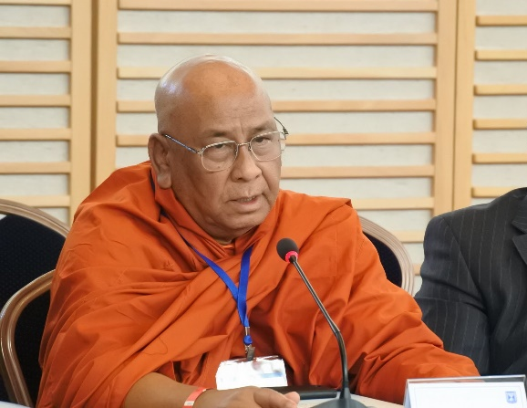

Orignial Pali:  ဒုကၡပတၱာစ နိဒၵဳကၡာ၊ ဘယပတၱာစ နိဗၻယာ၊၊  ေသာကပတၱာစ နိေႆာကာ၊ ေဟာႏၲဳ သေဗၺပိ ပါဏိေနာ၊၊ | Romanized Pali:  Dukkhapattasa Niddukkha၊ Bhayapattasa Nibbhaya။  Sokapattasa Nissoka၊ Hontu Sabbepi Panino။ | English:  May all beings in suffering be free from suffering.  May all beings in danger be free from dangers.  May all beings in sorrow be free from sorrows.

H.H. Swami Parmatmananda Saraswati
Convener, Hindu Dharma Acharya Sabha, India / Hindu
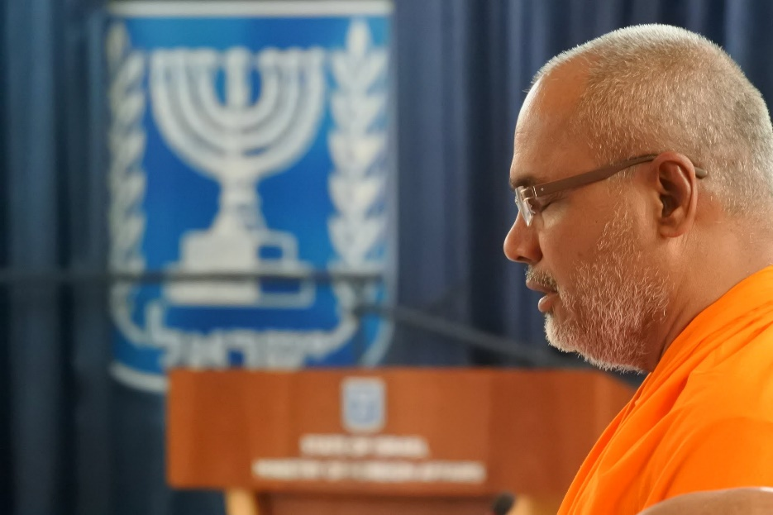

ॐ द्यौ: शान्तिरन्तरिक्ष शान्ति:  पृथिवी शान्तिराप: शान्तिरोषधय: शान्ति:।  वनस्पतय: शान्तिर्विश्वे देवा: शान्तिर्ब्रह्म शान्ति:  सर्वँ शान्ति:, शान्तिरेव शान्ति: सा मा शान्तिरेधि ॥  ॐ शान्ति: शान्ति: शान्ति: ॥ | May Peace radiate in the everywhere above the sky, as well as, in the vast ethereal space everywhere!  May Peace reign all over this earth, in waters and in all herbs, trees and creepers!  May Peace flow over the whole universe!  May Peace flow to the entire world of sentient and being inner things from the Supreme Lord..  May there always exist Peace in everything!  May there be Peace and Peace and Peace Alone!  May that Peace reach ME too!  May there be Peace Within-Peace Outside- Peace Atop All Natural Forces....

H.H Most Ven. Xue Cheng
President, Buddhist Association of China / Chinese Buddhism
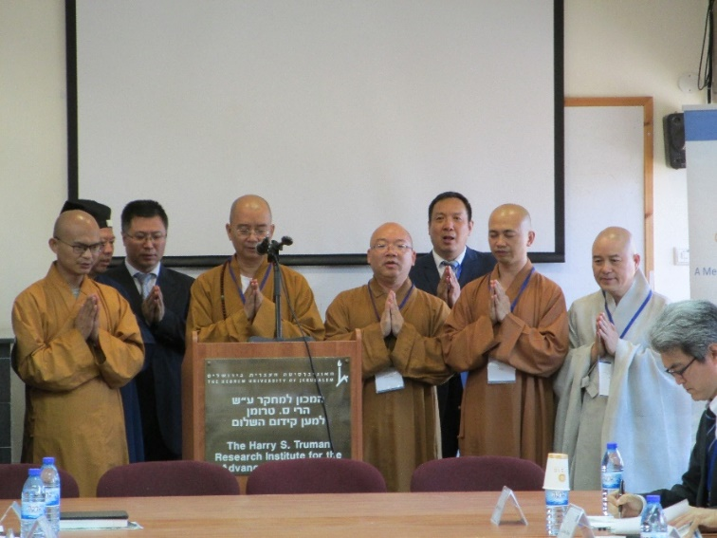

The Heart of Prajna Paramita Sutra
Translated by Tang Dharma Master of the Tripitaka Hsüan-Tsang on imperial command

When Avalokiteshvara Bodhisattva was practicing the profound prajna paramita, he illuminated the five skandhas and saw that they were all empty, and he crossed beyond all suffering and difficulty.

Shariputra, form does not differ from emptiness; emptiness does not differ from form. Form itself is emptiness; emptiness itself is form. So, too, are feelings, cognition, formation, and consciousness. Shariputra, all dharmas are empty of characteristics. They are not produced, not destroyed, not defiled, not pure, and they neither increase nor diminish. Therefore, in emptiness there is no form, feeling, cognition, formation, or consciousness; no eyes, ears, nose, tongue, body, or mind; no sights, sounds, smells, tastes, objects of touch, or dharmas; no field of the eyes, up to and including no field of mind-consciousness; no ignorance or ending of ignorance, up to and including no old age and death or ending of old age and death. There is no suffering, no accumulating, no extinction, no way, and no understanding and no attaining.

Because nothing is attained, the Bodhisattva, through reliance on prajna paramita, is unimpeded in his mind. Because there is no impediment, he is not afraid, and he leaves distorted dream-thinking far behind. Ultimately Nirvana!

All Buddha's of the three periods of time attain Anuttarasamyaksambodhi through reliance on prajna paramita. Therefore, know that prajna paramita is a great spiritual mantra, a great bright mantra, a supreme mantra, an unequalled mantra. It can remove all suffering; it is genuine and not false.

That is why the mantra of prajna paramita was spoken. Recite it like this:

Gate gate paragate parasamgate bodhi svaha!

H.H Giani Gurbachan Singh
Jathedar, Akal Takht, India / Sikh

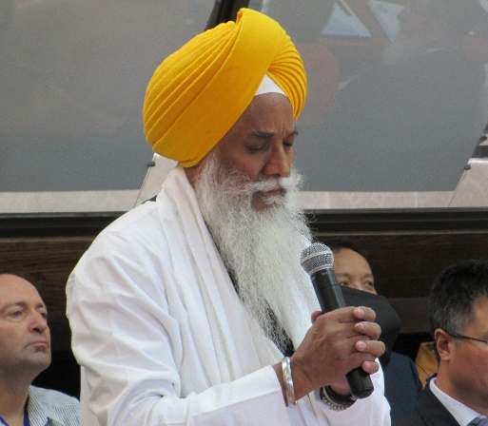

From Sikh Scripture Guru Granth Sahib

I offer this prayer to You, our Lord and Master.
This body and soul belongs to You.
You are our mother and father; we are your children.
In Your Grace, there are so many joys.
No one knows your limits.
O Highest of the High, Most Generous God,
The whole creation is strung on your thread.
That which comes from You is under Your Command.
You alone know your state and extent,
Nanak, your slave, forever surrenders to You!

H.H Most Ven. Hsin Bao
Abbot, Fo Guang Shan, Taiwan

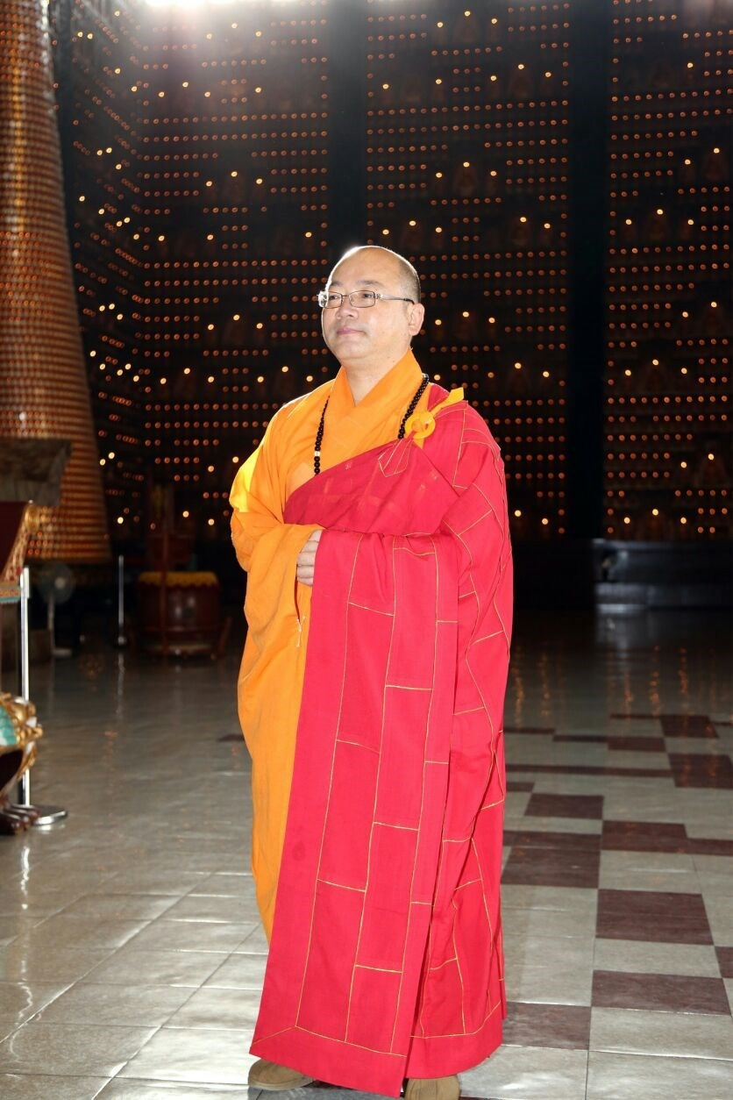

Thankful to the world peace religious conference, I am happy to see that different religious faiths have mutual understanding and communication. I hereby pray for all mankind to be highly attentive to world peace, build a harmonious society free from dichotomy, and that people all over world enjoy their precious internal peace together.

H.H Rev. Tanenori Terai
Chief Priest, Tenmangu Shrine, Japan / Shinto

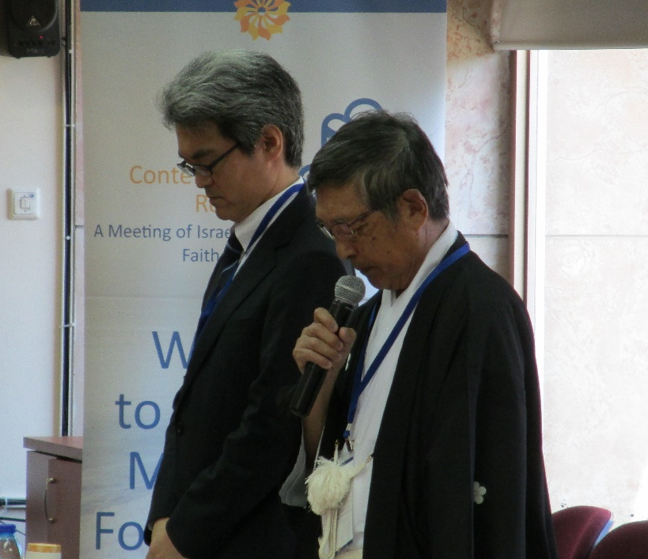

Please keep evil away from us, purify us, protect us, and be happy with us.

H.H Acharya Mahamandaleshwar Swami Avdeshanand Giri
Managing Trustee, Hindu Dharma Acharya Sabha, India / Hindu

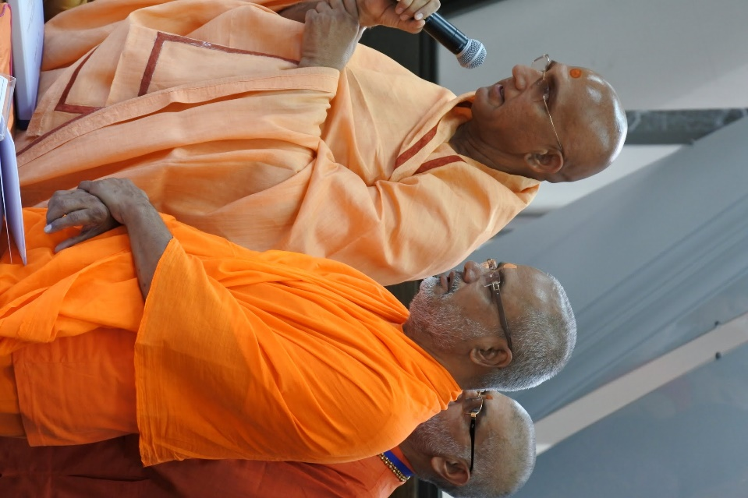

We eat every day, we get dressed every day, we sleep every day, we work every day, therefore we should also pray every day. By eating we increase our physical strength and become physically fit, in the same way prayer keeps our mind healthy, it gives us mental peace and protects us. Prayer keeps our negativity away.

When we dedicate our every deed towards God, then no sinful deed will take place and every deed done by us will become worship which will lead to success. According to Gita, every deed has a positive outcome. The attitude of prayer will bring this out. Our soul is our friend as well as our enemy. Our mind is the reflection of this. Ultimate truth is obtained only when we start praying. Prayers makes one Spiritual.

Rabbi Shlomo Dov Rosen
Communal Rabbi of Yakar Synagogue
Judaism
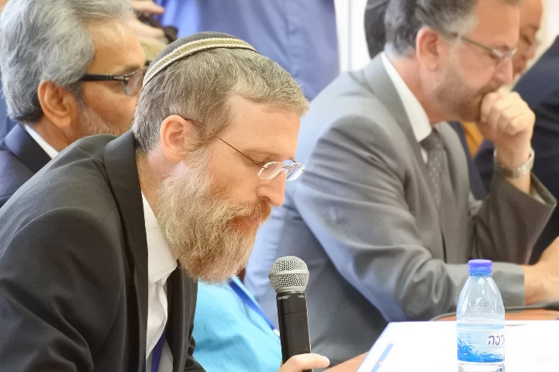

"Patach Eliyahu" is a mystical piece that Sephardic Jews say before prayer.

פָּתַח אֵלִיָּהוּ וְאָמַר: רִבּון עָלְמִין דְּאַנְתְּ הוּא חָד וְלָא בְּחֻשְׁבָּן, אַנְתְּ הוּא עִלָּאָה עַל כָּל עִלָּאִין סְתִימָא עַל כָּל סְתִימִין, לֵית מַחֲשָׁבָה תְּפִיסָא בָּךְ כְּלָל  רִבּוֹן עָלְמִין אַנְתְּ הוּא עִלַּת הָעִלּוֹת וְסִבַּת הַסִּבּוֹת דְאַשְׁקֵי לְאִילָנָא בְּהַהוּא נְבִיעוּ. וְהַהוּא נְבִיעוּ אִיהוּ כְּנִשְׁמְתָא לְגוּפָא דְּאִיהוּ חַיִּים לְגוּפָא. וּבָךְ לֵית דִּמְיוֹן וְלֵית דִּיּוּקְנָא (דְּגוּפָא) מִכָּל מַה דִלְגָאו וּלְבַר. וּבָרָאתָ שְׁמַיָּא וְאַרְעָא. וְאַפַּקְתְּ מִנְּהוֹן שִׁמְשָׁא וְסִיהֲרָא וְכוֹכְבַיָּא וּמַזָּלֵי. וּבְאַרְעָא אִילָנִין וּדְשָׁאִין וְגִנְּתָא דְעֵדֶן וְעִשְׂבִּין וְחֵיוָן וְעוֹפִין וְנוּנִין וּבְעִירִין וּבְנֵי נָשָׁא. לְאִשְׁתְּמוֹדְעָא בְּהוֹן עִלָּאִין וְאֵיךְ יִתְנַהֲגוּן בְּהוֹן עִלָּאִין וְתַתָּאִין. וְאֵיךְ אִשְׁתְּמוֹדְעָן מֵעִלָּאֵי וְתַתָּאֵי וְלֵית דְּיָדַע בָּךְ כְּלָל. וּבַר מִנָּךְ לֵית יִחוּדָא בְּעִלָּאֵי וְתַתָּאֵי. וְאַנְתְּ אִשְׁתְּמוֹדָע אָדוֹן עַל כּלָּא | Elijah opened and said: Master of worlds, You are one and not by number only. You are high above all that is high, hidden over everything that is hidden, no thought can grasp You at all.  Master of worlds, You are the source, the origin of origins, and the cause of causes that waters the tree from that flow. And that flow of water is like a soul for the body. It is life for the body. And for You there is no imagery and there is no image from all that is inside and outside. And You created the heavens and earth, and brought forth from them sun, moon, stars and constellations, and in the earth, trees, plants, the Garden of Eden, vegetation, living creations, birds, fish, animals, and people - to know through them that which is above; and how to act with them above and below; and how to know the above from below; and no one knows You at all. And besides You, there is no unity, not above and not below, and You are known as the master of all.

Two sentences from the main prayer during the High Holidays (Rosh Hashana, Yom Kippur prayer)

''חמול על מעשיך ותשמח במעשיך ויאמרו לך חוסיך בצדקך עמוסיך  תוקדש אדון על כל מעשיך כי מקדישיך בקדושתך קידשת נאה לקדוש פאר מקדושים'' | Have compassion on Your handiwork and be glad with Your handiwork. May those who take refuge in You say – when You vindicate those borne by You –  O Master, may You be sanctified upon all your handiwork. For with Your own holiness You have sanctified those who sanctify You. It is fitting that the Holy One be glorified by holy ones.

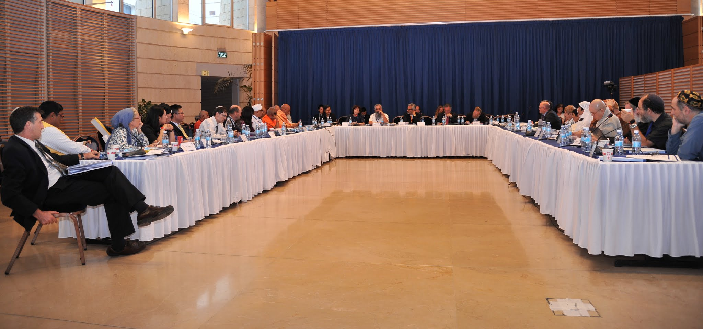

Deliberations at the Ministry of Foreign Affairs of Israel

The Purpose and Place of Religion in our Societies

The Purpose and Place of Religion in our Societies
Session Leaders
Bawa Jain, World Council of Religious Leaders
Rabbi David Rosen, AJC International Director of Interreligious Affairs

Summary of proceedings by Bawa Jain, World Council of Religious Leaders
This session provides the opportunity for participants to present and discuss some of the fundamental principles and values that underlie our traditions, both those which unite and those which make us distinctive. How do our religions see their role in relation to their societies? What insights can we provide each other regarding the challenges presented by the many facets of secularization in contemporary life, and the ways in which religions can remain relevant, vibrant and rooted?

This meeting brings together some of the oldest faiths that exist in the world today and as such is a historic meeting of leaders that has not happened in such an inspiring setting in modern times. In the room, we have significant potential to improve relationships and matters of global importance.

Our respective societies use faith as an anchor and an as an example of the way to live, behave and be governed, it intrinsically links to how our society works and people interact. Through this we see and value that our faith builds a strong community at home, work and in our pastimes. It also connects us into a global community through living such religious traditions – whether we are at home or abroad.
In the meeting that has just taken place with Prime Minister of the State of Israel, Benjamin Netanyahu he deeply understood the value such a forum can create, and encouraged us to meet regularly, at least annually. This direction we will all endeavor to follow up to ensure it becomes a reality. This gathering is of critical importance to understand the potential of and to strengthen the bond between faiths of Asia and Israel. There now follows a very important sharing of how each religion sees their purpose and place in society.
In our session, we will hear much information which will help our journey of understanding which can then allow us to better address the challenges in this world. To do this well will take time, persistence and application.

Let us through this understanding and respect identify areas where we can help to address the challenges we see, build on the opportunities where we can support and strengthen each other’s efforts and resolve.
H.H Acharya Mahamandaleshwar Swami Avdeshanand Giri
Managing Trustee, Hindu Dharma Acharya Sabha, India

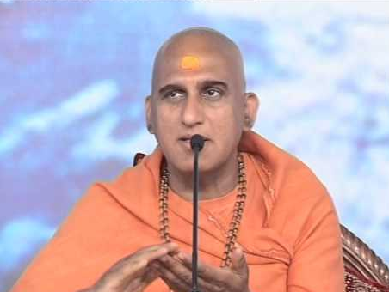
The importance of Dharma or Religion in one’s life should be taught right from childhood.
Human beings are intelligent social animals. God has given us the freedom. In every situation one can do good or harm to himself/herself and to others as well. But all other animals are not capable of doing so. Religion teaches us self-discipline.

What we don’t find good for ourselves should not be done for others as well. We should be the reason for someone’s happiness and not their sadness. Our good deeds will improve our personality as well as it will improve our society.

This is dharma. Such awareful living makes us human. In fact, it’s our duty to showcase humanity. It also gives us strength to be firm and immovable. It leads us to God.
When society at large is religious, it will prosper by itself. There will be peace for all. For, Dharma is, where we get inner peace. Unity, equality, co-existence and universal brotherhood are important aspects of Dharma and Religion- It teaches us to look upon the whole world is a family.

In our culture, we worship nature and environment as we believe nature is the manifestation of God.

Indian culture, backed by religion, believes in protecting our environment. Humans have an unbreakable bond with the environment. Human life is dependent on the environment. Living and existence itself are symbiotic. We all depend upon each other.

Therefore, we should respect every living being and nature. This itself is the true worship of God. The Hindu Vedic Culture believes in holistic well-being, mutual respect and safeguarding the needs of every living creature.

We are here to pay our tributes to Grandeur Personality of the Century, who not only protected, but nourished our ancient wisdom, scriptures and traditions. When Pujya Swamiji visualized to form Hindu Dharma Acharya Sabha, he invited me to share the vision.
It is a matter of joy and pride for me that I was the first member of Acharya Sabha and now I am heading this lineage.

He was a great visionary. In the past, we have met Jewish leadership almost 5-6 times. Today, again we are meeting Jewish leadership along with leaders from 6 different religious traditions. All these meetings are due to his Sankalpa-his strong desire and his inspiration. He lived for the entire humanity, nourishing the individuals with spirituality, religion, principles, values etc.
On this occasion, I would like to pay my humble gratitude and tribute to late Swami Dayanand Saraswati Ji, founder & convener of The Hindu Dharma Acharya Sabha, which is the collective consciousness of the
Hindu Dharma.

Hinduism and Judaism are the most ancient cultures of the world. The Hindu traditionalists respect all religions equally. Specially the Jewish traditions & beliefs.

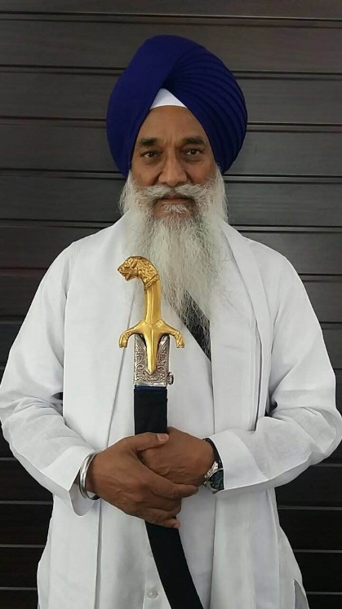
H.H Giani Gurbachan Singh
Jathedar, Akal Takht, India

It was an honor to assemble in a region where many ancient religions originated. We too come from a region which is a home to many ancient religions, however, the particular land from where we come is birthplace of a very young Sikh religion, a little under 550 years, which has a message that is very relevant in contemporary society.

Sikh religion is a way of life in which doctrine and moral-ethical values complete its understanding. Imbibing ethical values, having faith and believing in an all-powerful God makes one religious. Actually “religious” does not carry the essence of the actual word “dharmi “. Dharmi is one who follows dharma. Dharma can be explained as discipline and also as conforming to a religion. Ethical values have two aspects — spiritual and operational which complement each other. Human beings operate on a higher spiritual level once the human weakness of lust, anger, greed, attachment and ego is overcome. Our Guru says “Amongst all dharma, superior most dharma is when all actions are performed while remembering God."

The other aspect of this is, those who love God from the heart yearn to do good deeds. Dharma grows out of mercy. A heart that has no compassion cannot walk the path of dharma. The operational part of Dharma; love, humility, acceptance, contentment, patience, equipoise, etc., are qualities that have to be internalized. Without these qualities, spiritual journey remains incomplete. In Sikh belief journey of life co-exists with one’s spiritual journey. Living a spiritual life does not mean running away from family responsibilities unlike some other Eastern traditions.

The Sikhs believe in earning an honest living, meditating with God and sharing one’s earning with the less fortunate.

From our scripture, “When getting up, sitting, sleeping or awake remember God in every moment.“

Of the earning by honest means, one should keep what one requires for basic necessities and distribute the rest among those who need it more.

Again from the scripture “One who earns and shares his earnings recognizes the real path of spiritual living “.

Every day we pray “Nanak says may God give us optimism and positivity, may God bless everyone with wellbeing. “It underlines our basic belief that beneath skins of different colors there is a common thread that binds us, we all are children of the same God.

In an effort for people of different faiths to live in peace, secularism in society is presenting challenges by trying to cover the differences inherent in different faiths by insisting on uniformity. This creates confrontation with those wanting to adhere to purity of their religion. The Western world believes religion is something very personal and should remain confined to the four walls of a home. In the Eastern tradition, religion is part of one’s life and defines a person. A person of Eastern origin living in the West faces challenges because of this difference in understanding of religion and its practice in everyday life. An example of how it impacts believers is the French law that prohibits one from wearing any religious symbol in some public spaces. It does not allow a Sikh to wear a turban for official documents and a Muslim woman to wear hijab. A country like the U.S. sells guns freely but wearing a religious kirpan (small sword) could raise a problem.

In face of challenge, some young people assimilate in the local culture and tradition while others become even more firm in their faith. Generally, a person who follows their faith more staunchly than their co-religionists is called a fundamentalist and looked at with distrust. And I am not talking about those who take to violence in name of religion.

In this age of knowledge, reasoning has become very important. However, rationality may not necessarily explain spirituality, realm of the soul is not limited by the brain. Being too pious is sometimes misinterpreted as being a fundamentalist. Actually it is an emotion in good faith but at times gets distorted in a violent form. In its distortion it creates intolerance against the “other”. This “other” may be another religion, nation or sometimes a co-religionist who interprets religion differently. At that point religious leaders should intervene and take a stand before violence sets in because ultimately this violence will be damaging to one who indulges in it.

We are living in technology driven times. The technological revolution has converted the world into a global village, most nations have a multi-ethnic, multi-religious and multi-cultural population. Interfaith dialogue could have a significant role to play in creating a harmonious society. First Sikh Guru Nanak started interfaith dialogue more than 500 years ago. In one of his travels he went to Mecca-Medina and held dialogue with Syed Ruknuddin. Dialogue with Buddhist, Hindu and Muslim saints earned him the sobriquet of Lama, guru, fakir and pir.

Ninth Sikh Guru Teg Bahadur ji sacrificed his life for the right of others to profess their religion. It is significant to note that the first Guru refused to go through the ritual of Hindu boys wearing a sacred thread, but the 9th Guru supported the right of the Hindus (Kashmiri Pandits) to wear it.
The point I am trying to make is that for peace and harmony in society it is important that each religious group be allowed the freedom to live their spiritual life and religion be openly accepted in public spaces.

Religions are ancient, have been around for centuries and will continue to be relevant and inspire humanity towards higher living and goodness for times to come.

H.H Most Ven. Xue Cheng
President, Buddhist Association of China
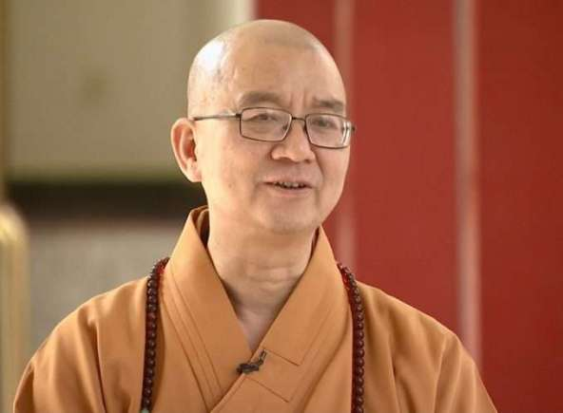
History, Features and Inspiration of Chinese Buddhism

It is a great opportunity to meet you all here in Jerusalem, the Holy Land in both ancient and modern times, to attend the meeting on religious dialogues with the theme: “Ancient Traditions, Contemporary Realities.”

Alongside advances of globalization, modernization and steps toward a future-shared world, religion continues to be an important factor in influencing people's lives and international relations. Religion also has a growing need to cope with, in appropriate manner, the new challenges brought by contemporary social, scientific and technological development. The harmonious coexistence and peaceful development of a diversified civilization relies on equal and open communication and mutual learning among religions. As a representative of Chinese Buddhist circles, I would like to express my heartfelt appreciation for the launch of this meeting, and discuss briefly the development of Chinese Buddhism.

A major innovation of Chinese Buddhism and which has contributed greatly to Indian Buddhism is the compilation of Tripitaka. The Tripitaka, which consists of more than twenty editions, each of which contains thousands of volumes compiled over the past dynasties, is a priceless treasure of Chinese culture and of great cultural significance in the history of the Chinese and world cultures. The compilation of Tripitaka provides the basis for a full understanding of the scriptures of Chinese Buddhism and its different sects. Since the Buddhist texts in Chinese have yet to be translated into western languages, western societies lack a comprehensive understanding of Chinese Buddhist scriptures and its sects, resulting in many misunderstandings. For example, quite a few people in the West think that Chinese Buddhism equates to meditation. But in reality meditation is just one of its practices. By delving into the voluminous Chinese Buddhist texts you will find the profound and extensive theoretical backing behind a multitude of Dharma practices.

If we look at the history of interactions among human civilizations, only by constant communication can we identify similarities and differences among religions and cultures, and hence transcend limitations and complement each other’s advantages. This progress will pave the way for peaceful co-existence and mutual-development among different religious sects and civilizations. In fact, world-wide frictions, tensions and even wars are all related to the dissimilarities and conflict of people’s thoughts and perceptions. The root cause is the lack of understanding and acceptance of each other’s culture, beliefs and traditions. Peaceful assimilation upheld by Chinese Buddhism, the flexible and practical attitude it promotes, and the working experience it has accumulated offer inspiration and hope for social progress.

Rabbi Professor Daniel Sperber
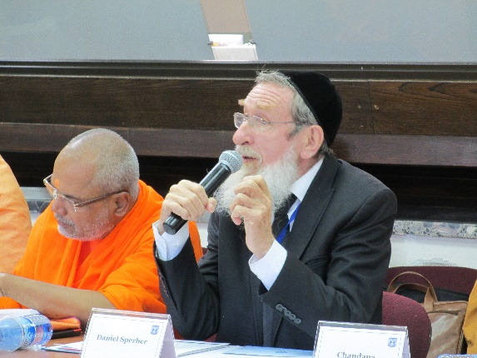
President, Bar-Ilan University Institute of Advanced Torah Studies

What can the West learn from the East from a religious point of view?

This is a very historic meeting being the first of its kind between Jewish religious leaders from the State of Israel, and leading religious authorities representing religions of the Far East. The question I would like to address myself to is what can the West learn from the East from the point of view of religion? The answer in a single word is: tolerance. I shall try to explain myself.

Western thinking, both religious and philosophical, is primarily based on classical Greek logic, according to which there are three primary laws of identity: (1) A is A, that is if something exists it has a single nature, it is what it is, (2) the law of the excluded middle – A cannot be A and not A at the same time and in the same sense; truth is not self-contradictory, and (3) a statement is either true or false. Consequently, if I know the truth, and you believe otherwise, you must be wrong. In the area of religion this meant that I had a moral obligation to show you your ways of error, to bring you to the true path, even if that means religious coercion. Thus, we understand the mediaeval Christian inquisition in which heretics or members to a non-Christian faith who refused to accept the "true way" were burned at the stake, or the contemporary position of extreme Islamic fundamentalists who even behead the unbelievers.

Far different is the position in Eastern thought. There we find the notion of the legitimacy of "multiple truths", something termed "coincidention oppositorum", meaning the legitimacy of opposites. There may be more than one truth; indeed, all truth is ultimately subjective, seen by the individual from his specific personal viewpoint. This, for example, is one of the most fundamental doctrines of Jainism, as formulated by Mahavira (599-527 18 C.E.), called anekantavada, the multiplicity of viewpoints, so that no single point of view (dristikona) is the complete truth. In this way, even opposites can be accepted, as Hajime Nakamura, in his "The Ways of Thinking of Eastern Peoples", Japan 1960, p. 44, wrote:
"… This idea of the oneness of opposite pairs [called concidentia oppositorum], held in the Upanisads was accepted by the Vedantins, the most influential philosophical school in India of later ages."

Margaret Chatterjee, in her essay, "Religious Pluralism in the Indian Context", apud "Culture and Modernity: East-West Philosophic Perspectives", ed. Eliot Deutsch, Honolulu 1991, p. 390, characterized Indian tolerance as follows:
"Differences are not correlated with "rival truth claims" and are even regarded as 'not mattering', that is, the differences do not surface in a sense that 'I am right and you are wrong'"

So too Buddhism has displayed a spirit of acceptance to the various primitive faiths native to the different Asian countries where it has become the prevalent religion. The amalgamation of popular native beliefs is very strong in southern (Theravāda) countries. And Judaism too to a certain extent.

So the East, with its basic respect for all kinds of religiosity – provided it does no harm to others – has already contributed much to appreciation of the legitimacy of tolerance. But I think we still have a long way to go and there is much for the West to learn from the East.
Rabbi Naamah Kelman
Dean of Hebrew Union College, Jerusalem

We Need One Another!
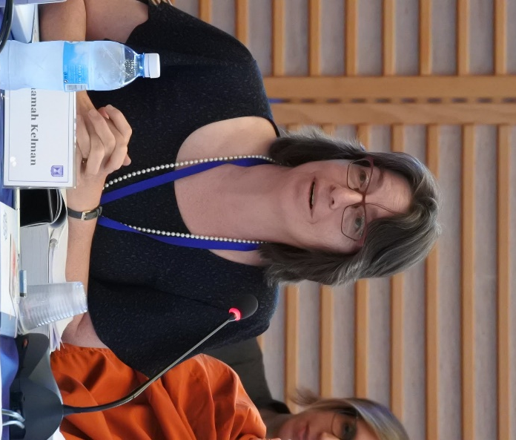

Jerusalem is a city of intersections…a city built on sacrifice and compassion, faith and despair. A city where, old meets new, east joins west, mountain meets wilderness. In Hebrew, the name Jerusalem is plural. When the Holy Temple stood, it symbolized eternity nestled in temporality. This notion translated into an everlasting image of 2 cities: The Heavenly or Celestial Jerusalem and the earthly Jerusalem. Then, when the Church of the Holy Sepulcher was built and the Mosque of El Aqusa too, Jerusalem became a place holy to the three monotheistic religions, who share the God of Abraham, the God of Israel.

Global connections have turned us into a world village. But technology has unleashed healing powers and powers of destruction as never before. We cannot keep up with the amount of terrible catastrophes facing humanity. It makes us numb with fear. Yet we also feel helpless in the face of poverty, disease, violence, and corruption. Doing God's work fights despair!

There is a wonderful Jewish parable about how we must act like God. Of course as soon as the Rabbis say this, they gasp at their audacity. How can we humans be like God? So they answer, just like God visits the sick, we too must visit the sick. We learn this because God "appears before Abraham" in Genesis Ch. 18, shortly after he underwent circumcision. So the rabbis deduce that Abraham is recuperating and God has come to "call". They rabbis seek Scriptural proof texts that God feeds the hungry, clothes the naked (Adam and Even in the Garden), consoles the mourners, etc. and therefore, we must walk in God's ways. These are the ways of God's grace. Of course, the most powerful proof text also from Genesis, Ch. 1, vs 27, makes it very clear that we were created in God's image, all of us, men and women, people of all colors and faiths. I must treat you as if you represent God's image on earth. But no one has a monopoly on suffering, just like no one has a monopoly on holiness.

We join hands as God's representatives on this glorious earth. So indeed, we start with those near us in pain and suffering and we spread our work. Justice according to our Prophets is also our mission. Care for the orphan, the widow, those most helpless in out societies. Build an equitable world. We turn to God in prayer and in action to fill the world with God's grace. We, of all faiths share a God of Compassion and Justice. And these two must go together.

Compassion without justice may heal us but will not mend nor move us toward where we need to go. Justice without Compassion might fix the wrong but will not give us the ability to hold on to each other. We serve a God who can move us, heal us, inspire us, and compel us.
In the Jewish tradition, we hold onto 2 key pillars that hold us up. They are Creation and Redemption. Creation is both the original act of the Creation of the World and the ongoing idea of renewal; renewal of the soul and renewal of the world. Redemption is the original act of Exodus from slavery and the ongoing hope for a redeemed world. While God is the source for these transformative powers, we must become partners with God to insure the ongoing forces of renewal and redemption in the world.

Simple truths are either/or; profound truths are either and or. This is a reality we live in, in the Middle East; with so many competing truths. No one has a monopoly on truth. No religion is an island, the great Jewish Theologian and social activist, Rabbi Abraham Joshua Heschel said; we all need each other.

H.H Ven. Master Misan
Director of Sangdo Meditation Center, Jogye Order of Korean Buddhism, South Korea

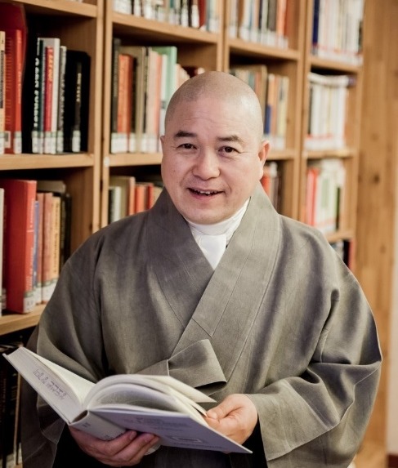
In this chaotic turning point of contemporary civilization, it is my great joy and honor to be here and reflect on the role of religion and its place and function in society. On behalf of Most Ven. Jaseung, President of the Jogye Order of Korean Buddhism, I’d like to extend my deepest gratitude to the members of Israel's Ministry of Foreign Affairs, the American Jewish Committee, and the World Council of Religious Leaders. I hope this conference will provide an opportunity for all of us to understand Israel’s current situation, as well as to recognize our religious diversity and plurality, and to share our wisdom and insight.

The Purpose of Religion and Its Place in Society

Throughout history, we human beings have posed numerous questions on the ultimate principles of human life and all things in the universe, and sought answers. Why are we born into this world and why must we die? What universal principles govern this world we inhabit? What is life and what value systems should we live by? Many religions have appeared on the Earth and have shared their own answers to these fundamental questions based on their founders’ teachings. The purpose of religion is to end spiritual confusion and insecurity based on insights into these ultimate questions and to live a life of peace and happiness together with all other beings.

In past traditional societies, before the advent of science and technology, religion was the spiritual pillar of society and culture, and set standards of ethics and morality. Religion led people to formulate perspectives on the world, life and values based on devotion and faith in an absolute being. Religion taught us essential values and the ideal world we should pursue. It gave us standards and norms with which we could distinguish between good and evil, and right and wrong. Religion exercised great influence in all facets of life including politics, economics, education, ethics, culture and art.

Secularization and Crisis in the Contemporary Era of Science

However, upon the advent of the contemporary science, social structures drastically changed, and many aspects of daily life were no longer under the jurisdiction of religion. Secularization supplanted religion. Secularization has taken hold to a high degree, though its dominance varies in different regions and cultural spheres. The primary reasons behind this are: the development of scientific thinking and historical thinking. Scientific thinking poses challenges not only for Christianity but for all religions that claim to know truth beyond empirical truth. Contemporary society is skeptical of religious teachings that seem contrary to scientific common sense and rationality. For example, the concepts of karma and reincarnation adhered to by Buddhists and Hindus cannot be proven by science so fewer and fewer people believe in it.

What really struck a blow to the role of religion, no less than scientific thinking, were the new development in historical thinking. According to the new trend in historical thinking, all things that exist in the world, all the products of civilization, all systems and philosophies developed by humans, including religion, are simply the creations of people who lived in a certain place and time. Religious teachings that were formerly deemed absolute are now considered the products of a certain period and are subject to change over time. People today take it for granted that even religious truth is not free from cultural conditions and restraints.¹

As religion gives way to science and to historical and cultural relativism, the harmful consequences of our materialistic civilization intensify every day. As the role of religion is reduced, materialism becomes more solidly established, and we see a radical increase in social maladies such as self-centeredness, consumerism, hedonism and loss of identity.

As materialism spreads in capitalistic societies, religious lifestyles that seek spiritual values shrink drastically. This often creates an identity crisis for many individuals, and as a result their ability to perceive relationships between self and others, self and society, self and state and self and nature is greatly diminished. Excessive competition exacerbates the symptoms of various psychological pathologies, including a rise in stress levels, divorce, suicide, depression, obsession, alcoholism and addiction to games. Interest in psychotherapy and counseling is on the increase and so is widespread social distrust, crime and violence.

Our contemporary economy’s push to pursue limitless growth and maximum profit has resulted in indiscriminate development. Our ecological environment is deteriorating rapidly due to the negative consequences of capitalization, including the rapid expansion of consumerism, automobile exhaust emissions, and the increasing discharge of harmful gasses from the large-scale raising of animals for consumption.

Recently, as a result of global warming, extreme weather conditions like scorching heat, torrential rains and heavy snows occur more frequently, and glaciers are melting at an accelerated rate. There are also more frequent natural disasters like earthquakes and tsunamis. The continued destruction of the natural environment necessary for all living organisms to thrive and reproduce is not something our global village can survive.²

All over the world we see religious conflicts, race riots and regional conflicts between countries over territory or resources. Every day casualties increase from terrorist attacks, and major European cities live in constant fear of terrorism. The Korean Peninsula also is under heightened tensions due to the confrontation between South and North Korea in the aftermath of a series of military measures including North Korean missile launches and discussions on the deployment of the THADD missile system in South Korea. There are also other critical issues to be resolved, including the economic gap between advanced and developing countries and the growing refugee problem.

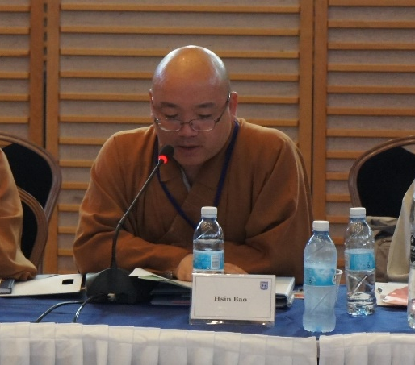
H.H Most Ven. Hsin Bao
Abbot, Fo Guang Shan, Taiwan

Fellow colleagues- It is an honor to be invited to attend this meeting.

Peace is precious like air, something that we cannot live without even for a second. And we, as modern people, become more and more connected with one another, peace has become all the more important. My spiritual guide and master, Venerable Master Hsing Yun, during his keynote address for the Buddha’s Light International Association, proclaimed that “the themes of co-existence, respect and tolerance, equality and peace, are all important revelations for today’s world. Venerable Master Hsing Yun advocates religious fusion, frequently inviting leaders of various faiths to join in prayer for world peace. He also advocates the “Five Harmonies” ideal. As the Buddhist saying goes, “a monastery without issues is a prosperous one”; this means that people need to live harmoniously for the monastery to be free of troubles. Within the traditional monastic community, the “Six Points of Reverent Harmony” are observed to maintain harmony. As for the general community, I propose that we consider the concept of “Five Harmonies”, that is, “Inner harmony achieved through joy; Interpersonal harmony achieved through respect; Family harmony achieved through deference; Social harmony achieved through cooperation; and World harmony achieved through peace.

Perhaps allow me to elaborate on each of the five harmonies.

As for Inner harmony, we all know that it is mind over matter, and that the mind controls the body. If we have maintained a mind of purity, sincerity and honesty, then we can broaden our horizons to embrace others, society, and the Buddhist teachings. As such, no matter whether we are engaging with people or dealing with matters, we are able to remain joyful and delighted.

As for Family harmony, if one wishes to have peaceful relationships between parents and children, husband and wife, or between siblings, then there needs to be mutual understanding, respect and tolerance; as the Chinese saying goes, when family members unite in mind, even dirt becomes gold.

As for Interpersonal harmony, one should be polite, caring, understanding and respectful, and render our help whenever needed. We could perhaps also avoid confrontations and conflict by being forgiving, and actively seeking out the good in people. By doing so, we can maintain harmony in our interpersonal relationships.

As for Social harmony, we may be reminded that society is the culmination of various ethnic groups, and each group has its own history, culture and customs and aspirations. Amidst the myriad differences, we can work towards harmony by being respectful, friendly, and helpful towards one another, and be willing to engage in sincere dialogue and exchange.

As for World harmony, the one thing that may undermine it is opposition. Opposition between spouses or siblings is not conducive of a loving family. Opposition between nations or ethnics groups, leads of course, to unrelenting issues on a global scale. However, if every nation is willing to embrace trust and morality, and with of Loving Kindness, Compassion, Joy, and Equanimity, act magnanimously towards those who differ, then we can prevent the cruelty and aggression that war brings to humankind. If we can treat others with a selfless attitude, then we can harmoniously co-exist.

Peace, is when we take the initiative to be on good terms with others, it is not an expectation we place on others. Change is easiest when it starts from oneself, and as such, only by proactively extending our goodwill to others, will good results come to fruition.

Only when we drop our attachment to the “I”, can peace be realized.
In simple terms, war and peace are both the creation of human beings. If we do not rest our enmity towards others, and if we persist with using force to conquer others, that we will never realize the universal ideal of peace.

The concept of “Five Harmonies”, which I today humbly bring forth, begins from oneself. When we achieve inner harmony, we may then extend this harmony to our families, to our interpersonal relationships, to society, and ultimately to the world.

The power is in our hands.

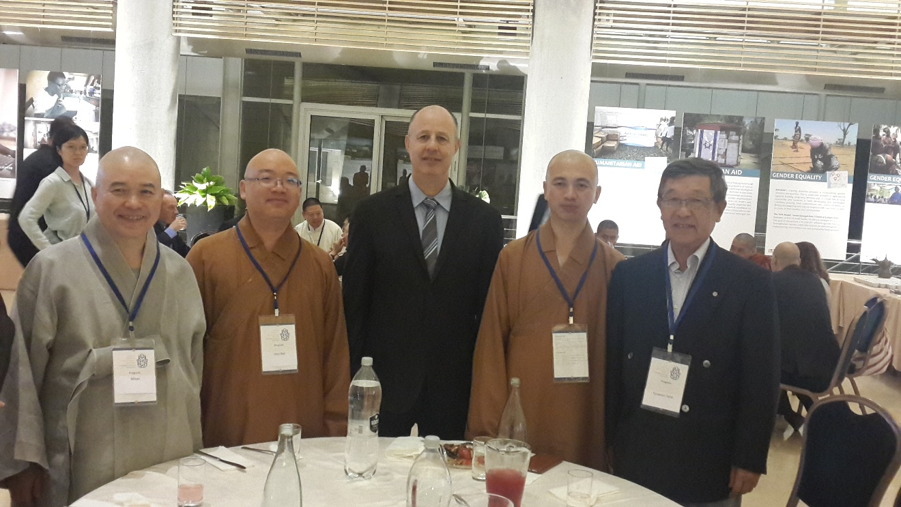

H.H. Most Ven. Dr. Ashin Nyanissara
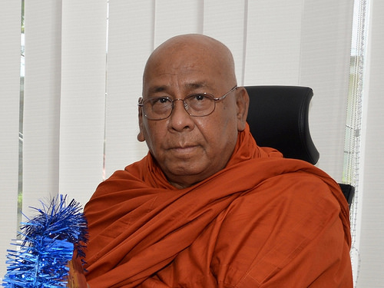
Chancellor of Sitag International Buddhist Academy

It gives me great pleasure to be invited to this Summit Meeting of Israel-Asia Faith Leadership organized by Israel's Ministry of Foreign Affairs and the American Jewish Committee in collaboration with World Council of Religious Leaders with the noble theme to create better understanding and relationship between religious, intellectual and political leaders of Israel and Asia. I sincerely believe that frequent meetings of this kind would be highly conducive to the strengthening of world peace and stability.

The world today is full of chaos, full of crimes, full of miseries, full of evils, and full of violence. The nations are arming themselves to their teeth. Arm races among great countries are most frightening and the weapons they are using are highly destructive that people are living insecure lives.

Today, I'm very much pleased to share one of the salient teachings of the Buddha over the power of mind, which is largely instrumental in establishing individual peace. This plays a very powerful stepping stone to the promotion of world peace and stability.

We, human beings, are mysterious beings with inconceivable potentialities. Noble characteristics and criminal tendencies are latent within us. These may rise up to the surface of our lives at any time unexpectedly without using strength and power. These potentialities or tendencies are dormant within us in various degrees.

Within the powerful complex human's mind, we find a treasure vault of virtues and wisdom, then we find a rubbish heap of wickedness and corruption. By developing these respective characteristics, we may become either a blessing or a curse to humanity. We human beings, are consisted of both mind and matter. One of the Buddha's messages in Manopubbangama Dhamma - mind is forerunner, mind is chief in life, mind is the master of man, mind molds the human life, mind makes happiness and suffering, mind creates beauty and ugliness. Therefore, human beings are architects of their own lives. Thus, in order to create our beautiful life or beautiful world or peaceful world, we must mold our mind to be beautiful and peaceful first.

From Jina to Jesus, all great founders of all religions have emphasized it with virtues of tolerance and non-violence. But the world we live in is often driven by religious conflicts and sectarian strife, or even the war of brutal fighting. Because we usually attach importance only to the outer shell of religions and we overlook the universal truth or the inner core of religions. The result is a lack of love, compassion, tolerance, forgiveness and self-understanding in the mind.

When there is no peace within individual, then there could not be peace in the world. Violence and peace never can coexist. The only way to achieve inner peace is insight meditation. This is non-sectarianism but scientific result-oriented technique of self-observation and self-realization of the truth. Practice of Insight Meditation brings some unprecedented result -- that is -- experiential understanding of how mind and body are interacting.

Every moment to moment, the mind generates hate or love, compassion or cruelty, sympathy or jealousy, positivity or negativity, pleasantness or unpleasantness and selfishness or selflessness. So the entire mind is flooded with pleasant sensation or unpleasant sensation all the time. Insight meditation reveals that mental action precedes every physical and vocal action, determining whether that action would be wholesome or unwholesome. That is why we must find practical methods to create pure and peaceful mind.

The practice of insight meditation can be used for keeping a balanced mind and sound health. By exercising insight meditation, everyone can remove mental disease of negativities and can achieve balance of mind. The balanced mind will make the unbalanced world balanced, a stable mind will make the unstable world stable and a peaceful mind will make the violent world peaceful.

People of any faiths can practice such insight meditation without discrimination of caste, color and creed. At the same time, they may follow their own religions and traditions in peace and harmony. There is no need for conversion of religion. A common source of tension and conflict create negativity only. Therefore, conversion is only for changing negative mind to positive mind. As an observer, one will find a society to live in peace and harmony in its natural setting.
Today in the world, we see clearly various degrees of spiritual pollution like discontentment, dissatisfaction, disagreement, argument, demonstration, strikes, violence, invasion, aggression, and tension, etc. These spiritual pollutions are always creating bad consequences to human societies and human environment.

This is the manifestation of unbalanced and untrained mind. They are motivated by negativities latent within human mind. We all understand that we need to protect our environment and society, removing such mental pollutions.

People are searching for a place of peace and tranquility. However, it cannot be found in this materialistic world. So, let us change our mind from negativity to positivity. Removing such pollutants of negativities while seeking forbearance and selflessness promotes peace and harmony among human society as well as balanced mind and healthy relationship between human society and its natural environment. This is what all human beings have to practice for individual and world peace.

May all beings be free from aversion. May all beings be happy.
May Peace and Harmony prevail in every corner of the world.
May the sublime Dharma prevail in its pristine purity in every corner of the world.

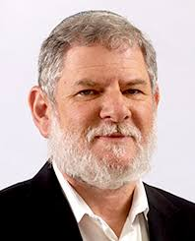
Rabbi Avi Gisser
Rabbi of the community of Ofra

We have heard a lot, and we have shared a lot about our ideas and missions, and we found out how much we have in common, which is so important in this time. For example, in this era we constantly challenged by the culture of screens. We say that babies are born in this world with a cell phone in each hand. So the mission of educators, Rabbis, and leaders in this age is to deal with this challenge and to find ways to bring our children out of the screens and to develop human beings with strong relationships to other people and to society.

I am teaching parents now that the most important place in the community is the basketball court. In the past, we kept our children inside, saying they should not go out because outside there is danger, and instead we should stay at home. Now, staying at home is the problem because at home the whole world is inside the computer. This is a big challenge for educators in our time. So I believe that we share this common fight against the screens.

But I want to add one comment because you know that the religious are educated in honesty, friendship and tolerance. You will tell me perhaps that you have it in your own religions, but in Judaism the most important thing is free will. I think that you can speak a lot about tolerance and you can be tolerant by having good manners, and you can be tolerant as it is practical to society. But to be tolerant is not only good practice for life. It is also a mission from God, because each person is unique. No one is like you. We have a short story that tells how when a person will come in his time before God after his life, God will not ask him why he didn't behave like the big leader, the Chief Rabbi, or like Moses or Abraham or Jacob. He will ask him, "Why weren't you yourself? You are so unique. I didn't create anybody like you in the world, in all of history."

So be yourself. How, you may ask; can a person be himself, and not be under the influence of others? We see free will as the most important value in life. If there is no free will, we are robots, and where is the will of God in this creation? So we need to be tolerant and to respect each person because we admire free will, and this is the way in which we are similar to God, and reflect the image of God. God can decide in His own way, and a person in the image of God has the same privilege. If you respect this privilege as a gift of God, then tolerance is one basic value in your religion. This is one comment I hope will enrich all of us here in our sessions and we will create a lot of new ideas, ways of thinking and points of view to repair the world from all its problems with God's help.

Religion and Responsibility: The Vision of a Just Society

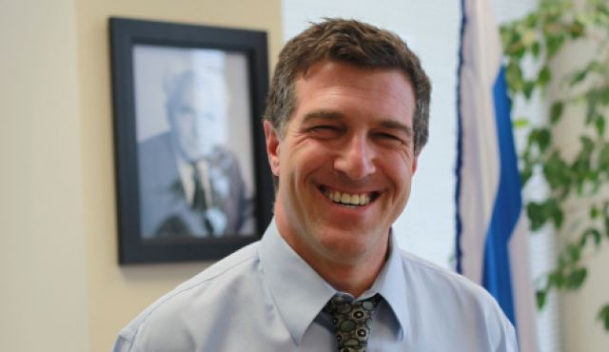
Akiva Tor
Head, Bureau for World Jewish Affairs and World Religions, MFA

Session Summary

The position of Judaism on human dignity and rights derives from the concept that humans are created in the image of God. Hence they are possessed of Human Rights, translated in Hebrew as “Right of Adam”, or rights which belong to human their being children of the first man created in the image of the Creator. How do Eastern traditions see this question? Should more emphasis be placed on the rights of society, the fabric of humanity, rather than the full realization of an individual’s freedom in seeking the realization of a Just society?

The moderator, Dr. Tova Hartman, pointed out that religious rules and traditions have at times engendered deep injustice, as in the subjugation of woman. The command in the Torah to be a “Holy nation” means in her view, a requirement that the religious community and individual seek to be good, beyond dogma and commands. Faith and religion require us at times to exceed the bounds of religion itself in order to ensure justice and pursue the Good.

Rabbi Yuval Cherlow understands faith as a meeting with God. This can empower the good person, it can correct the bad person, or God forbid, it at times empowers the person who is bad, intolerant, self-righteous and against all other faith traditions because of “how truth”. Hence, can the faith traditions form and cohere a joint ethical framework which will guide all of us in the understanding of our faith and revelation? Rabbi Dr. Goshen-Gottstein unpacks the meaning of a just society as pervasive expectation of the State of Israel from itself, by itself, and by others, as the realization of the dream of Abraham’s children whose path is justice and righteousness.

Shinto has many thousands of deities, explained Chief Priest Tanenori Terai, and these express the life force and divine energy of the natural world. Faith is the wisdom inherited from our ancestors and the long history of humanity. Mt. Fuji can be understood as the vision of the just society, but there are many ways to ascend the summit, some steep and difficult, others seeking beautiful panoramas, so too there many faith directions leading to the just society, a vision we share.

In the Jain tradition, all life is revered, including plant life. Jainism promotes equality for all forms of life and a reverence for all of them. Ecological degradation and the destruction of the environment which promotes life must be addressed in promoting the just society, which supports life.

Taoism, explains Most Venerable Lu Wenrong, is dedicated the ideal of Natural Unity, and views the Just Society through this lens. If we are aware fi the shared fate of mankind, rather than seeking the logic of competition, if we withdraw the beams of our ambition, we can resolve the layers of conflict and violence to the state of Natural Unity.

Zoroastrianism places responsibility on individuals and religious leaders to pursue the good. Evil needs to be sublimated and we ought to follow the practice of good thoughts, good words, and good deeds. If we pursue this, we will achieve the Just Society. Cyrus, a great kind of Persia achieved this through his doctrine of liberty for all peoples, the freeing of slaves and the right to pursue each their own form of worship.

For Hinduism, peace requires none other than oneself, but in society there is the possibility of abuse, and to be human is to live responsibly. Dharma requires us not limit freedom, but to exercise it in a way that respects all. Here is only one self that pervades all, but the two hands must come together in unity. This is the Hindu vision of Namaste, a just society.

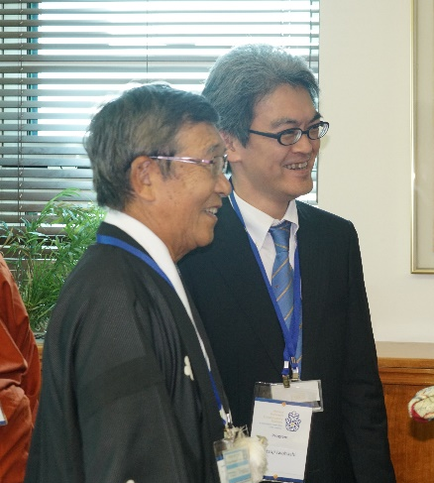
H.H. Tanenori Terai
Chief Priest, Tenmangu Shrine, Japan

It is very meaningful for the world that religious leaders and representatives from international bodies get together to have an international dialogue in Jerusalem.

I am here as a priest to represent Shinto, Japan’s traditional religion. Today in Japan, there are approximately 80,000 Shinto shrines or Jinja in Japanese. I am chief priest of one of them. Jinja Honcho or the Association of Shinto Shrines is an organization to administrate Shinto shrines all over Japan and commits various activities as a traditional faith to preserve and inherit Japanese traditions to the next generations.

Shinto is an indigenous faith of the Japanese. Since the ancient times, Japanese people have expressed the divine energy or life-force of the natural world as kami and have worshiped them. Such Japanese way of understanding the natural world is called Shinto. Literally, there are eight million deities, and there is no one single omnipotent creator in Shinto. Natural elements such as sun, moon, sea, mountains, rain, fire and thunder are worshiped. Individuals who have made a great contribution to the state or society are also worshiped as deities. The Shinto shrine where I serve as chief priest enshrines a historical figure who was a great politician and a scholar about 1,000 years ago.

I think that Shinto is something different from what is expressed as religion. Shinto is a Japanese tradition or Japanese traditional sensibility and it is directly linked with people’s life. We have succeeded our lives from ancestors together with respect and appreciation to nature. Shinto is an expression and a narrative of such feelings.

When we look around the world, we can see rapid and drastic changes everywhere. The same can be said in Japan where traditional value is still maintained. More than seventy years have passed since the end of the Second World War in which atomic bombs were dropped for the first time in history. On the very date that Japanese people were informed of the end of the war, I turned twelve years old. Since then, I have witnessed the recovery and development of Japan as a peaceful country.

However, as we look around the world, it is difficult to say that the world is filled with peace and prosperity in these seventy years. In spite of the devastating experience, human beings have never stopped fighting.

In Japan after the WWII, the new constitution prohibits the government to have any relationship with religious organizations. Taking this article rigidly, the government tried to remove any religious aspect from politics and education more than necessary. Due to this attitude, Shinto sometimes experienced unfair treatment by some people. Through this process, although Japan has become one of top developed countries, it has left something important behind.

Recently, Japanese society is observing change in its nature. Five years ago, a huge earthquake hit Japan and people from all over the world sent support and love. Realizing the power of nature and the importance of mutual support, Japanese people started to change their way of life and re-recognized the traditional value of Japan such as Shinto.

Two years ago, Jinja Honcho held an international symposium in Ise, the sacred place of Japan, to discuss natural environment and sustainable development from religious perspective inviting those who are involved in conservation activities around the world. In Ise, there is a Shinto shrine named Ise Jingu where the ancestral deity of the Japanese Emperor is enshrined. Ise Jingu is surrounded by forest that is about the same size as the city of Paris and represents the spirituality of the Japanese.

In this symposium, there were religious leaders and representatives of international bodies such as the UN. The participants visited the Ise Jingu which has been continuously rebuilt in a deep forest, and I suppose it might have been an opportunity for them to recall the simple but profound value that they had in the past by actually experiencing the Japanese faith and its view on nature. A representative from the UN pointed out that the support from faiths that maintain historical and traditional value is essential for sustainable development.

Along with Ise Jingu, world famous Mt. Fuji is also a spiritually important heritage for the Japanese. It is the highest and most symbolic mountain of Japan. Since there are deities of mountains in Japan, Mt. Fuji is naturally an object of worshipping and is a sacred place. Every year, about 200,000 to 300,000 people walk up to the top. They take various routes. Some are steep and rugged and some are with beautiful views. I suppose faiths are the same as the routes to the top. Peace, human rights, natural environments. Such issues and goals we share are, in other words, high mountains like Mt. Fuji. There are various routes we can chose and take to the top, the shared goal. What is important is an idea to admit the existence of other routes to the goal.
This is not only about religions. Politics and religions should admit each other in order to achieve the shared goal. Because, politicians are surely involved in resolving various issues of the world and in order to do so, taking care of people’s spiritual aspect is inevitable. Those who can take care of spiritual aspect are no one but religious people. I am saying this here in this conference because I believe you are the ones who can share the importance of this idea.

Faith is the wisdom that has been inherited from our ancestors. Faith is the wealth that has been fostered by human beings. And faiths in this world and people in these traditions have wisdom to coexist and prosper together in peace.

Shinto, which has many deities and has coexisted with Buddhism through the history, is not close minded at all. In the story of divine age of Japan, it is illustrated that deities got together and discussed to solve issues. I believe, this meeting is a chance to gather wisdom inherited by faiths and practicality of politics to develop a bright future of the world.

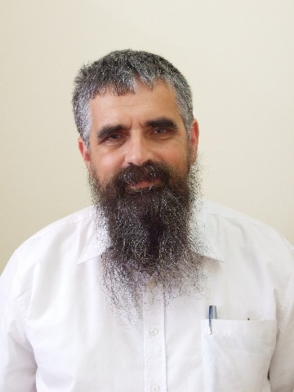
Rabbi Yuval Cherlow
Head of the Amit Orot Shaul Yeshiva

Does one's belief in God or his participation in a particular religion necessarily make him a good person?

The answer to this question is extremely complex. In order to answer it, we must first clarify what it means to be "good", for without this clarification we cannot fully answer the question. However, for the sake of this important conversation, I will concede the complicated philosophical discussion and use the word "good" as it is widely accepted, meaning to treat other human beings well, behave in an honest and fair manner and act ethically. So does faith inevitably result in the aforementioned behavior?

Faith is a meeting with God. To this meeting, one brings himself; that is, his character, his surroundings, his friendships and relationships, his time and experience. If he is fundamentally a good person, then this meeting with God has the ability to empower the forces of good within him - his inner world, and his desire for a life of justice and honesty. However, if he himself is a bad person, two different possibilities can develop. The first is that his meeting with his faith will generate a change in him, his conscience will awaken, and he will choose to change his ways and align with values of righteousness and kindness. The second possibility, which we unfortunately have faced many times from the past to the present, is that he will recruit God to contribute to his wrongdoing, and in the name of faith will engage in terrible acts towards other religions and to people who do not adhere to his own extremist interpretations. This is a tremendous danger.

Therefore, it is of great importance for the different religions to cooperate in creating the basic infrastructure of the revelation that they bring; to work together in jointly designing an ethical framework that will serve as the backbone of religion faith, through which all faiths may develop according to its ideas. We should not fool ourselves into believing that this will eliminate religious war and the various challenges surrounding it. But, it can help bring about change and contribute to making the world a better place, precisely from the strength of religious faith.

Religious leaders therefore must address their own religious communities internally, together with the special illumination present in every religion, to bring their attention to the dangers that faith can bring if it is conceived as an ideology that replaces moral behavior and conscience. Doing so will lead religious faith forward in making the world a better and more moral place, as well as prevent the empowerment of injustice in the name of religion.

Rabbi Dr. Alon Goshen-Gottstein
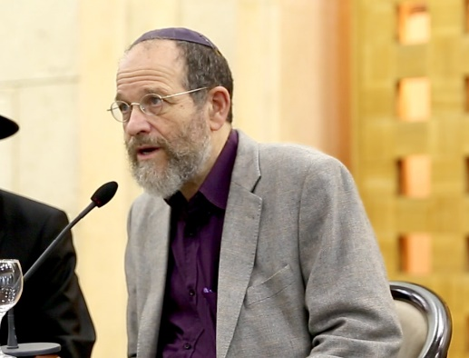
Director of the Elijah Interfaith Institute

Social Vision of Judaism

The question of Judaism’s social vision takes on particular coloring from the perspective of the State of Israel and therefore has a very special perspective in this conference's deliberations. Unlike consideration of a social vision of Judaism, or any religion, that might be articulated in some neutral context, there is special charge on this question in the State of Israel, in as much as a significant part of Israel’s self-understanding and mission is related to the fulfillment of Jewish ideals.

Accordingly, we have to consider the question of a social vision in light of a broader history relating to the Jewish people. Judaism, unlike other religions, is both a people and a religion. Judaism should not be understood as a set of philosophical or metaphysical ideals, with rituals and a way of life that enforces them. Judaism is best understood as the story of a people. This story has to be understood within the context of a special view of human history. This story has strong associations with the notion of an ideal society and its social vision.
The Torah tells of the formation of the Jewish people, through the person of Abraham. In one story, Abraham is told of the immanent destruction of a people, of Sodom and Gommorah. God chooses to share the fact of their impending destruction with Abraham, and offers the following as a reason: God’s way is justice and righteousness. This path is the way of Abraham’s family, but is expressed in relation to all of humanity, as we see in the immediate context of praying for others.

Why would God seek to create a model nation? This question has occupied Jewish thought for millennia. One very common response relates it to the sense of instrumentality and helping humanity achieve a higher spiritual and moral standard. The biblical tale places the story of Israel’s formation following a sense of broader failure and disappointment with humanity, as told in the first 11 chapters of Genesis. Accordingly, creating an ideal society in the people of Israel is actually part of a broader strategy for bringing all of humanity to perfection.

The story of Israel as God’s people is one of ups and downs. It is not at all a story of achievements and successes. Rather, it is a story of repeated attempts to achieve a spiritual and moral high ground, and repeated failures, attempts, lessons, and gradual achievements.
In line with this history, one must understand the Jewish people’s return to their homeland following nearly two thousand years of exile. Situated in the tale of Israel’s aspiration for achieving its designated calling it is, in fact, a story of yet another attempt to realize a mission of a just society, a moral high-ground, and a perfected people of God.

It is against this background that we must consider the question of the state of Israel and a just society. It is not simply that there is some contribution by Judaism to the question of what a just society would be. Rather, the very enterprise of the return home and the creation of the State of Israel is to be identified with such a quest. This places very high stakes and high demands upon the State. Certainly in the eyes of the world, the State of Israel is judged in accordance with an implicit, often unconscious, expectation of high moral standards. The same is true of how Jews themselves view the State and the society created therein. There are many criteria for judging a society in moral terms. Significantly, one of the most central, in the Torah’s own evaluation, is the attitude to the stranger, the other, the minority within. I believe this remains one of Israel’s most fundamental challenges. It is continuously judged by its attitudes to the other within and will continue to be put to the test on this matter, in the hope of applying high moral ground to one of the most fundamental existential challenges, by means of which it can also be a model to the world.
H.H. Acharya Chandana ji
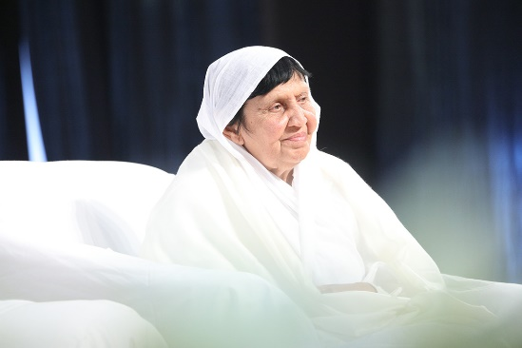
Spiritual Head, Veerayatan, India

Environmental and Ecological Issues Propagated and Discussed by Tirthankara Mahavira

Before I start about the environmental and ecological issues discussed & propagated by Tirthankara Mahavira, I would like to ask how we have fallen into the trap of this environmental and ecological crisis in the first place. It is clear that at the center of all crisis lies the human race. It is the human community among all forms of life on this planet, who are interfering with the laws of nature by squandering her gifts, or by destroying the existence of other species for personal and selfish reasons. Ironically, this issue of protecting the environment and the ecology has not necessarily come up because we have begun to hear the cries of plants, animals and other forms of life – a direct result of our maltreatment of them – but that human life itself is in danger.

A fundamental shift in our thinking and in our behavior towards other forms of life is required. It isn't because I am a Jain nun, but because I am a student of comparative religions, that I understand Tirthankara Mahavira endowed humanity with that fundamental thought upon which our behavior patterns and relationship with the environment could be based. An equality for all forms of life and a reverence for all of them is his central teaching; 'As you want to live so do others.' and in his definition of 'others' he embraced the existence not only of all living beings but also the existence of earth, air, water, and vegetation. He even expressed a reverence for the inert. By making people aware of the existence of life in earth, air, water, and in vegetation, he made a fundamental contribution to our understanding of ecology. He considered any injury to these a sinful act. The Acaranga-Sutra, the first main scripture of Svetambara Jain tradition, describes the thoughts of Mahavira on the life in vegetation: Vegetation has life just the same as human beings. It is born like human beings are, its body grows and feels pain when pricked or cut with weapons. Like human beings' vegetation needs food. So the consumption or use of vegetation for personal propaganda, publicity or even in the worshipping of god is a sin. If someone uses it in such a way, it may lead to his misfortune. He further proclaimed that anyone who neglects or disregards the existence of earth, air, fire, water and vegetation disregards his own existence which is intrinsically bound up with them.
He discussed and propagated these ideas and went on to make the protection and care of life in all its manifestations, an obligatory duty for all Jains.: For example, the daily prayer of the Jains contains a word of forgiveness for any harm of pain caused not only to fellow human beings but to all forms of life.

Care in all our actions became the norm for the Jain way of life. This developed to the extent that those who renounce the world are required to take precautions for the protection of life before every action they perform e.g., every morning and evening they should check all their belongings to ensure that no little creature has been hurt or killed even unintentionally. Jain devotees are dissuaded from throwing any waste into rivers and lakes and are urged to guard the lives of alt creatures found in and around this precious commodity. Instead of just dumping waste anywhere a place should be found where the least harm would be done to other living organisms. With such enlightened thinking and caring for all beings. The entire Jain way of life is in harmony with the environment. Simply by adopting vows laid down in the Jain discipline for inner development one can live peacefully in perfect harmony with nature.

Unquestioned and unplanned technological advances are considered to be the major reasons for ecological imbalance. Tirthankara Mahavira was also very thoughtful in guiding his disciples in the selection of their trade, business or profession. He said that people should not go in to professions which destroy nature and perpetrate violence. A Jain lay person is required to take twelve vows for spiritual progression. The seventh vow, Bhogopabhoga-vrata-means limiting one's use of resources clearly forbids involvement in fifteen trades, such as earning a livelihood from the destruction of plants, a livelihood from carts, this includes the construction and sale of carts to be drawn by animals and the driving of them, whether done by oneself or at one's instigation, any trade in animal by-products, trade in lacquer or trade in alcohol and forbidden substances, trade in destructive articles like poisons, weapons, spades, all of which are potentially dangerous to life. The underlying idea is avoidance of injury to animals, insects or plant-life. Jain teachers were conscious that these professions are potential health hazards because they pollute the environment in a big way. Off-course rejection of these trades also means that the Jains should not consume such products.

We all know about the environmental and the ecological crisis in the developed countries due to accelerating industrial and technological growth, but there is another form of ecological crisis taking place in the underdeveloped countries. It is due to the lack of the essentials of life. The natural resources are exhausted and overused, just to meet the basic demands of life. I come from Bihar, the place of Tirthanakara Mahavira's birth, teaching and final death where most of population lives below the poverty line. The villagers keep cutting down trees for fuel for their cooking and they also sell the wood to earn their livelihood. There is a community called Mushar there, whose main food is rats. They have nothing else to live on. They dig holes in the fields and fill them with water; rats running around in the field fall into the pits, the rats drown and are eaten by the Mushar community. The other children of that area have no facilities for education and play, so they make a hobby of killing birds and fish. The lakes and ponds have been emptied of fish and other animals because the hungry populace of the surrounding area has used them to meet the basic needs of life. Sacrificial rituals are still the norm for the locals. This then results in the killings of thousands of animals. Needless to say that if such activities continue, the ecological and environmental crisis in such places will be staggering.

The mission of these active religious people, and I emphasize the word active because religion is often seen as passive and unconcerned with the world is based on the universal principle of Tirtahnakara Mahavira that the sun, the air, the water, and nature as a whole is giving of herself silently and selflessly to us all the time. It would be selfish on our part if we take, take, take, and not at least return the portion we have taken till the time we leave the world. So the mission works on this motto, given by Mahavira in his last sermon, recorded as Uttaradhyana-Sutra: Let friendship be our religion, not only in our thoughts but in our actions as well.

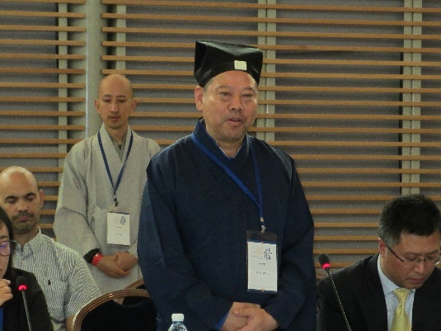
H.H. Most Ven. Lu Wenrong
Vice President, Taoist Association of China

The Tradition of the Taoist Religion and the World of Natural Unity

I am from the beautiful island of Hainan in the South-east of Asia and I am a follower of the Taoist religion – a religion grounded in a long history and yet, to this day, full of vivacity and potential. I am most honored to have been invited to take part in this Conference of Asian Religious Leaders, and to have the opportunity to hear the illuminating insights of other religious leaders, each speaking from their own traditions on contemporary issues. I am awed by this environment preserved in friendship and the shared motivation towards world peace. All this that I have felt here at this conference is in keeping with my faith in the Taoist religion, and so for me this conference has been a joyous experience.

A traditional religion rooted in the ancient history of China, Taoism yet remains in step with the spirit of this conference throughout. On the one hand, deeply concerned for the reality of a society sometimes full of conflict and violence; and on the other hand, resolutely dedicated to pursuing the ideal of Natural Unity that results in harmony between people and between humankind and nature. For over a thousand years, from our predecessors in Taoist cultivation to our Taoist brethren of today, we have been following the earnest teachings of the Daodejing, which says, “Blunt the sharpness; Untangle the knots; Soften the glare; Let your wheels move only along old ruts. This is known as Natural Unity.” Blunting sharpness and untangling knots, softening the glare and raising no dust - this teaching passed down from our Ancestral Master encourages us to look upon reality with a gaze that transcends it, seeking possible ways to dissolve conflict. The ideal of the harmonious world of Natural Unity springs forth from the resolved conflicts of the real world, like a cicada shedding its old skin, and gaining new life. In our religion, transcendence from the everyday to the ideal is not only an obligation, it is seen as a genuine possibility, made possible by our combined efforts directed towards a common goal.

We know that we live in the same world, and can only live in the same world. This fact that usually goes without saying gives rise to the tension of civilization unique to humankind. On the one hand, because we can only live together in the same world, problems may occur around the issues of resources, territory and so on, conflict and even violence arises. Sometimes it seems as if there is not enough resources and space to go around to meet the needs of humankind, as if the world were too small for us.

On the other hand, also because we can only live together in the same world, one cannot ever leave it, and neither can anyone else be pushed off of it, and so we need must find some way to co-exist, we must transcend the urge towards conflict and violence. Doing so allows the brilliance of human ingenuity and willpower that is unique to us to shine through, the world grows in its capacity for existence and life. Therefore, as long as we are concerned with the real world, we will necessarily find that the existence of conflict and violence that leads people to point weapons at each other is a constant and ubiquitous possibility. The choice that we must make is to withdraw the beams of our ambition, to respect the different states of existence and characters of all things. By dedicating ourselves tirelessly to finding ways to make peace, heading towards a goal of achieving a state of Natural Unity, to resolve the complex layers of conflict and violence. It is only in this sense that we can truly understand that humankind has a shared fate, and the most essential meaning of civilization should be to constantly work towards building and improving ways of coexistence.

Humankind has invented many excellent methods to finding ways of coexistence – science and technology increases the value of resources, expands the space that we live in and constantly relieves the tensions of resources and space. Law and politics, by establishing order, have their own value in revealing a way of coexistence; a shared community with effective law and order can effectively control conflict and violence, and allow resources and space to be sensibly used. However, at the same time we are very clear that these methods – science and technology, law and order, that could be used for such means, have the characteristics of instrumental reason, they can be used for good or for evil. For example, science and technology, which in many cases is used for the good of humankind, is yet occasionally used to create weapons that bring destruction. Even though law and order, in the vast proportion of situations and times brings order to human society, it cannot be denied that at some points in history, law and politics have been used as an axle by which to skew the fortunes of the whole of society, leading to many problems.

These lessons and experiences from the history of civilization ought to make us ever more convinced that before the instrumental reason of such tools, it is necessary for there to be a bright, guiding light of rational values to show us the way, so that we may consider how these tools should be used and to what ends. Religious conviction has been passed down throughout history as just such a guiding light of substantive rationality. Therefore, from a historic point of view, the present day is a continuation of history, the responsibility and meaning passed on to religion in the present day should be to, as this conference shows, pass on and spread afar substantive rationality.

As for my own Taoist religious beliefs, inheriting substantive rationality and seeking ways to resolve conflict means, in the first place, being fully aware of the shared fate of humankind, and secondly encouraging that common fate, the direction we choose is that of Natural Unity, rather than seeking to conquer through the logic of competition.

It is not a complex matter to perceive the common fate of humankind from an emotional perspective. There is an ancient Chinese saying that goes, “We all share the same heart, and the heart shares the same principles”. The heart that is sympathetic, empathetic, has been traditionally viewed in China as the part of human nature endowed by Heaven, their celestial nature. As long as a person can preserve this celestial nature, they will naturally resonate with the shared fate of humankind. Theoretically speaking, on the matter of the communal fate of humankind, various religious traditions offer us amazingly rich and diverse resources to consider, forging our celestial nature and emotions, raising it up to become a solid idea.

The thirty-fourth chapter of the Daodejing expresses this idea in Taoist terms,
“The way is broad, reaching left as well as right.
The myriad creatures depend on it for life yet it claims no authority.
It accomplishes its task yet lays claim to no merit.
It clothes and feeds the myriad creatures yet lays no claim to being their master.
For ever free of desire, it can be called small;
Yet as it lays no claim to being master when the myriad creatures turn to it, it can be called great.”
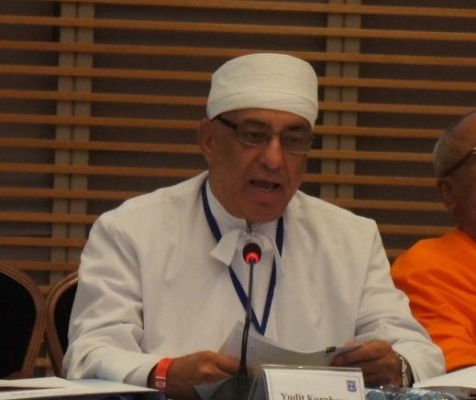
H.H. Dastur Kobad Zoralia
High Priest, Zoroastrian, Canada

Let us start with the words 'JUST SOCIETY'. We all might have a different view of just society. Every human being and every country will justify their own version of just society.
The dictionary gives the following description of word 'just': "used especially of what is legally or ethically right or proper or fitting."

Religions do not have very much control of the legal laws of much of the countries but all the religions have Ethical base and teachings which if followed will make the world, or any country, or any village a just society

My own religion Zoroastrianism, lays the responsibility on its followers shoulder to make their society just.

Religion is a fundamental set of beliefs and practices given by Prophet. These set of beliefs concern the cause, nature, and purpose of the universe, and involve devotional and ritual observances. They also often contain a moral code governing the conduct of human affairs.

Our Prayers teaches us to practice hamuta, hukta, and huvaresta which means good thoughts, good words, and good deeds every day. If we all practice that we all will be living in a just society.

ALL Good things come from AHURA Mazda, in the prayer Din-no-Kalmo, or Confession of Faith which we pray every day we say ”I attribute all things Good, to the holy One.’

Say where all bad things come from, how the society becomes unjust.

Hence it is our belief that no harm of any kind, such as pain, sorrow, suffering, hurt, unhappiness, wars, disease, etc. can come to humankind from Ahura Mazda, and such harm is manifested in the Force of Evil (Ahriman or devil) that tries to negate all the good workings of the collective force of good.

In one of our prayers DOA- NAM-SATAYASNA it is said GOD has given men the highest position in the universe by giving them the power of thought to oppose, fight and be away from bad emotions. The person praying promises to keep pure the six faculties granted to him: the power to think, to speak, to act, and to reason as well as wisdom and intelligence by keeping away from bad emotions.

The difference between a good person and a bad person is only this, a good person sublimates his evil emotions by good thoughts, where as a criminal is wholly carried away by his evil emotions. In Zoroastrianism there is a great stress on sublimation of all bad emotions.

Let me give you two incidents in history; one just society and another one not just society.

This vision of human dignity and rights is enshrined in the Cylinder of Cyrus II, fondly known to us as Cyrus the Great.

Some 2500 years ago when Cyrus liberated Babylon, he declared his edict to all that he and his army would not plunder and pillage, nor deprive any one of their property or personal effects, nor enslave anyone as noted in the freeing of all slaves, and pronounced that all people were free to pursue their own forms of worship. This is considered by many as one of the earliest declarations of human rights.

This account is given in the Old Testament in the Book of Ezra, where Cyrus is considered as the Anointed of the Lord, further recording forever the freeing of the Jewish people and return of all the religious items and helping in the rebuilding of the Temple in Jerusalem. This declaration of Cyrus was engraved in a Cylinder, later excavated and stored at the Museum in London, England, with a replica displayed in the United Nations building in New York.

For us Zoroastrians, all over the world, these are not just words of a Great King of Persia, but a path to imbibe, follow and live by every day of our lives, as a commitment to human dignity and rights. For we strongly believe the SOCIAL IDEAL that to enjoy human rights we must first give them to others. To enjoy peace and prosperity for ourselves we must first avail them to others.

Now let me give you an unjust society example. As per Canadian History there were residential schools established in 1880. This was a joint venture between Christian Churches and Government of Canada. The purpose of the schools was attempt to both educate and convert aboriginal youth and to integrate them into Canadian society. These schools were populated by children of Native Canadians who were forcibly removed from their homes and taken away to the schools. The Church people never cared about the harm they were doing these children and their families. This lasted for about 50 years before the politician put a stop to it. This what happens when you have religious heads and the followers who do not care for other Humans?

Now the history teaches us that it was the worst treatment of human beings done by a church.

Now just think when all these unjust acts against society were going on, why were the other priests of the church quiet. Why did they not protest?

In 2007 The Church and the Government apologized to the people who were wronged.

This is still happening in the world, the religious leaders keep quiet when they see unjust acts happening in their city or in their country. It is a basic responsibility of all religious leaders and all human beings to protest when unjust acts are done.

Let’s all of us make it our duty to make sure the society remains just.

LET THERE BE PEACE ON EARTH, AND LET IT BEGIN WITH ME!

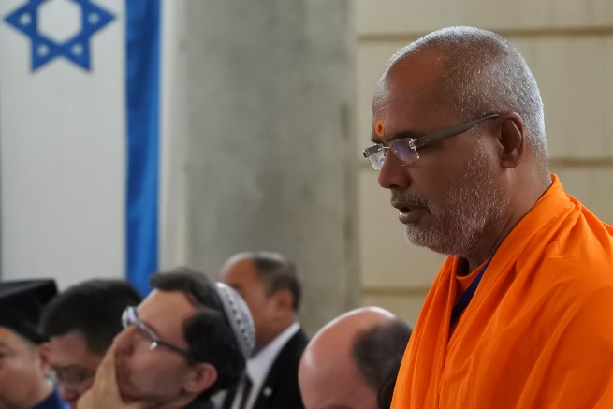
H.H. Swami Parmatmananda Saraswati
Convener, Hindu Dharma Acharya Sabha, India

Life situations are always demanding stressful, confusing, challenging and often unpleasant. Every human heart yearns for peace, happiness, contentment, composure. The solution to this dichotomy is provided by Hindu Dharma.

Hindu scriptures reveal that peace is neither inside nor outside. Even if it seems that an outside place can bring some peace, often having gained that so called peaceful place the human mind is in turmoil. For peace, one requires nothing other than oneself. Peace is centered on “I” – the self. How we look at the world outside, how we relate to fellow human beings, what are our priorities in life and what is our understanding about the reality – all of this leads to peace. All of this determines whether one is at peace with oneself or not.

It is a great blessing that we are able to play different roles. Since we play different roles, all these roles and each role player is different. This self, the role player, is complete – free from any problems of roles. When one is at peace with oneself, one discovers oneself, the role player, as an adequate person. It brings about a paradigm shift in the sphere and understanding about the external world. This is Hindu Wisdom – Hindu spirituality.

To own up this vision, Vedas gives a lifestyle, popularly called as Hindu Dharma or Hinduism. Hence Hinduism is often spoken as a “Way of Life”.

In the case of animals, birds and other creatures etc. their efforts and choices are motivated and governed by instinct. They are not subject to choice whereas we human beings are blessed with unique faculty of choice. We have freedom to choose our ends and the means to them. In fact, we have no choice but to choose. Generally, most of our choices are based on our likes and dislikes. Our choices for ends and means are subjective. This is, often referred as human freedom or human dignity. As Rev. Swami Dayanandaji said – “That which can be abused and misused can be called freedom – otherwise not”.

Therefore, while exercising our freedom, while fulfilling my desires and needs, one should be careful in not trampling upon freedom (rights) and needs of others. Since we live a symbiotic life, our choices should not be based on our likes and dislikes only.

The possibility of abusing and misusing freedom, necessitates that there should be an ecology – an order governing usage of this freedom. The order that accommodates and protects – freedom of all, rights of all. This is called Dharma in Hinduism – popularly called religion.

Our action certainly has an effect. In particular, instinctual actions can certainly disturb the order of harmony or social ecology. These disturbances in turn will create disorder, will disturb others. To exercise our choice in being deliberately ethical, is responsible living. An awareness or alertness to edge our freedom in guarding other’s freedom is responsible living.

To live responsibly is to be human. The religion does not inhibit our freedom but it teaches us prudent use of freedom and thereby makes us a human being. In other words, adhering to such religious life leads to a “Just Society”.
The Lord has created all of us. We are interconnected and interdependent. We have to live with each other. Since all of us are created by the Lord – “We Live and Let Live” – “We Live Happily and Let Others Live Happily” – “We Live Peacefully and Let Others Live Peacefully”. Our Hindu religion teaches us how to interact or how to live with the world outside. It teaches us to interact with compassion and love. It teaches us to accept and respect others.

For Hindus, creation is sacred. We respect the nature. The world outside is not for man’s consumption only. It is not “Bhogya” (for more consumption) but “Pujya” (to be respected also). To maintain the harmony and ecology, each one of us should be a “contributor”. Mere “consumer” will disturb the ecology. To be contributor, means to respect the creation-to be religious.
In Hindu tradition, when we greet each other, we say “Namaste”, with the expression of bringing one’s two hands together. Though my two hands are entirely different, they don’t match with each other in any which way, yet they never fight with each other. They can be together because they belong to one person. The essence of both is one. That which gives them strength and movement, that which gives sentiency to both the hands is ONE AND ONLY ONE.

There is only one SELF. Similarly, there is one Non-Dual Lord that pervades in and through the entire creation that gives sentiency to all. There is one and only one consciousness in the hearts of all. Bringing two hands together, is a symbol of unity, symbol of oneness. This is Hindu vision.

NAMASTE

Safeguarding the Garden:
The Ecology of Planet Earth in an Industrial Age
Safeguarding the Garden: The Ecology of Planet Earth in an Industrial Age
Session theme:
At the heart of our traditions lie the veneration of life and the imperative to safeguard the balance of nature. This session explores how values of sustainability are reflected in our traditions and practice; and how faith leadership can help better protect our planet and conserve its resources.

Session Summary by Phil Harrison, World Council of Religious
Discussion and responses led by MODERATOR - Dr. Deborah Weissman, Educationist and lecturer in Jewish thought

The early stages interpreted our role as that of guardians entrusted to care for the planet:
“In Ecclesiastes Rabbah, chapter 7, section 13, the writer tells a story. When God created the first man, he led him around all the trees in the Garden of Eden. God said to him, “See My works, how beautiful and praiseworthy they are. Everything I have created has been created for your sake. Think of this, and do not corrupt or destroy my world; for if you corrupt it, there will be no one to set it right for you.”

Rabbi Michael Cohen
Arava Institute for Environmental Studies
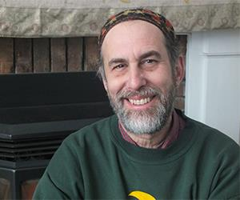
Let There Be Light: Diversity as a Biblical Message

One of our great challenges today is living with and supporting diversity in all aspects of our lives as a species including the care and support of a thriving environment. Diversity is not a liberal value; it is the way of the world. We know that the environment is healthier with greater diversity, coral reefs and rainforests being prime examples. It is also true for humanity. We are better off because of the different religions, nations, cultures, and languages that comprise our human family.

The opening of the Bible understands diversity not as a noun but as a verb; the basic action of life as we know it. Its importance is underscored by the fact that its many mentions in its opening chapters highlight diversity as a foundation of the world. Such an orientation is essential for our survival as a species.
This a basis of the Arava Institute for Environmental Studies located on Kibbutz Ketura in the Arava desert on the Israeli-Jordanian border where we bring a diverse group of college students and researchers together - Israelis, Palestinians, Jordanians, Internationals; Christian, Muslims, Jews, and others. Please consider sending students from your countries and religions to come and study with us. Since 1996 it has operated with the knowledge and understanding that Nature Knows No Borders. To put it another way reduced to one of its essential components, the conflict here is about land – more precisely, the borders that nations draw on the land. When we look upon the land solely as a geopolitical instrument, it is viewed as one of the major stumbling blocks to any reconciliation. However, when we view the land from an environmental perspective – which does not know from political borders, walls, or fences – a new framework opens up. That is to say the needs of the environment, rather than disputed land (the same piece of real estate), can become a bridge between peoples. Building on shared concerns and interests is a way to build and rebuild relationships.

The Sun which shines equally on all peoples in this region can be a resource for building and rebuilding those relationships. With this is mind the Arava Institute houses our very active Center for Renewable Energy and Energy Conservation directed by Dr. Tareq Abu-Hamed. We are involved with many important solar projects. Some 20% of the world’s population lives off-grid; as we know this can lead to many challenges when it comes to quality of life - and we are talking here about well over a billion human beings. At the Arava Institute we have built an Off Grid Technology Village. The village houses three different structures used for technological research and demonstrations. The structures include mud, thatched roof, and simple wooden buildings. Current research projects include a Reverse Osmosis Desalination Project and Solar Collector Air Heaters that utilize solar energy for heating homes. In addition, our SunD Water Project is a stand-alone fully automated water distillation unit with no infrastructure or external energy source required. The project converts unsafe or salt water into potable water for human consumption or irrigation.

Also located in our Off Grid Technology Village is a Home Biogas system that is part of our Organic Waste Recycling Biogas Project. Many rural communities in the Negev, Palestine and Jordan suffer from a lack of municipal services. Organic waste disposal is of particular concern because animal and human waste often piles up at the edge of villages waiting to be burned. Bio-digesters have been established in the Negev, Palestine, and Jordan, providing a source of low-cost cooking gas to local communities using livestock waste. This project not only provides low cost cooking fuel and organic fertilizer for crops but also reduces the risk from diseases and accidental burns, as well as conserves natural resources by reducing the amount of wood collected for cooking.

The work of the Arava Institute with bio-digesters was a result of one of the environmental trips we take our students on. One year, some of the students were greatly affected by what they saw in the Bedouin communities and took an interest in Bio-digesters as a solution. Mazen Zoabi and Ilana Meallem went to China to learn bio-digester technology and introduced it to the Bedouin community. Of the bio-digesters used by a company directed by an alum of the Arava Institute, Yair Teller, UN Secretary General Ban Ki-moon said, "Millions of women and children die each year due to indoor smoke from open fires. This is just the thing they need.”

I began this talk by discussing the importance of diversity in our world, and that on the most profound level we are united by the One, the Source, of all of our diversities. That interconnectedness reminds us of our responsibilities we have to each other and this planet we all inhabit. That idea was perhaps best expressed by the Rev. Martin Luther King, Jr when he said:

“All I'm saying is simply this: that all humankind is tied together; all life is interrelated, and we are all caught in an inescapable network of mutuality, tied in a single garment of destiny. Whatever affects one directly, affects all indirectly. For some strange reason I can never be what I ought to be until you are what you ought to be. And you can never be what you ought to be until I am what I ought to be - this is the interrelated structure of reality. John Donne caught it years ago and placed it in graphic terms, ‘No person is an Island, entire of itself; every person is a piece of the continent, a part of the main,’ and then Donne goes on toward the end to say, ‘any person's death diminishes me, because I am involved in humankind; and therefore never send to know for whom the bell tolls; it tolls for thee.’ And by believing this, by living out this fact, we will be able to remain awake through a great revolution.”

That interrelated structure of reality that ties us into a single garment of destiny is what the Apollo 8 astronauts and the world realized that December eve in 1968 when millions of people around the world saw the first earthrise from the moon. Many point to that moment as significant in the creation of the environmental movement. From the sun’s light we can refract a diversity of colors, from the sun’s light we can answer many of our energy needs.

Highlights from Discussion
Safeguarding the Garden: The Ecology of Planet Earth

Dr. Deborah Weissman

In two weeks we will be celebrating Rosh Hashanah. Up until recently I used to translate that as the Jewish New Year, but I’ve realized that it's really a universal new year.
There are two rabbinic traditions I would like to share with you.
One says that on Rosh Hashanah we’re celebrating the birthday of the world- literally, the first day of Rosh Hashanah is the first day of creation. The second says that actually the world was created six days earlier on the 25th of Elul. What happened on Rosh Hashanah was that the human being was created, six days after the beginning of creation
Now, I actually like the second tradition even better because it poses a human being as the equivalent to an entire world. That’s an idea not only in our tradition but I've also heard it in the Islamic tradition and perhaps there are others as well. I like the idea that on Rosh Hashanah were celebrating the creation of humanity. In inter-religious dialogue we look for commonality but we also respect differences. I think that on the issue of creation, humanity, the environment, the divine, there will be difference of opinion in this moment in the world both theologically and philosophically, and that’s okay. In fact, that’s what makes for interesting dialogue. We don’t always agree with each other at every point but on a practical level we can, and must work together, as the Dalai Lama said:
“Because we all share this planet earth, we have to learn to live in harmony and peace with each other and with nature, this is not just a dream, but a necessity.”
And Midrash Kohelet rabbah says:
“When God created Adam, God lead him round all the trees in the Garden of Eden God told him see how beautiful and praiseworthy all of my works are. Everything I have created has been created for your sake, do not corrupt the world for if you corrupt the world, there will be no one to set it right after you."
I think the human being is the crown of creation and yet at the same we have to remember that a gnat or a mosquito was created before us. There has to be a balance between these approaches. It’s not so important what we think theoretically, it's more important what we do together practically.
One of the important frameworks for doing this work together, in a multi religious, multinational, multicultural way is the Aravah institute located in the south of Israel. Rabbi Michael Cohen teaches at the Aravah Institute for Environmental Studies.

I would say that our friend Akiva Tor in the Ministry of Foreign Affairs is entrusted with peacemaking and you have involved religious leaders in the process of peace building. I think that’s the distinction between diplomacy and the grass roots. One of the things about the Aravah institute that Rabbi Cohen mentioned is the cooperation among Israelis, Palestinians and Jordanians. It is a very important cooperation. I am also glad that you mentioned the Bedouins because I think that is one of the minority groups of Israel that we really have to help in a more serious way. I'd like to pose a question: In this discussion, if you could contribute some insights into your own environmental practices, both grounded in your traditions and those that you're working on in the contemporary world, we would be glad to hear.
Sadhvi Shri Shilapiji Maharaj

I really appreciate your enlightening talk. India has many centers and each one is designed environmentally friendly. Everyday a thousand people eat there and the entire kitchen is run by solar panels. We also created huge sewage treatment plants and planted about 25,000 trees. We put a windmill there to generate electricity. Not even a small piece of paper gets wasted- we use it on one side and then we use it on the other side. We then send it to be recycled. We make vegetable and food waste available for the cows. This brings amazing results. In India lots of different villages do not have proper drainage systems so by use of this sewage treatment plan, we reuse the water, and we reuse the waste, and generate wonderful energy. We have 10,000 kids in all the centers and each child is motivated to plant trees as part of the curriculum.
Also there are so many trees and flowers and not even a small child will pluck any plants or flowers. It’s a very hygienic and environmentally friendly institute. We mange every drop of water and it results in the center being lush and green. What is being said in theory, we have been doing and implementing for many years.

Giani Gurbachan Singh

We come from an organization- SEPC which runs more than 100 sacred places of worship. In each place of worship there is free food and free lodging. The vegetables from the agricultural land come to the kitchen where they are cooked and nothing is wasted because whatever is left over is saved and then is given to the animals to eat.

We have many schools and colleges and at every level we teach them about environment. We have a tree plantation drive and almost all the students from 1st grade to those taking professional education as doctors or engineers, all plant their own trees and contribute towards nature.

Rabbi Dr. Shlomo Dov Rosen
The fundamental problem is that in reality a concern for the environment and ethics often comes up against concern for poor people and social issues. It could be that there are parts of the world where this is not the case but that’s how it is here.

There is a discussion about food that is organically grown. Organically grown in most parts of the world is much more expensive. If you have a soup kitchen for hundreds of people, you do not want it organically grown in these parts of the world. These are fundamental problems. I think about how ethics works and I think that maybe we have something to learn from the leaders of Eastern religions who may have thought about it quite a bit.

Nahum Rakover

I was born here in Jerusalem. Jerusalem is not only the most beautiful city in the world, but this is a place where the whole world was created by God. The connection between us, between people, and between God, is that God created us all. Not only human beings, but the whole world. This is the key to understanding what our obligation is towards the environment.

Abba Eban was invited to an international conference on ecology and he called me asking what the Jewish tradition is toward this issue of ecology. Then I tried to understand the Jewish process dealing with those areas. I discovered that most of the problems that we are dealing with yesterday and today, are connected to the understanding that we are all creatures of God. Not only because he has created us and the world, but because he gives life to us and gives life to the whole world. This is a concept that brings people to understand why peace is so important to bring forth good connections between all citizens.

Here in Jerusalem, as a young boy, I was very connected to many in this multi religious city, such as Muslims and Christians. In the old city we had connections with many from various religions and the secret of how to have good relations between all people is to understand that we are all sons of God and the land was given to us a deposit.

I’ll tell you a nice story that was told 2000 years ago in the Toseftah. A certain person was removing stones from his ground, onto public ground when a pious man found him and said,

“Fool, why do you remove stones from ground that is not yours to ground that is yours?”
The man laughed at him. Sometime later he was compelled to sell his field. Later, when he was walking on the public ground he stumbled over the stones he had thrown there. He thought back to what the pious man had said and thought:

What is mine? What is yours?

This is a very interesting legal and philosophical question. What is the obligation between one person and another person? The obligation is not only to receive but to give. We should understand that the other is not a stranger, it’s our brother which is part of our own personality. We have to understand this feeling not only between humans but also between man and environment.

There is another story from Rabbi Levine who was pious person here in the last decade. He said:
“I recall early years from 1905 onwards, when it was granted to me by the grace of the blessed Lord, to go up to the Holy Land and I came to Jaffa. There I first went to visit our great master Rabbi Kook who was the Chief Rabbi of Palestine there who received me with good cheer as it was his hollowed custom to receive everyone.

We chatted together about Torah study and in the afternoon service, he went out as it was his custom to stroll a bit in the field and gather his thoughts. Whilst walking with him I plucked some branch of flower. Our great master was taken aback, and then he told me gently:

“Believe me, in all my days I have taken care never to pluck a blade of grass or flower needlessly when it had the ability to grow or blossom. The sages teach that there is not a single blade of grass below here on earth that does not have a heavenly force telling it to grow. Every sprout and leaf from grass says something. It conveys some meaning. Every stone whispers some inner, hidden message in the silence. Every creation utters its song.”

From that time, I began to feel a strong sense of compassion for everything.

Rabbi Dr. Ronen Lubitch

I would like to sharpen the notion of the importance of what we are doing here and the importance of us religious leaders in combatting environmental issues.

In environmental thinking there are two different approaches.

One is called the anthropological approach, according to which, the person is the center of the universe and the creation. He is the most important creation but he has to take care of everything around him.

The second approach is the biological approach. According to this approach we belong to nature. Human beings are not superior to nature; we are part of it.

In the last three decades I had many opportunities to give many lectures on the issue of environment and other issues regarding religion, and Judaism especially. I was always emphasizing that there is a third approach which is theological.

According to this approach, man in not the most important thing. It is God that is the center of creation. As religious people we have to take care of the environment, we have to take care of the resources of the world even more than non-religious people.

I emphasize that because sometimes you can see that there are people who have moral behavior with human beings but they don’t care about the environment. You can see the opposite as well. What bothers me the most are people who are very strongly religious, but do not care about the environment. For many years, I have seen religious Jewish people who really care about morality, kindness, charity and helping others, but do not think that environmental issues are important. What I would like to emphasize is the importance of the religious components in our attitudes toward environmental issues.

About ten years ago I was invited by an Israeli organization that deals with protecting the environment to be on their management committee. I wondered to myself what my tasks would be. They have legal advisors, lawyers, engineers, and high ranking people. They told me that they need me because they need a spiritual leader to guide them since the spiritual component is very important to them. In the last ten years I saw that they were right.

As an American leading activist once said:

“We are now in the third world war between man and nature. That bad news is that we win.”
We religious leaders have to take on the role. People are looking for religious inspiration and when they know that preserving the environment is a religious commandment and duty, it gives a high importance to what they do and they put in much more effort.

Each one of us must to go to our community and try to enhance and promote all the activism that is taking place and to try to give it a boost.

I hope we will manage to lose in this third world war.

H.H. Swami Parmatmananda Saraswati

I would like to present the Hindu view, which I believe is not only Hindu, but also represents the view of all of us. In India, we have a tradition of dialogues, not only between religions but between teachers and students as well. All of our scriptures talk about the dialogue and openness and its desire to know and debate the fundamentals of others.

Mass killings among humans have been estimated as 1.2 billion worldwide. It is worth noting that until the 13th century there was virtually no mass killing and no violence on the basis of religion in India. There was a safe garden. We safeguarded it and nourished it- that was our approach.

In the 15th century Parsees came to India. They had their own beliefs and traditions and they were accepted in society. In all their years, they were never persecuted and no violence ever took place. That is the Hindu way of safeguarding the garden.

All Eastern and Asian religions are also rooted in the building of environmental consciousness. I do not limit environmental consciousness only to nature- I also mean psychological environment, religious environment, and social environment. We have this basic attitude only because all of us respect nature. All of us look upon nature as something beautiful. The divine itself manifests in every tiny atom in this universe. Everything has been created from the divine.

We need to view all of nature and creation as a manifestation of divinity, not as simple secular assets to be exploited indiscriminately for the human consumption and human satisfaction of life. We have to promote amongst the people of the world deep ecological and environmental consciousness in place of shallow ecology based on consumption. We need to stop ridiculing the ancient society and the people of the past as backward and primitive. Instead we must hold a dialogue with them to understand their belief systems.

Lastly, the world needs to accept that eating red meat produces 22 times more greenhouse gasses then all of industrial pollution. The source of any animal is ultimately mother earth.

Dr. Ithamar Theodor

I am looking at this forum and I think that we have a very wide agreement on environmental issues. I tried to summarize 7 points here about things that seem like this forum would agree upon.

Firstly, in Genesis it is written that first God created the sky and the earth and I would say that the five elements, earth, water, fire, air, and space are the infrastructure that connects both human beings and the universe and they have a special position.

The second idea is everything belongs to divinity. Whether the divinity is a personal God, or a different definition of divinity, it does not belong to us.

The third idea is about the earth and its sacredness. We have it in various traditions. There is an idea that earth is not just simple matter. I think somewhere around the 16th century that idea changed and the earth just became an object to be conquered. Before that various traditions held the idea of the earth being sacred.

The fourth is a sense of ancient ethics. The easiest term for me would be Dharma in the sense of duty and religion. In the sense that environmental issues should be taken in a religious matter. There should be a religious feeling in doing environmental service, I think this forum has those ideas in the various traditions.

The next one is the idea of the Jiva. Of seeing life everywhere. We look around and we actually see life. This tree represents life, the flowers represent all the people. It kind of represents a vision which I think most of us or all of us share of seeing life.

Following that, there is a very famous principle of no violence. We could consider nonviolence also in environmental terms. This can be done by not treating the earth in a violent way.
In the last one, there is a truly ethical principle to be followed and that is modesty. If you like anti consumerism, then you can’t expect a population of 9 billion people to have a villa and two cars. It will not work. In this day and age there have to be philosophies of modesty. That requires a culture of change. There can be a person who is successful not only in terms of possessions and consumerism but of self-purpose, of service to others, and I think that this forum deeply shares these ideas that everyone in their tradition has in a deep way.

Rabbi Professor Daniel Sperber

Let me tell you a story that appears in the Ramayana. There was a great sage who fasted for many decades. Through his fasting he managed to mask a tremendous amount of power. At one stage he reached the pinnacle of the powers and he decided that he would create a second world. In order to do this he had to expend his power. As he started to do so he immediately lost all his power and became a simple humble person again.

Humanity is like that. They reform the world, and restrict it, and in doing so, they’re destroying it. We understand that this world war that was mentioned could be absolutely devastating, but I think that we cannot avoid taking into account that in facing the challenges of ecology and conservation, we also come across certain clashes of basic values. For example, the population is expanding and maybe the world cannot survive with an increased population. There was a time when there were cultures of zero population growth- in China we know this is the case. However, this runs counter to other basic values.

We all need a certain degree of comfort. We like to be cool in the blistering summer, we like to be warm in the freezing winter. Our governments and societies give us heating and air conditioning. Obviously in doing so, they’re hurting nature. There are solutions of a partial nature but on a global scale, is a solution possible? Governments function on a shorter policy because they need to be reelected every few years. They have to keep their constituents at a comfort level. The comfort level works against long range planning. Long range planning may be very uncomfortable for our society even if it’s necessary. It’s difficult to see politicians taking upon themselves such polices.

Morally speaking, we may need to go in opposite directions, but on the other hand we also want to give comfort to people that require it. The solutions to these clashes are not simple. For many years I was a member of an international organization called ARC (Alliance of Relations and Conservations).

These were the sort of challenges that we were discussing. I just want to say that things are rather complex. Undoubtedly, there has to be a moral and theological input but we must also be practical.

Professor Yudit Kornberg Greenberg

Given that I was trained in philosophy and theology, I would like to just offer some concepts by which to understand the conceptual issues that have also contributed to the disaster and the crisis that we are now facing with the environment. Western philosophical traditions have been molded by dualistic and hierarchal thinking. For example, we have the notions of mind above body, men above women, and humanity above nature. I think that that kind of dualistic thinking has a conceptual mind frame by which we have simply assumed that we are superior.
I want to bring into the conversation a theological notion that we are in fact co-creators with the divine and it is our responsibility to take care of the environment and certainly being to correct and promote a correction of the abuse and violence.

It’s so interesting that there’s a whole theoretical camp called ecofeminism that essentially draws where scholars of religion and philosophy draw parallels between the abuse of women or degradation of women and the environment. The relationship between the ways we treat others is directly impacted by humans and directly correlates and impacts our entire being in this world. This has therefore also contributed to our sense of superiority towards nature and our violence against the earth.

May we continue to think of ourselves as co-creators with the divine. May we treat nature, the environment, and others with equality. Know that practically speaking there are hierarchies everywhere and inevitably the notion of a hierarchy is part of existence but I think we should attempt to mitigate harsh hierarchies and work towards more collaboration.

Akiva Tor

I’ll be very brief speaking not as a faith leader but as a Jewish Israeli diplomat. I fear that at least in our own tradition- the Jewish tradition, there is clearly reverence for nature, but what can we say? After Adam was commanded to safeguard the garden he was told to subdue the world and to populate it. This is very deep in our tradition and from everything that I’ve felt, and the places that I’ve served, it leads to a kind of magical thinking where we think that if we develop, build, grow, make roads, and make the world look beautiful and cultured, somehow the creator will make sure that this all works.

I think this is one of the problems. At least in the Western religious traditions there’s a deep resistance to accepting ideas about climate change. We think that the creator told us to settle the world so he, or she, or it, is going to take care of it and that everything be in balance. This is a problem for our religion and we maybe need to listen more to the East.

However, as a diplomat I fear that the conversation here is far too easy and that Rabbi Professor Sperber was far too polite because he only spoke about air conditioning and heating. There is a clear and unavoidable clash between sustainability and friendliness towards the environment and development. This rises out of poverty to achieve the human dignity required in order to emerge from poverty. It requires deep industrialization. We don’t know how to manufacture clothing and food without polluting. Everything that we are going to do to achieve human dignity is going to be at some cost to the planet. We speak about sustainable development but in a religious conversation we have to think very hard about how we prioritize human dignity versus the dignity of the planet.

In Israel we love children. We have large families. I think we’re one of the societies where both the secular and the religious have large families and culturally we’re very much inclined to this. I guess a question I would ask in a room with so many leaders is:

In order to safeguard the planet, we would have to limit the number of souls. But how can we even bare to think about limiting the number of souls which will be on the planet?
Perhaps this is even the deepest conundrum.

Rabbi David Rosen

So I am really glad that I am now following Akiva because I think that he has reflected one of the biggest fallacies in developed society.

10% of humanity consumes 90% of our resources. There is enough food to feed our world, it’s simply that we do not distribute it fairly. That is an enormous responsibility of the developed world in that regard. In our conversations there has been clarity and perhaps some confusion and that’s probably the way it should be. What we share are certain universal values, but we have our own special characteristics, our own different identities, and our different ways in which we approach those values. What is really interesting about the Jewish tradition (and in that in a sense we are closer to Islam than perhaps any other religion) is that our tradition is a legal tradition and our issues need to be approached legally. This I think is a really important way for the internal Jewish conversation to continue, with regards to some of the issues that were raised.

We have an obligation we all agree on; we want sustainable development. We need to have a common call that we share both with regards to human dignity, firstly, and our sustainable relationship with the environment for development. We have all shared the value of responsible stewardship. You have to be responsible for it and therefore it must be sustainable. That is the idea in the book of Genesis “to develop and protect” – a

creative tension between development and preservation.
There is also the prohibition in Jewish law which has been discussed in general terms but is critical to our deliberations. This is the prohibition of “bal tashchit”- you must not destroy. Waste is prohibited. Wastage has become a central facet of western indulgence in particular.
For example, 100 times the amount of water necessary is used to produce a pound of beef than to provide grain as food. All that wasted water could be used to quench the thirst of millions of people. Moreover 80 percent of land is used to raise animals for food, involving not only terrible waste and destruction of rain forests , but also the pollution and degradation of our environment threatening humanity’s survival .

There is also incredible cruelty to animals in the livestock trade on a scale like never before.
In addition, animals and fowl are maintained in a conditions that require that their bodies to be pumped with antibiotics and hormones which are then passed on to the human consumers of their flesh. As in the egg production industry male chicks are not of commercial value, they are subject to a barbaric death thrown into a grinder or suffocated alive.

There is a famous Rabbi in America, Rabbi Herschel Schachter, who has stopped drinking commercially produced milk because from his an analysis of the internal organs of dairy cows, he has found the internal organs of animals so distorted that they would not be considered to be kosher for meat consumption; and in Jewish law, milk from any non-kosher source is not kosher itself. In other words, the commercial response to human demands for animal products involves not only the desecration of Jewish legal prohibitions against cruelty to animals and wastage ; and not only cause enormous damage to the environment that we are obliged to protect; but also involves distorting the animals themselves to a degree that questions whether such products can be considered kosher for consumption.

There is an obligation to argue for these universal principles according to the particularities of our own particular tradition. I doubt that it is realistic to expect Western society to become fully vegan. However, I do think that it is realistic to say to our Western world that it is outrageous how much wastage and destruction and harm we are doing when there are so many people dying; I believe something like 300 people are dying every minute in the world when we have the potential resources to feed all.

If we as religious people change your own lifestyles, we can inspire others and enable the provision of more resources for the needy. I believe that my religion (like the others here) demands of us to act responsibly and pursue an ethical and sustainable lifestyle, personally and collectively .

Bawa Jain

I have been involved in the environmental movement since the Earth Summit at the United Nations. The reality is, even the issues that were being discussed in the early 90s, are still relevant today. After more than 20 years of the Earth Summit, we have gone back from what we committed to do.

The other reality which I think is as startling is that of all the effects of the climate control, the greatest sufferers are going to be the Asian continent. One third of the land that you see today will be gone. The other reality is that we talk about nature, ecology, and the movement, but if you look at the Asian culture, this is intrinsic to the core values and life. To them this is viewed as karma- you destroy nature, you’re destroying your own karma and sewing seeds which are going to damage you. The Western world still hasn’t understood that.

The other part which I think is a disconnect between our liberal lives and what we should be doing, is the language that we use. Who amongst the common people have studied any international documentation and seen what is being talked about? It’s not in a language that a common person can understand. The people that understand those documents are less than one percent of the population. You have to build this as a global movement and you do that through religious leaders. How can we have information related to our religions and theologies and have them understand that they can bring about preserving nature? If you do that right humanity will always survive. We want to be a surviving culture. Unfortunately, you see Japan now, the old are getting older, the young are growing up and not having children. You can’t promote this.

There are common values that we have between the Jewish and the Asian cultures. I think that kind of new model is central to our lives and needs to come out a bit more. But the West also needs to understand that they need to take responsibility more for the damage that they’ve created and not just keep blaming Asia and the Asian religions. Yes, things can be done, but you have to do it in a responsible way that doesn’t destroy your life and allows your economy to keep building. It’s easy to attack China, it’s easy to attack India, but that’s not a solution. Were here to work together by respecting each other.

Professor Ben-Ami Shillony

I think the great difference between Asian religions and Western religions is that according to Eastern religions, mainly Hinduism and Shinto, the world and nature is divine. Meaning, God came from nature therefore we’re supposed to treat nature as something divine not something to hurt.

In Western religions like Judaism and Christianity, nature is a creation of God. It is not that God came from nature but rather, he created it. Although nature is not considered divine, since God created it, it should be respected. The Western world looks down on Eastern religions regarding them as animistic whereas Eastern religions look down on Western religions saying that if God created nature and he also created man, man can decide to not respect nature but also change nature or ruin it.

If you look at the bible the assumption is that man was given the right to use nature and ruin nature. If nature is regarded as divine, we don’t have right to ruin or destroy it. The question is, how do we relate between God and nature? Are they the same thing or are they different from one another? I think that our respect of nature leads us to discover the divinity in any natural phenomena and that’s exactly what Shinto was and is doing regarding natural phenomena.
According to Shino everything is considered divine and human beings become divine when they die. This surrounds the question between the divine and nature. It’s impossible at this time of existence to ask God to give us an answer to this question of how we relate between God and nature. We have to live in duality with it and understand that in both senses it can teach us to respect nature whether it is something divine or something created by The Divine.

Repairing the World:
The Role of Religious Leadership in Peace Making


Professor Menahem Blondheim
Head, Hebrew University Harry S. Truman Institute for the Advancement of Peace
Peace Making as a Religious Endeavor

Session Summary

Conventional wisdom, almost universally held by statesmen and scholars, policy circles and media savants, holds that in order to give peace a chance, religion must be avoided, sidestepped and neutralized. After all, religions are mutually exclusive and inflexible total systems. Since resolution of conflicts requires compromise, pragmatism, and experimentation, religion can only represent an obstacle to peace. Indeed, the role of religion in exacerbating human conflict and bringing about violence and death is no longer looked at as an irony, a paradoxical aberration. History aside, our daily news headlines sadly demonstrate why linking religion with conflict, war and death has become a commonplace.

Yet “it ain’t necessarily so.” All world religions emphatically carry a vision of harmony and peace as a religious ideal, even as a godly virtue. World harmony may well be seen as a universal religious spiritual aspiration, and living in peace a fulfillment of spiritual laws. True enough, some religionists may believe that this godly peace will be achieved only at the end of time, once heresy, as they see it, has been eradicated. Nevertheless, ontologically, peace and harmony remain positive religious values, in past, present, and until that coveted future time.
Religions of the East have the moral and historical authority to teach the occident how to uncover and extract the fundamental elements of this religious vision of universal peace and harmony. If listened to, they can lead the way in constructing peace as an ideal counter-world, many of its elements common to a variety of world religions.

Dialogue between religions of East Asia and their counterparts in a globalizing world is only a beginning. Religious leaders can go beyond crystallizing theological and moral constructions, and consider applied dimensions: Can religious notions of peace be a force in shaping the ideas about peace held by large publics and lay leaders? How can a religiously-based universal vision of peace be shared and communicated? What forms of dialogue can yield these notions and promote them? Can religious notions of peace be translated into real-world programs for promoting it?

This last issue is precisely where non-political academic institutions committed to the cause of peace, such as the Truman Institute, can potentially play a role. Speaking the language of ideas and values, but also conversant with a hard-nosed political process, they can facilitate interaction between lay and religious leaders, translating ways of thinking and ideas from the world of religion to the world of politics. This may be our best hope at achieving world peace.
Playwright Oscar Wilde, upon touring Canada, was apparently underwhelmed by the Niagara Falls. It would be much more impressive, he said, had the waters flowed in the opposite direction, up the falls rather than down. Can we possibly change the course of the rush and tumble of political and military events, with their potential to escalate, and have them guided instead by an elevated, universal notion of a religious counter-world of peace?
Rabbi Michael Melchior
President of Mosaica, the Middle East Religious Peace Initiative
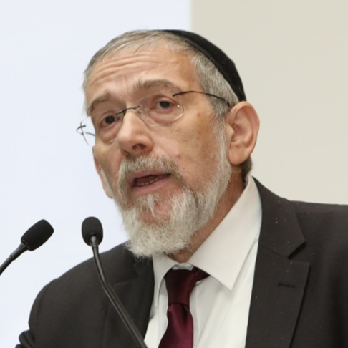
Position Statement

Repairing the World: The Role of Religious Leadership in Peace Making

When I had the chance to sit around the table with some of the people here, I asked them about their impression of Jerusalem, and they said that everybody told them not to come because it was dangerous. I hope that we are better than our image. And I think that just as that is so for Jerusalem and the State of Israel, it also applies to religion and the image of religion and the contribution of religion. What is the image of religion amongst the people? This is important also when we talk about the role of religion, its interaction with political affairs and especially with the issue of peace and war.

Last year, this holiday of Eid al-Adha fell together with the Jewish holiday of Yom Kippur, which won't happen again in the calendar for another 33 years. Yom Kippur is considered to be the holiest day in the Jewish calendar. It’s a day when we do not eat or drink for 25 hours, and we delve into ourselves and try to achieve atonement with ourselves and God and the community around us. This was also the beginning of a lot of unrest here in Jerusalem and there was some bloodshed in the weeks before. Some people had been killed, and the chief of the Jerusalem police came to me and said "we have serious warnings that this will be a day when Jewish extremists and Muslim extremists will use this day which we celebrate very differently to create more violence." The Jews withdraw into themselves and the Muslims externalize and travel to each other. The Jews who see the Muslims all driving to each other and eating and barbecuing see this as a provocation because we celebrate differently. And the extremists will use this day to increase the bloodshed and hatred and fear in the two communities. So the police chief said we have to do something about it. And I said, "Well you're the chief of police so you have to do something about it," and he said, "But you speak to all the religious leaders, they have the influence over the communities, you have to do something about it."

So I went to the most extreme leader of the Muslims here in Jerusalem, who was even fired as the mufti of Jerusalem by the Palestinian Authority because of his extremism. I went to his house and I said to him, "Listen, do you want this holiday to become a day of bloodshed?" He said, "No, God forbid, I don’t want that." So I said that if you don’t want that, then we have to do something together about this. He asked what I wanted him to do, and I said, "I want you to issue a religious decree, a fatwa, to prevent bloodshed on this day." So we wrote the fatwa together saying that all Muslims have to respect the Jewish holiday of Yom Kippur by toning down the celebration this year. They will celebrate, but in a modest way. When he sent this out, 56 other Muslim leaders joined his signature because when you go to the most extreme then all the others will sign also. It was in all the Palestinian newspapers and it was read in all the mosques Friday before Eid al-Adha. Then I went to the Rabbis and I said, "The Muslims have done their job, now you have to do yours." They sent out a declaration that the Muslims are celebrating their holiday, and we have to respect it. Then we went to social media and made a YouTube video explaining why our each of us are celebrating these holidays in both Hebrew and Arabic. The main message was that God does not want us to sacrifice our children. He wants us to celebrate in respect of God. The film was seen in Jerusalem by 260,000 people in the two days before the holiday, and we had four days which were absolutely quiet.

The chief of police came to me said it was a miracle. I said, "It's not a miracle, it's that the religious leaders took responsibility." So he said, but then why can't we do this 365 days? I said we can.

In religion we know that it is really only God who has the one total truth. We possess only part of this truth. We are limited as human beings, and other human beings and even other religions also have part of that truth. Therefore, we can be in the front of fighting for peace because we understand the modesty of our own limited understanding. We fully believe in our own truths, but we understand that there is something much greater than us, and we respect that others have another truth. So we can come to the peacemaking in a way that politicians do not have a chance to do.

As religious leaders, we also know how to differentiate between our ultimate dreams and hopes for what will be in the future, which in the monotheistic religions can be described as what will be in messianic times, and what we can achieve now as a religious peace. What we are doing here is that we have created a great coalition of religious leadership that is now being copied in other places. We are building on religious jurisprudence with the Jewish and Islamic traditions, and it's really incredible to see how this has translated amongst the most radical leaders who now want to join our coalition. When I met with the leader of the Iraqi waqf, he said, "I've heard about religious wars before. But religious peace? Now you give me the basis to go back to Iraq together with my Shiite and Kurdish friends and create a coalition to build a new Iraq based on the same concepts as you are doing here in Jerusalem."

I am saying this just to stress that to bring God back into the equation will mean, according to the concept of religious peace that everybody can be in the tent. A peace which excludes the religious identities will never succeed. It will never happen because unfortunately it only creates bigger and bigger problems. To ignore the problems doesn’t mean they disappear. It means they blow up in our faces, and that’s what has happened here in the Holy Land. So by opening our tent and welcoming everybody who is willing to be inside, and finding the language and the values to be inclusive, then we can repair the world.

In Judaism we believe that there is a cosmic consequence for everything we do here. If something bad happens in Taiwan or in India or in Canada, it is connected to what we are doing here. And if we do something good here in Jerusalem, we also believe that it affects everybody else. So we hope that with this concept of religious peace, by making this the centerpiece of our peace, that next time we welcome you here you will see that we have both religious peace and political peace here in the Holy Land.

Highlights from Discussion
Repairing the World: The Role of Religious Leadership in Peace Making

Dr. Deborah Weissman
"We have to involve women in the peacemaking process. Unfortunately, in most of the religions in our part of the world, most of the religious leaders, sometimes all of them, are men. I am wondering how we can find the balance. For me, one of the most outstanding experiences at this conference was meeting our sisters from the Jain tradition. I think it is so wonderful when a woman can be recognized as a religious leader."

Rabbi Dr. Alon Goshen-Gottstein
"I have found that the benefit of the teaching and the presence of teachers from Eastern traditions helps to change the chemistry of what goes on. It makes the conservation more spiritual, and takes it out of the family competition that exists between Jews, Christians, and Muslims. I would be very grateful if any leaders from the delegations that have visited here and have been involved in peacemaking efforts would share with the group what they have done."

Bibi Kiranjot Kaur
"A word that is constantly being used here is 'tolerance', and I would like to change it to 'acceptance'. We in India have a culture of accepting others as they are. It is with this acceptance that we exist in harmony. The problem comes when a person is asked to identify themselves whether they want to identify according to their religion or to their nationality. What I have seen visiting the Western Wall, is that despite the very sharp divide between the Church and the State, there are certain issues which create an unrest within a community that is impacted. For the peace process, everybody has to feel happy, everybody has to feel they have the freedom to choose their beliefs and to live their identity the way it is."

Tanenori Terai
"In Japan, the definition of pre-war and post-war is divided by 1945. After the end of WWII, Japan experienced drastic change. For example, the constitution of Japan was changed by the allied forces. After a tough 5 years of occupation, Japan experienced a rapid and drastic recovery from the damage of the war. I believe that the fundamental part of that effort lies in the Shinto's way of thinking – that the concept of deity had a great influence on it. For example, everything is divine – but that is not precisely true. You see, in Shinto we say that everything is deity itself. A deity of sky, a deity of wind, and a deity of land. Through the process of recovery, Japanese people again started to recognize that we are surrounded by many deities. Everything needs to be appreciated, everything needs to be praised, and everything needs to be worshiped. That is the propelling power of the recovery from the time of the war."

Ashin Nyanissara
"In 2002, there was a major conflict between Hindu and Muslims in India. There was a lot of tension in the area. Gujarat was burning because of these tensions. We said we will not allow this violence to happen here. All of the students, kids, and families kept saying we should be one community, one religion, one nation, and one global community. We should not support this violence at all. Because of this constant prayer, motivation, inspiration, we could save Gujarat and there was not a single episode of violence moving forward."

H.H Ven. Master Misan
"I was involved in peacemaking affairs when I was Director of the Social Affairs Department in Korean Buddhism. There, I visited North Korea more than 50 times and we tried to reconnect the culture, not the religion. Communist thinkers think religion is dangerous. We restored the traditional painting of culture because it had disappeared. We sent them chanting because they forgot how to chant. After that they were really happy to restore. Cultural contact is quite peaceful. Peacemaking is very important in governance. Religious people can try and make an effort, but the main pull is governance. Religious leaders have to act accordingly not in a political side, but in a cultural side. Mutual understanding is lacking when we have conflict. First we have to restore a peaceful mind, and we need to make some kind of movement and meditation with different religious traditions. All religious traditions have a kind of meditation; love and kindness meditation. We must spread love and kindness all over the world."

Rabbi Michael Melchior
"I think the whole role of leadership is to speak the truth. The whole role of religious leadership is to speak the truth- both to kings, and to governments. To do this with fearlessness even if there is no public support. I am not sure that the old prophets of Israel would have much public support, and I don't know if they would pass the threshold and go for elections, but we're still studying their texts and we're inspired by them every day. We only know about the kings and the leaders because they were written about.

I realize that there is a danger in the world today of the romance of anarchy and the romance of violence. Some of it uses religious language and the older religious leaders don't have any influence whatsoever and don't have the means and the media to deal with it. Therefore, it is very important for us to deal with religious leadership who are of a different age than us. It's not that we can't speak to young people – of course we can. But, the leadership who are 25 year olds who know to speak much more of the language of the 17-20 year olds, because they have just been that age, and they use the social media and they come into the contact in a different way with a different kind of charisma than we have. They have questions. They have good and deep questions. We need to address those questions. This is an important part, to listen to their questions and to address them as part of the work for religious peace."

Swami Parmatmananda Saraswati
"To stop them from disturbing peace, the only solution is we have to be strong. We, the non-proselytizing people, have respect for other religions, and we should form a strong lobby together and learn to be together. When we are united we are strong"

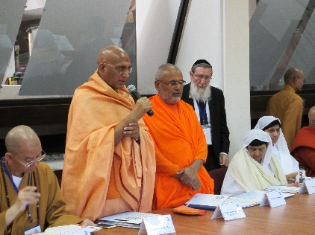
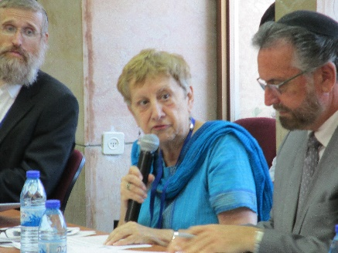
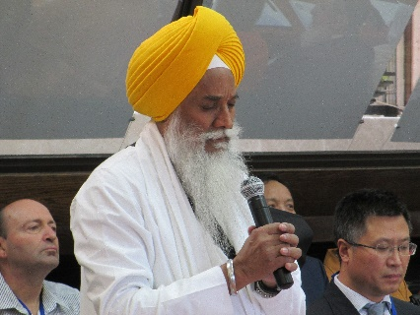

Professor Yudit Kornberg Greenberg
"The importance of the feminine presence is crucial to the process of nations and religious leaders and scholars in the promotion of peace. From the Jewish tradition, one of the ways we believe in promoting peace is through studying and learning. I think that in future conferences, I really would like to see a mutual study and learning from each other about our different traditions. In my professional area, which is the academic study of religion, I can give a couple of examples of groups that study together. One is called scriptural reasoning and it has been bringing Jews, Christians and Muslims and hopefully Eastern religions to the fold, where instead of just hearing academic papers when we get together, we actually sit together and study each other's text.

Additionally, I think it is important to focus on youth and the generation to come. For example, my daily experiences in a small liberal arts college, where the liberal arts tradition is one in which we sit together around the table and employ the Socratic method of discussion, is one which engages everybody in the group. I think for students of today it is very important for them to create this discussion in the way of creating peace and it comes out of the Jewish tradition. I do think this is something that we can all learn and benefit from."

Professor Ben-Ami Shillony
"The problem now in the world is not that the religions don't do enough for peace, the problem is how religions prevent peace. The key factor is of course religious fanaticism. Most religions unfortunately are fanatic, especially those religions which are based on belief of commands from God. These tend to be more fanatic, such as not recognizing each other, and calling for the destruction of each other. I think Japan is a great example of religions not being fanatic. Shinto is very tolerant to other religions that enter Japan – especially Buddhism. There was never a religious war in Japan unlike Europe and the Middle East. In many countries of the world, religion cannot work with modernization. It disturbs modernization. Japan is an example of religious tolerance. It was so tolerant that may Christian missionaries thought that if anything goes in Japan, Christianity will be accepted. Thousands of Christian missionaries went to Japan before the war and after the war trying to convert the Japanese to Christianity. The Japanese rejected this conversion. Not because they thought that religion was very important, because the Jews also rejected Christianity, but because religion was not important to them at all. Tolerance of religion in Japan was very conducive to Japan's modernization. This also had a negative aspect, because before the war and during the war, Buddhism and Shinto supported the war and the government. But after the war, when militarism lost its appeal, all religions became pacifistic. Today you have strong pacifistic moods within the religious sects in Japan."

Rabbi Sperber
"There is a difference between peacemaking between individuals, and peacemaking between countries and civilizations. The place of religion is complex. Let me give an example: Ghandi was a deeply religious person and also a politician. His religion expressed itself in his political machinations where he would fast, etc. It was through his religious faith that he succeeded on the one hand in preventing great bloodshed in East India, and at the same time causing enormous bloodshed in West India. Melding of religion and politics is a very complex issue that we do not have easy solutions to."

Akiva Tor
"In our tradition, throughout the Hebrew Bible, we have the example of the King and the Queen being influenced by the Prophet. In other words, political leadership that was being influenced by a religious message. Even this very institute is named after Harry Truman. Truman's decision to recognize the State of Israel was against all of the political advice of the State Department. He simply felt he was doing the right thing. He is also reported to have said of himself, "I am Cyrus". In other words, he said himself as a biblical figure who was carrying out God's plan and therefore he didn’t listen to the State Department. Due to this, we are now able to sit in this building.

The question I wanted to ask of the group is the following: In Jewish tradition we have a concept of a just war. We have a concept of wars which are required by divine command. As religious leaders – are there times when violence is required?"

Most Ven. Xue Cheng
"Everyone should wish for peace, pray for peace, and work for peace. In every traditional religion, they advocate for peace and undoubtedly make great achievements in different regions in the world. Why are so many unpeaceful problems and phenomena's existing? There must be some underlying reason to these problems. If we learn not to kill human beings, all wars will be ceased."

Giani Gurbachan Singh
"I will speak from my scripture, because every scripture talks about peace and values that we don’t really practice, and that’s why there are problems within society. When we feel no ill toward anyone, then everyone will become a friend. There will be no enemy, no unknown person, and everybody will seem like a friend. Our philosophy talks about humanity as one, and us as the children of one father. Religions should always be a priority over politics. This is signified in our holy place the Golden Temple, where the temple is created for the religious purpose. Sitting there right opposite is where the political decisions of the community are taken. Sitting at the religious place, you cannot see the political place. But sitting at the political place, you can see the religious place. It is important for religion to take charge, and politics to be subordinate to it. When politics walk behind religion and there is the rule of justice. Peace begins from home, from within, and once the home is peaceful, the person will go out and be a messenger of peace. We are all like one big family, and in a family there are elders and there is youth. It is the duty of the youth to respect their elders, and for the elders to love the youth. The religious places are places from where the peace message should go, but sometimes these are places from where the message of hatred is also sent."

Rabbi Shlomo Dov Rosen
"There were two narratives that were contradictory but were running simultaneously. One narrative that Rabbi Melchior was presenting, and another from Professor Shillony. The questions is whether the wars of religion are about religion. Both extreme positions can't be right – it can't be true that both the wars of religion were not about religion. But it doesn't seem to be correct that it was about religion in the way that people think it was. Very often what causes religions to go to war with each other are deep cultural rifts and all kinds of other social issues. Then it's easy for the narrative of the West to call it a war of religion and then to think a secularization will solve the problem. I think it's very important to put on the table the assumption that the religious world can help you come out of conflict. It shouldn't come out of some naïve assumption that religion doesn’t have anything to do with conflict. It has to come out of a place that we assume that the narrative that we were brought up on is somehow incorrect. A lot of history can argue for that. The place that you see that most is with Islam. As a Jew I can say that over most of our history it's been Christianity that has been dangerous for Jews and not Islam. The fact that it suddenly became Islam recently shows that it's not necessarily the religion but a lot of aspects within the religion that are awakened by other factors.
I think that in many religions they are simultaneously pushing in both directions. That's necessary because a religion that believes in an absolute truth has values that it is trying to push forward. Now, there are some religions that don't believe in an absolute truth in the same way but they still have those values that they're pushing forward. If we wait until our religions become pacifist we'll be waiting a very long time. If we can simultaneously awaken those other aspects of the religion then I think that is where the complexity lies."

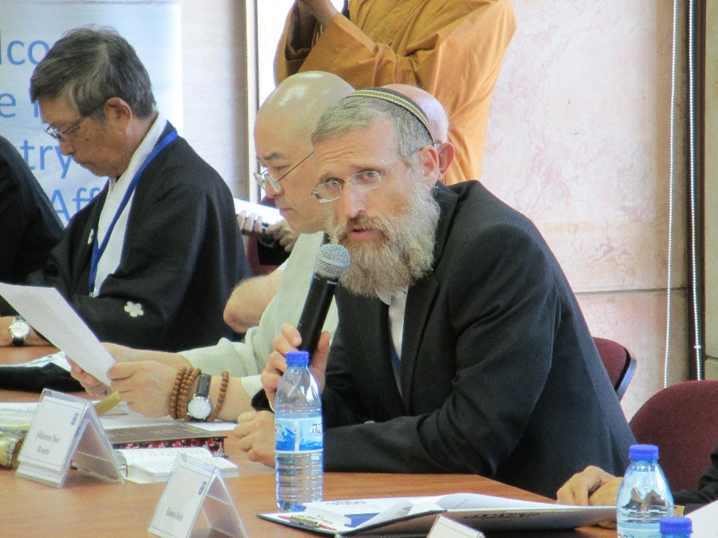

Rabbi Michael Melchior
"There were some comments made that I disagreed with – most naturally made by the Jews around the table. In an ideal word we take God out of the equation or we all become Japanese and that's the world some of you suggested to us and then everything is fine. That is also not the world we are living in. Also, Professor Sperber who I usually do agree with… maybe I didn’t express myself well enough, but actually what we're doing is very practical peace not like the peace of politicians. It is the peace with which influences the communities and the peoples, not the peace of individuals and reaching out to the identities in the conflict. I think this is the real work which was never attempted to be done in the peace work and this is why the peace work failed. I hope that when the religious peace comes out, its full strength will really bring in all the groups who have been outside the tent of peace and have avoided peace. These are the people in the countries around us in the Holy Land who we are going to live with in all eternity here in Jerusalem, and therefore these are the people who we need included in the peace – and it's possible. There is a new attitude that if peace comes from the source of truth and religion and not from a secular place, then they want to be a part of that people. I think that is the good news which you can bring back from the Holy Land when you go back to your home countries. Somebody mentioned that people in the West are insecure about religion – they don’t know how to deal with it and therefore they're afraid. Then populists go into this fear and use it to create hatred. If we can expand and include all the different groups, including those who are considered radicals, with a different kind of language then there's a whole new equation and hope for the future of civilization and the populists will not be able to spread their hatred, which today is spreading in Germany and France and America and in the East etc. They will not be able to spread that message of hatred. We really need to create these grand coalitions and create that civilization because today in the world with the kind of weapons we have, we don’t really have any other alternative."

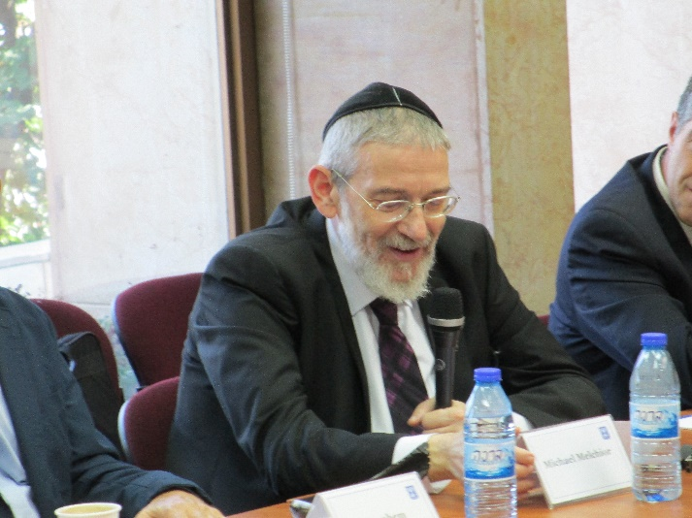

Bawa Jain
"I struggle when I hear the word tolerance. I absolutely struggle. I have been trying to raise this at the United Nations for the last 25 years. This concept of tolerance was modeled in 1968 by UNESCO. There was a time when they were trying to promote that we should at least tolerate each other. I think this word should be banished from the English dictionary. We are not at an age where we just want to tolerate each other. Enough already. That concept shouldn’t be there. You won't find that in the Asian traditions. Coming to the international arena – I remember just before the millennium summit, the Camp David Accord was signed. So a journalist from the NYT or CNN came to interview me and said "Bawa you don’t need the millennium summit now. There's peace in the Middle East so there is no need for a millennium summit. The media conflict in the world is here and is done." I said "I wish I was wrong, but I don't think this will sustain. Why? Because you did not include the religious leaders." I think religion is the missing dimension of state craft. If you want to reach 90% of the world's population at least, you have to include the religious leaders across the spectrum. The challenge is, can religious leaders and political leaders work in parallel in support of each other. The world's greatest diplomats are the world's greatest leaders. They know the parts of every community and what to do and where to do it and what is needed in the communities. The political people don't know that. They are there for elections and then they come to the religious leaders when it's time for elections because they want their support and blessings and then you know what happens. In Asia religion and culture are deeply intertwined – you don’t separate it. What I've seen in Israel is absolutely unique. If you talk about building the Jewish people, Orthodox, Reform and Conservative, they have a lot of conflict amongst themselves. But when it comes to the identity of the State, irrespective of who you are, you become one. Identity is deeply tied into that. That concept, set aside your differences for a common purpose. That concept needs to be promoted more. That can come from the Asian and the Israeli experience from this initiative primarily. I will just say, I think this meeting here with Dr. Blondheim and the Truman Institute is so important. I'm so grateful. I think this is a bridge between the political process and the religious process. I hope we can expand on this with people like Rabbi Melchior and all the other scholars. The Ministry of Foreign Affairs has the work cut out for them."

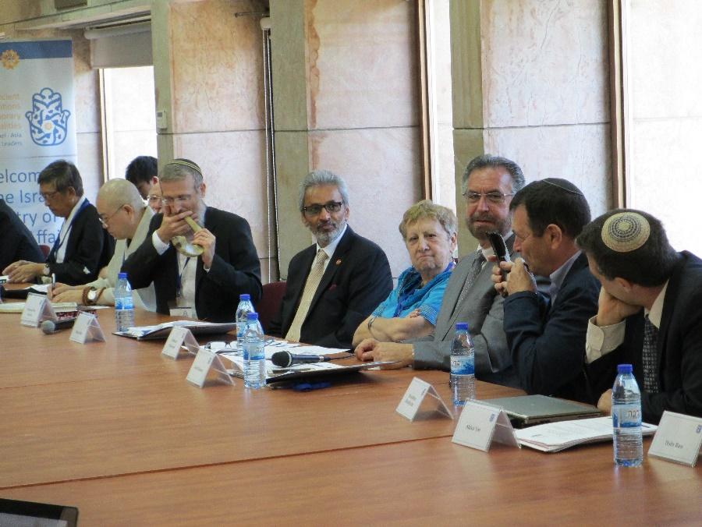

Special Moments

Address in Memory of Swami Dayananda:
Swami Parmatmananda Saraswati

Acharya M.M.H.H.Swami Avadheshanandaji

Introduction:
We are here to pay our tributes to Grandeur Personality of the Century, who not only protected, but nourished our ancient wisdom, scriptures and traditions. When Pujya Swamiji visualized to form Hindu Dharma Acharya Sabha, he invited me to share the vision.

It is a matter of joy and pride for me that I was the first member of Acharya Sabha and now I am heading this lineage.

He was a great visionary. In the past, we have met Jewish leadership almost 5-6 times. Today, we are meeting Jewish leadership along with leaders from 6 different religious traditions. All these meetings are due to his Sankalpa and his inspiration. He lived for the entire humanity, nourishing the individuals with spirituality, religion, principles, and values.

H.H. SWAMI DAYANANDA SARASWATI MEMORIAL LECTURE
BY: H.H. SWAMI PARAMATMANANDA SARASWATI

In our tradition, when we greet each other, we say NAMASTE. With this expression of words, we bring our two hands together and join the palms.

My two hands are entirely different. They don’t match with each other in any which way. Neither the position of the fingers nor the finger prints nor the lines that are in my palm. But these two hands never fight each other. And can be together. They both belong to only ONE person- there is only one essence. The truth of both, that which gives them strength and movement that makes them sentient is ONE AND ONLY ONE. There is only one self. The same self that pervades the left hand pervades the right hand too.

Similarly, there is one Non-Dual Lord that pervades in and through the entire creation. This is Hindu Vision. This being the case, when I bring two hands together. It is a symbol of identity, oneness and unity. One may say its acceptance and respect for each other, in spite of differences. This is an expression indicating that we can together in spite of differences. We can work in harmony in spite of differences. The harmony between two hands leads to harmony with the entire body. Similarly, there can be religious harmony in spite of differences and harmony between the religions can help in maintaining harmony (peace) in the entire world.

Two hands accept each other. They live in their own space. Similarly, I live in my space and you live in your space. Also, a given religious tradition lives in its own space and the other one lives in its own space. Both should accept the differences and respect each other.

His Holiness Param Pujya Swami Dayanandaji was committed to this vision. Throughout his life he worked to actualize this vision. This kind of relationship between Hindu Dharma Acharya Sabha and Rabbinate was special. Jewish leaders are the fruit of Pujya Swamiji’s vision and efforts.

In our religious tradition, we see the whole creation as a manifestation of the Lord. There is only GOD and that being the case, everything is sacred. Nothing is mundane. Nothing is taken for granted, the air, space, water, earth, sun, stars – they are all sacred to us. This is the view of Hindu Dharma and Hindus’ way of life. For Hindus, creation is sacred and we respect the nature. It is not for man’s consumption only. The world is not “Bhogya” but “Pujya”, something to be respected. To give respect means to be a contributor and to give. It means to live in harmony – to live happily and let others live happily. This necessitates the individual to become a contributor and not a mere consumer. This is responsible living.

Jewish traditional view of life, as I understand, also values the sanctity of life because everything is sacred for according to Jewish tradition.

During one of the meetings David had quoted a story from the works of the Midrash (exposition on the books of Moses). It says that if you rise in the morning and see the sunrise, and if you go the bed at night and see the sunset, and if you have not said or acknowledged this as blessings, you are a dead man. The statement implies that everything is a blessing. It means the Jewish way of life must have an awareness or alertness to appreciate the fact that our whole life is a blessing. We also have quite number of scriptural texts - Vedic mantras, Shlokas from Bhagwad Gita saying that everything around me and my entire life is a blessing.

I feel that Sabbath teaches us to contribute to the harmony. It brings out a harmony within and without. These two traditions – Hindus and Jews today, need to contribute these values to the world. Ecological problems that the whole world is facing today is because of improper attitude of being a mere consumer. There seems to be a mad rush to consume. We shall live a healthier society and natural infrastructure for the next generation. I think that is responsible living.

To conclude, I wish to quote the Founder Convener of Acharya Sabha and my teacher His Holiness Swami Sri Dayananda Saraswatiji -

“The redwoods are tall trees. Each tree is three hundred and sixty-five feet or so high. They are big trees that you can drive through. They cannot have long roots to help them stand. They stand straight but have shallow roots. They hold each other at roots so that no storm can get them. We live together and we are together. These two traditions of Hinduism and Judaism have to come together. We need to have a setup that should work actively to promote understanding and harmony among religions. Together, we stand like the coastal redwoods. Therefore, I appeal that there should be dialogue and that they should promote peace. I am committed to peace and shall continue to work for this peace and harmony”. I think if Hindus and Jews work together to bring this vision into reality, that would be the best tribute to HH Swami Dayananda Saraswati.

SHALOM

Namaste

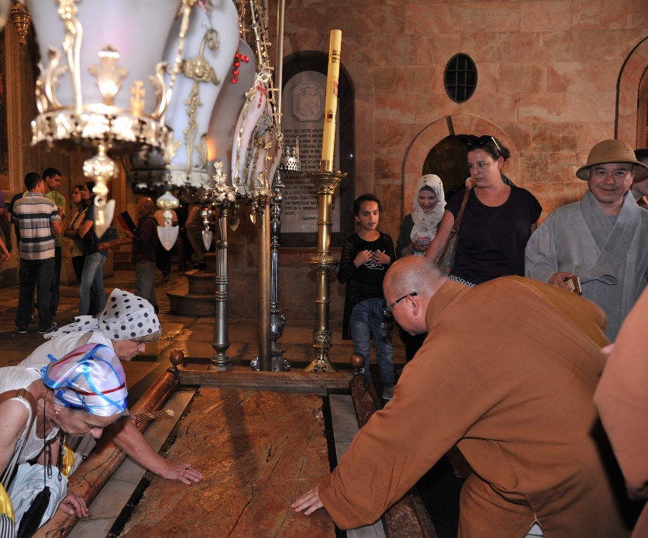
In the Old City of Jerusalem

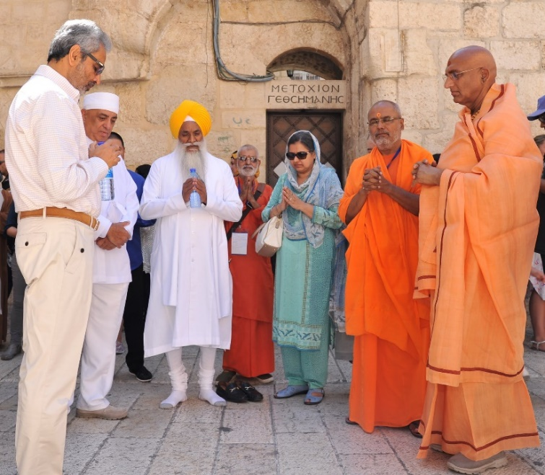
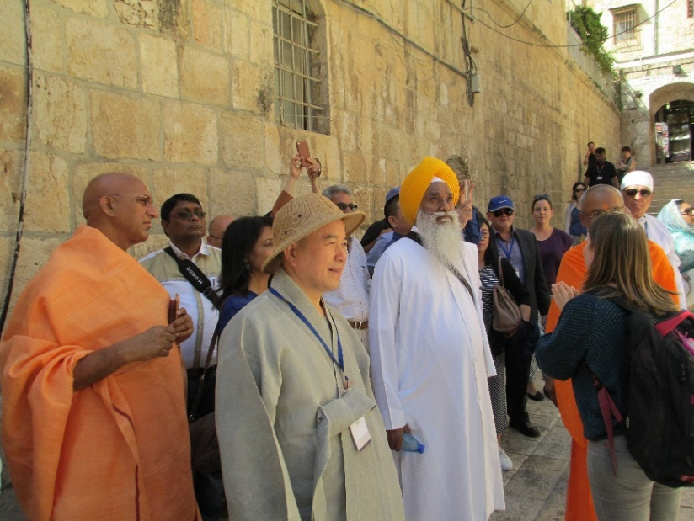
Prayer for the health of former President of the State of Israel, Shimon Peres, z"l
Inside the Church of the Holy Sepulcher
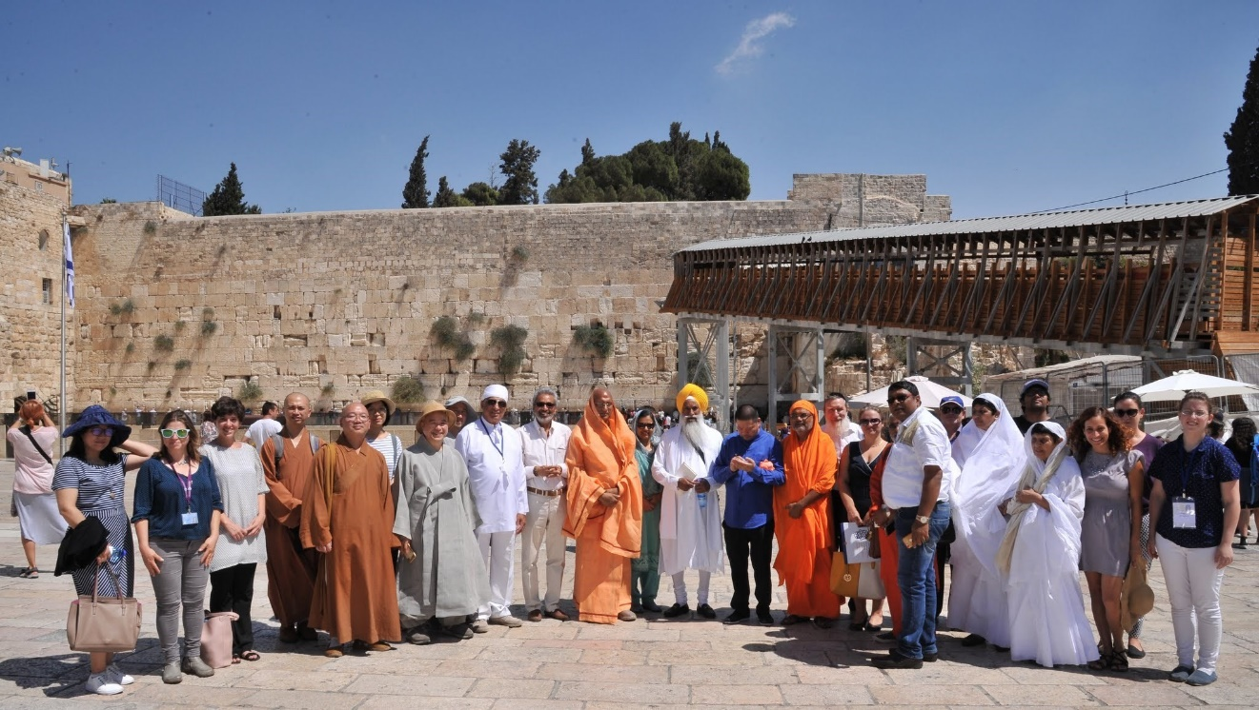

At the Western Wall

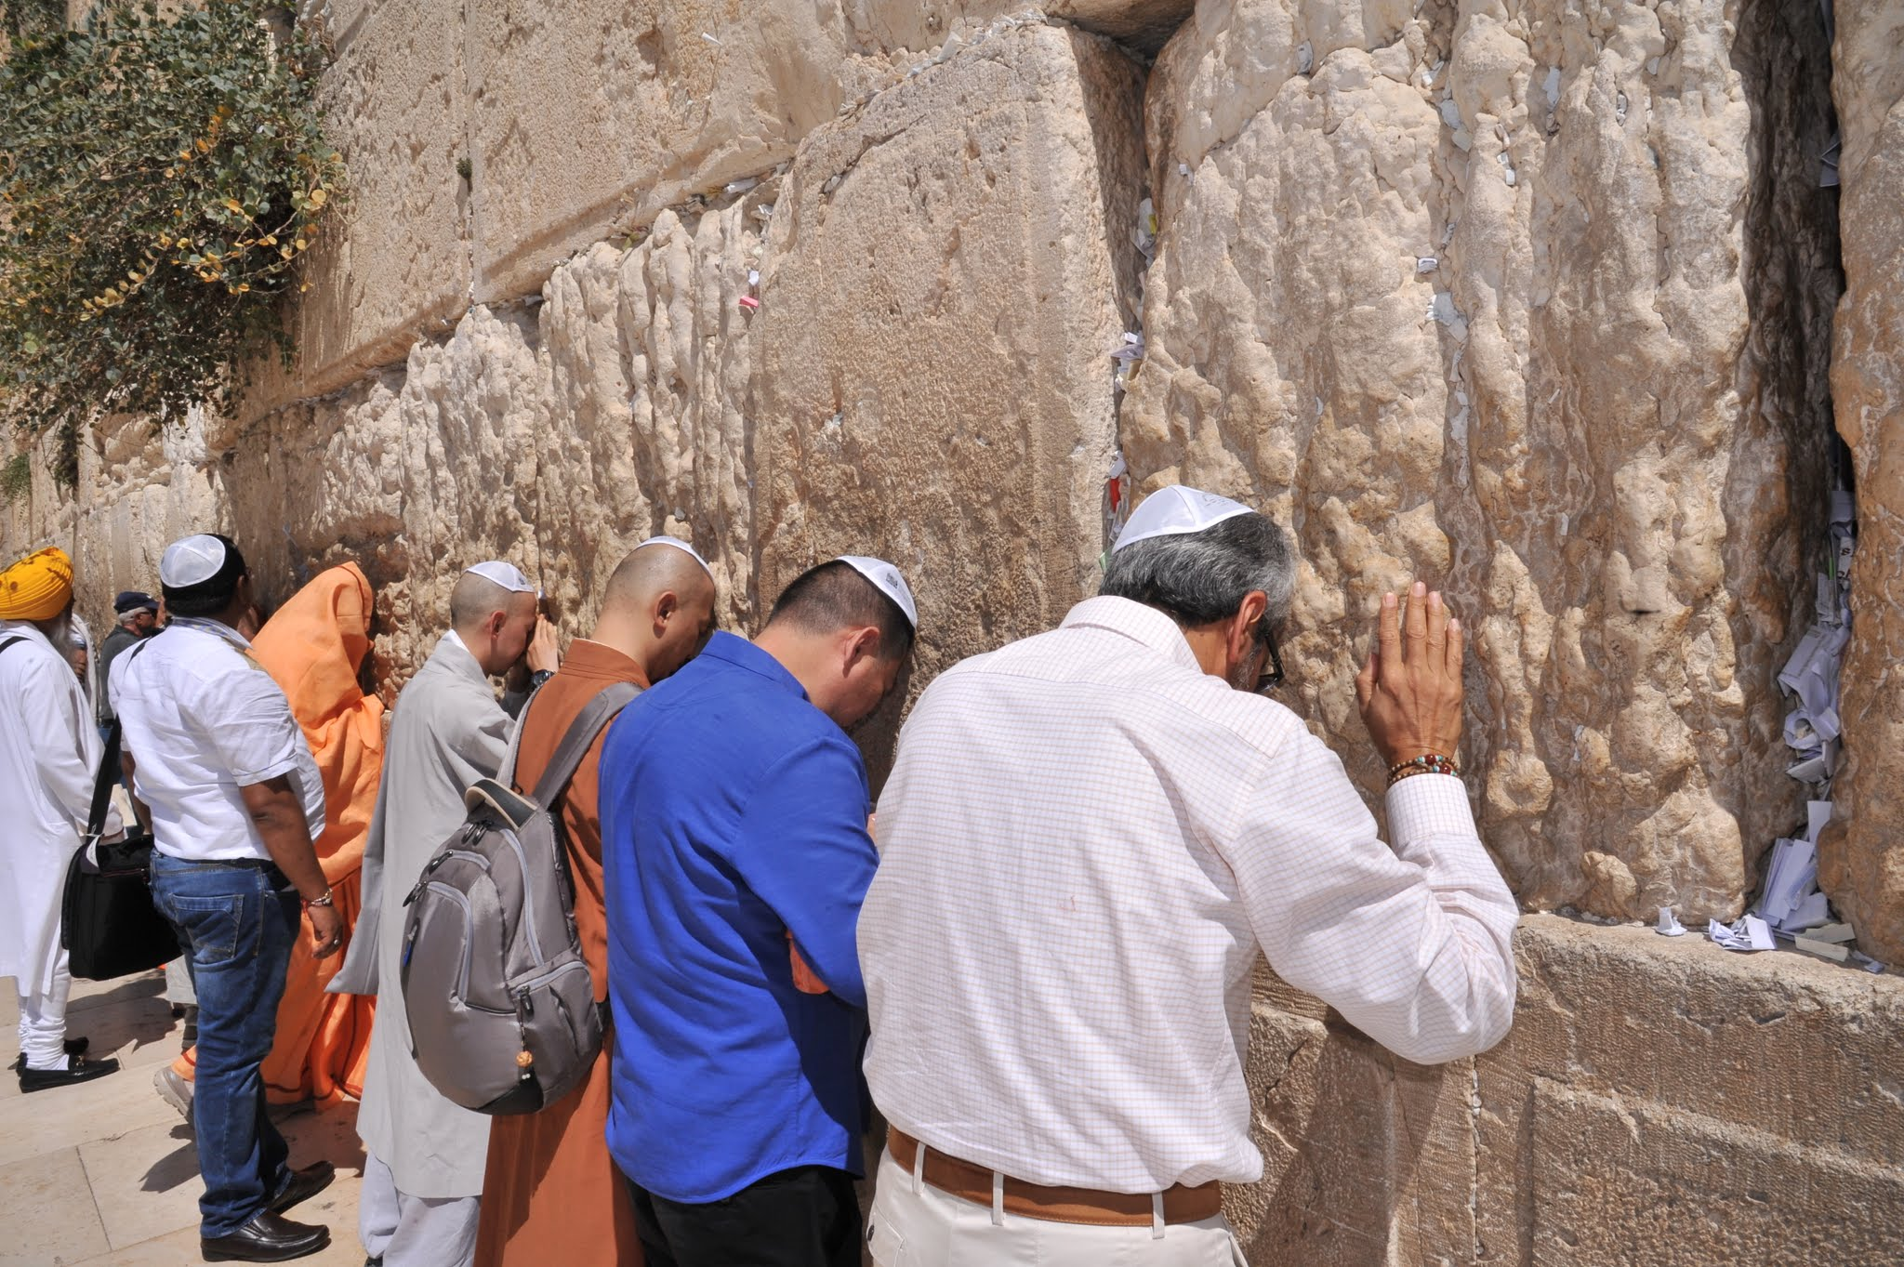

With the President of the State of Israel, Reuven Ruvi Rivlin:
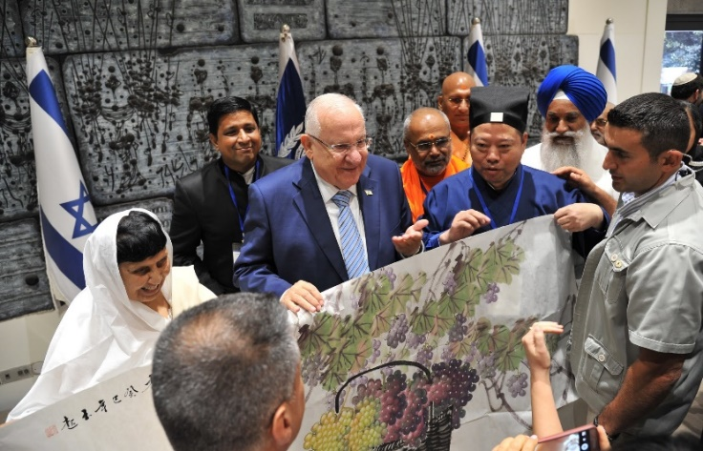

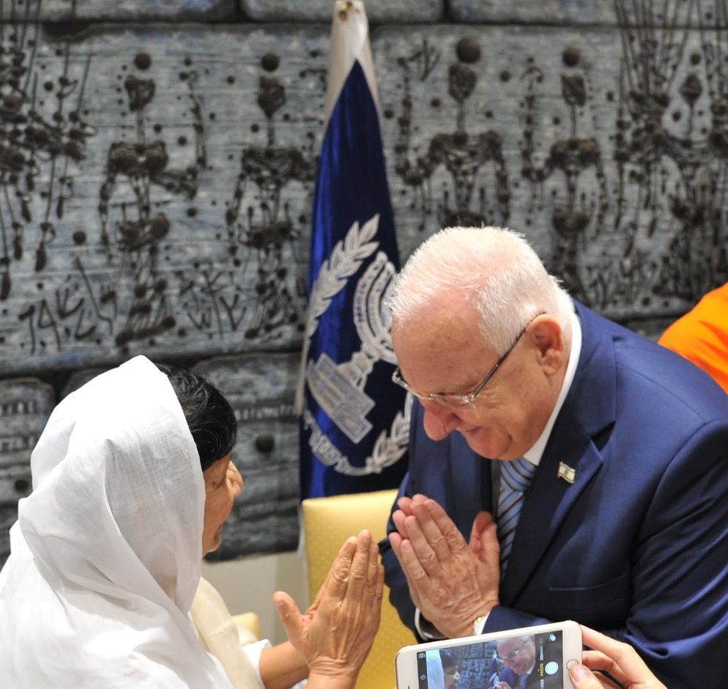

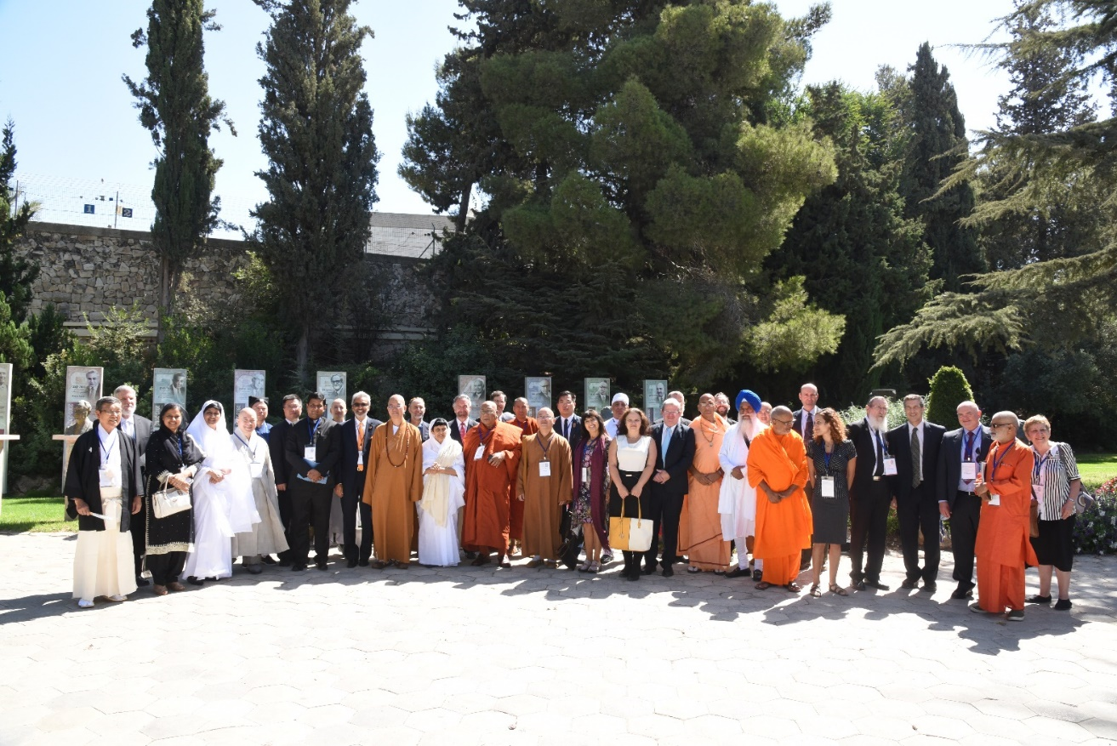
Group photo at the President Reuven Ruvi Rivlin's residence

Meeting the Prime Minister of the State of Israel, Benjamin Netanyahu:

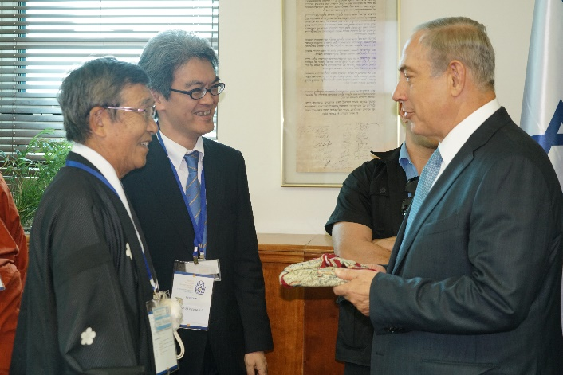

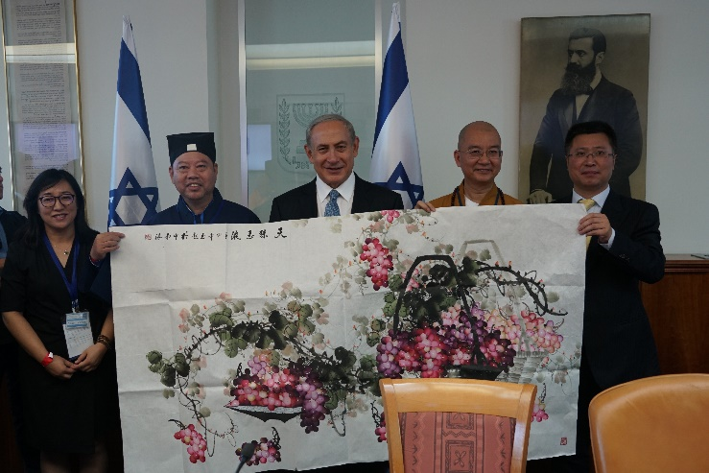

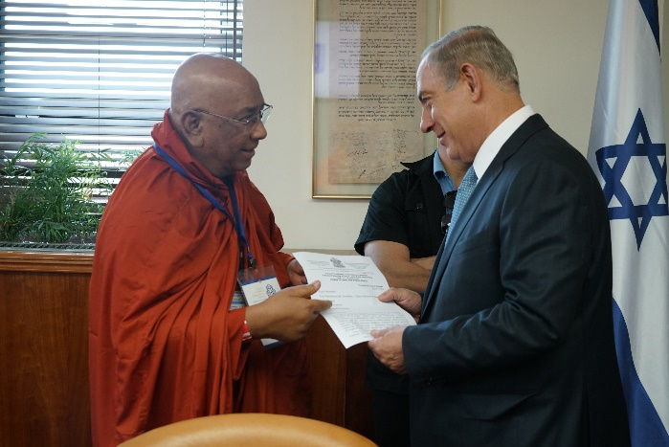

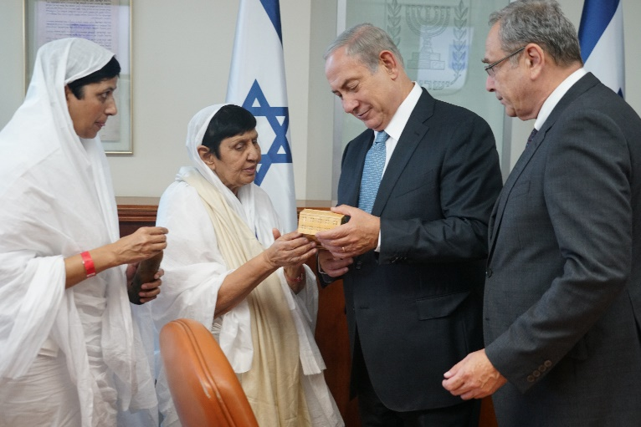

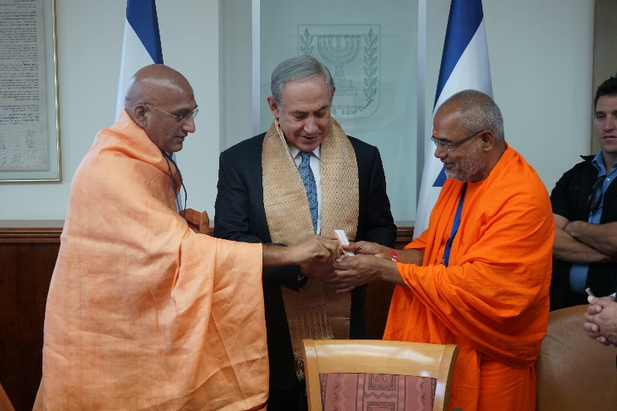

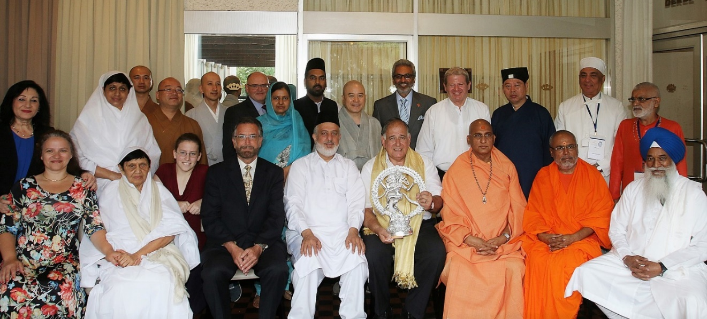
Meeting with the Mayor of the City of Haifa, Mr. Yona Yahav:

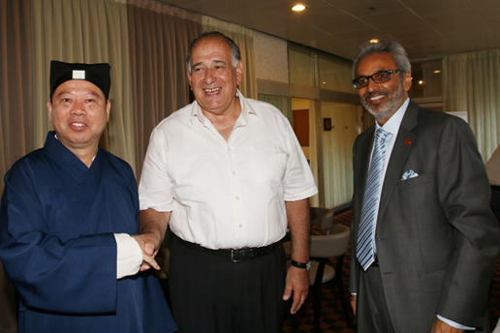

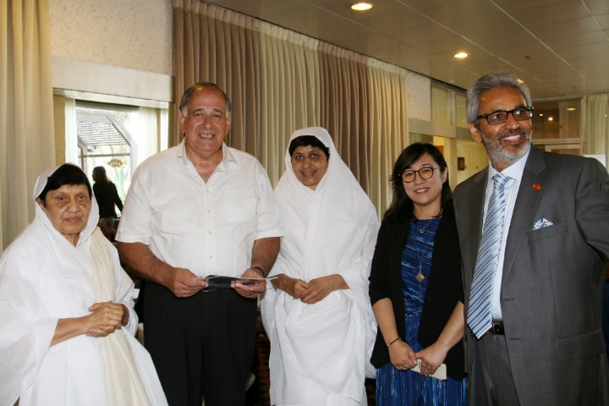
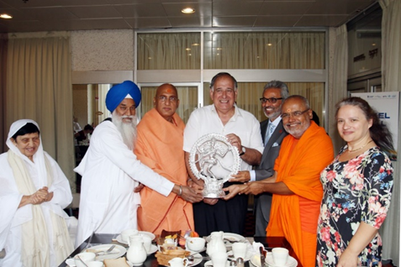
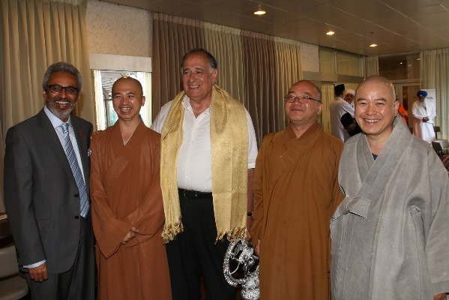

Visit to the Baha'i Gardens

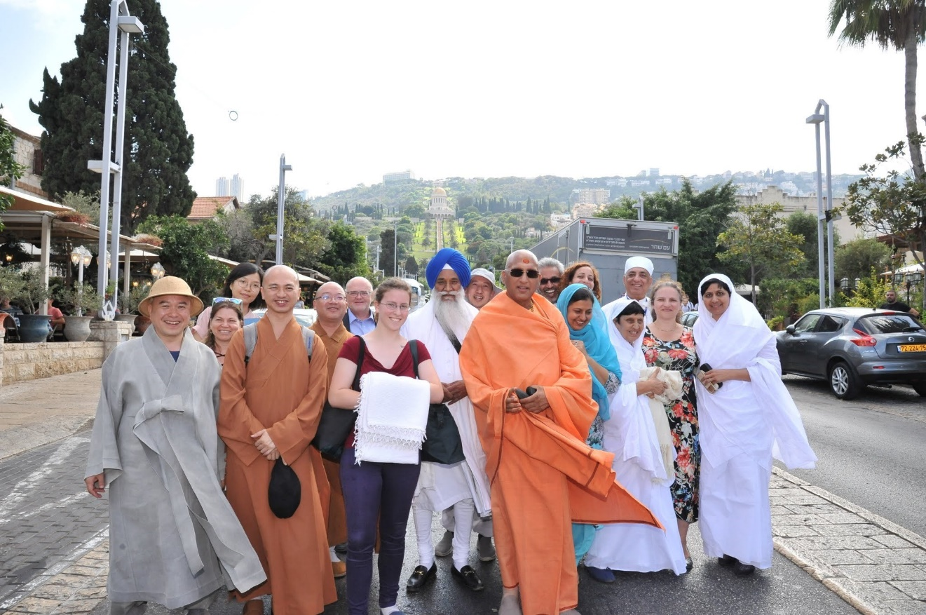

Meeting with the Council of Religious Leaders of Israel
Dr. Joshua Lincoln, the Secretary-General of the Baha’i International Community hosted in Akko at the Baha'i World Center the Asia Faith Leaders and the Israel council of religious leaders.

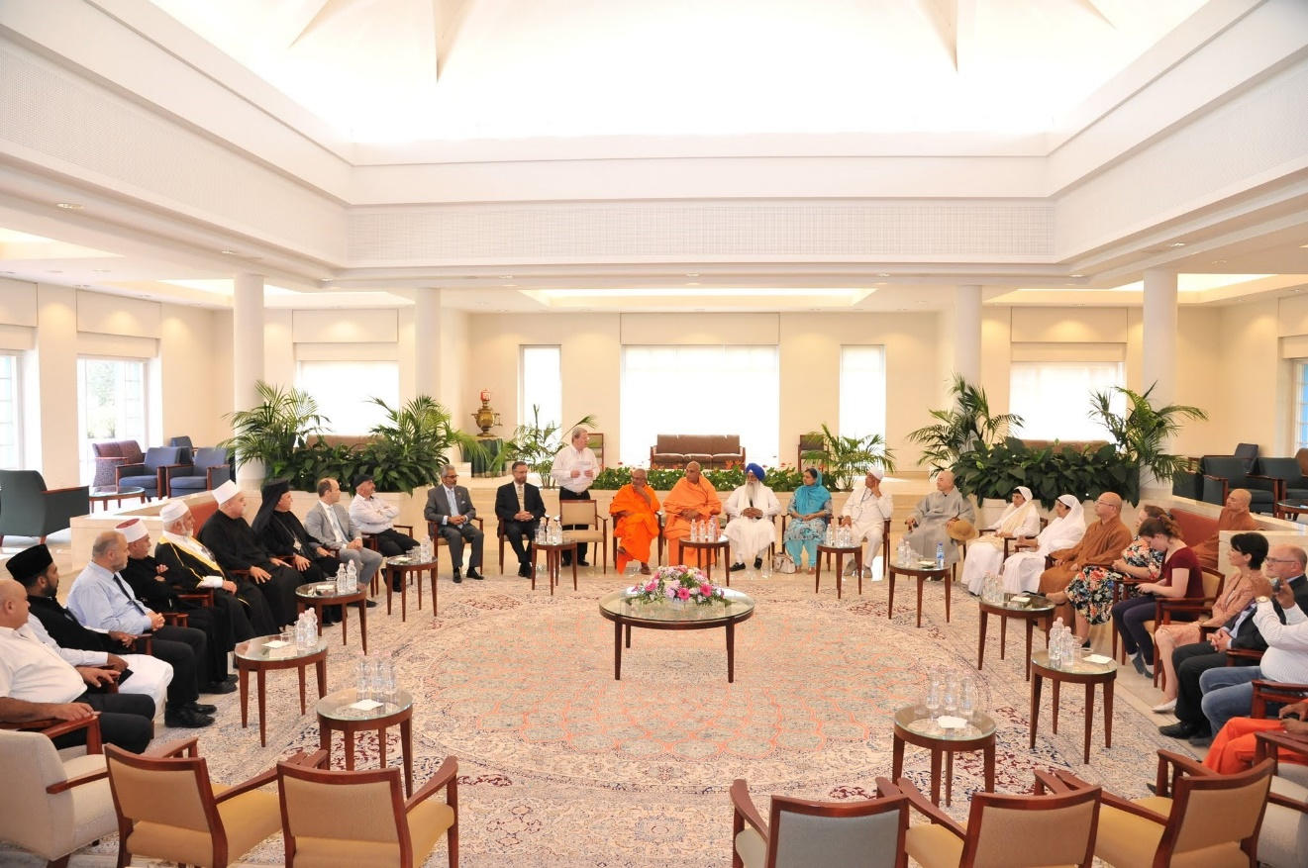

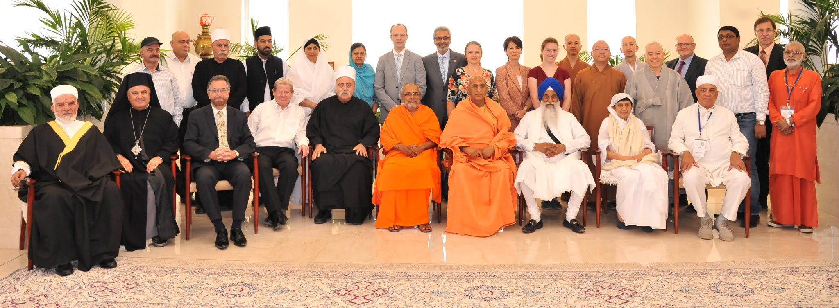

Visit to the Dead Sea

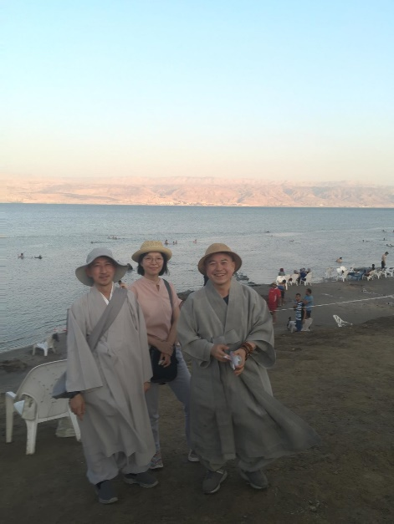
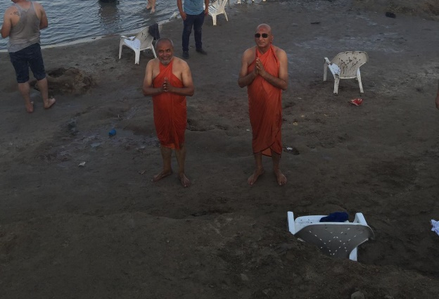

List of Participants

East Asia Faith Leaders

Most Ven. Hsin Bau, Abbot of Fo Guang Shan and President of Fo Guang Shan Committee Board, He is the disciple of H.H. Most Venerable Master Hsing Yun, born in Jiangdu, Jiangsu Province in 1927, is the 48th patriarch of the Linji School. He came to Taiwan in 1949, and established Fo Guang Shan in 1967 situated in Dashu, Kaohsiung, Taiwan, which is composed of five ridges shaped like petals of a lotus. The architectural layout shows the miniature of the four great mountains in China. Fo Guang Shan has become the biggest Buddhist monastery in Taiwan and a Buddhist holy site recognized worldwide. In 33 countries, he has established over 200 branches, and the members of the Buddha's Light International Association are worldwide.
Acharya Shri Chandanaji, the first and only Jain nun to be bestowed with the title of Acharya. In 1971, she founded the charitable organization "Veerayatan" in India - an organization that aims to work towards the care of humanity through health, education, and spirituality without any distinction. Some of Veerayatan's flagship projects include free eye operations for the poor and free school and college education to rural populations. To date, Chandanaji’s vision and benevolence has benefited thousands of disadvantaged people and given them a hope for life.
Most Ven. Xue Cheng, President of the Buddhist Association of China, He is a Member of the Standing Committee of the National Committee of the Chinese People's Political Consultative Conference. He currently serves as President of the Buddhist Association of China, President of Buddhist Academy of China, President of the Fujian Buddhist Association, Abbot of Guanghua Monastery in Putian, Fujian, Abbot of Famen Monastery in Fufeng, Shaanxi, and Abbot of Beijing Longquan Monastery.
Acharya Mahamandelshwar Swami Avdheshananda Giriji, Maharaj is the Chairman of Hindu Dharma Acharya Sabha Trust. His Holiness is a Board Member of the World Council of Religious Leaders.
He is Spiritual Head of Panch Dashanam Juna Akhada - referred as “Acharya Maha Mandaleshwar”. Sri Swamiji being the Spiritual Head is the leader of over 2 million Monks and Sanyasis and millions of devotees. He himself has initiated more than about 650,000 Monks - Sadhus.
Bawa Jain – Founding Secretary General, World Council of Religious Leaders. Secretary General, the Millennium World Peace Summit, United Nations 2000, The World Council of Religious Leaders, Is the direct outcome of the Historic Millennium World Peace Summit, United Nations in 2000. The Council is charged with being a strong resource and a collaborator with the United Nations and other international and national organizations whose purposes include promoting peace, harmony, tolerance, and mutual respect among human beings and the evolution of world social and economic justice. Amongst other things, WCORL launched “Religion One on One”, initiative which brought together two of the World’s Oldest Religions, Jews and Hindus in a series of Hindu-Jewish Summits which, resulted in a signed “Declaration of Mutual Understanding and Cooperation” and the creation of a "Standing Committee” for Hindu-Jewish Relations for ongoing bilateral relations.

Bibi Kiranjot Kaur, Member Shiromani Gurdwara Prabandhak Committee (SGPC), Golden Temple, The Sikh religious reform movement in early 20th century culminated in formation of SGPC, a statutory body in 1925. The members are elected for a period of five years through adult franchise. It has 30 seats mandatory for women out of the House of 170 members. SGPC has a rich history of taking control of more than 100 historical Gurdwaras (Sikh place of worship) from British supported priests and letting the community take charge. SGPC implements Sikh code of conduct in places of worship, watches the Sikh interest, has established educational institutions, hospitals and is the voice of the community.
Sadhvi Shri Shilapiji Maharaj, is the disciple of Acharya Chandna ji Maharaj. She is the first nun in the Jain tradition to pursue overseas education, has an M.Phil in comparative religion from the University of London. She has done an extensive study of the systematic comparison of the doctrines and practices of the world's religions and has cumulated their learning’s into one mantra – that of compassion in action. In the interim of completing her PhD in 2001, a devastating earthquake hit Gujarat. The massive relief and rehabilitation project she initiated immediately after stands tall today as a beacon of hope in the form of Veerayatan Vidyapeeth India, creating thousands of opportunities for the educational and professional development of the rural population. In the pursuit of her vision of a more unified and solicitous world, Shilapiji has travelled to over 20 countries, touching the hearts of millions of people through her sermons and igniting a light of change.
Venerable Misan, Master Sangdo Seon Center of Jogye Order of Korean Buddhism, became a monk in the Jogye Order of Korean Buddhism forty-four years ago in 1972. After his formal training in Buddhist meditation in Korean monasteries, he enriched his practice by pursuing theoretical aspects of Buddhist teaching in universities and obtained a doctorate degree at Oxford University. He has devoted himself to train disciples for more than ten years and recently focused on the development of the Heart-Smile Meditation Program, which is the adaptation of metta (compassion) meditation to contemporary contexts for modern lay Buddhists as the head master of Sangdo Meditation Center in Seoul. The Jogye Order of Korean Buddhism is the representative order of the 1,700-year-old Korean Buddhism, with the largest following of lay Buddhists among other Buddhist sects in Korea. Established officially in 1962, it followed the Seon (Chan/Zen) tradition and has worked for the three goals: training and education, translation of sutras from traditional Chinese into modern Korean, and Dharma propagation. It also increasingly engages in social concerns of the contemporary Korean society and the world.
Most Ven. Ashin Nyanissara is the Chancellor of the Sitagu Academy Myanmar, He is one of the foremost Religious Leaders of Myanmar, travels extensively and is active in Global Inter-Faith Dialogue.
Swami Paramatmanandaji, General Secretary and Convener of Hindu Dharma Acharya Sabha, is the collective voice of various Hindu Ancient Traditions, a body where all the heads of the different Hindu traditions are represented on one platform. He is a senior disciple of H.H. Swami Dayananda Saraswati. Swami ji as General Secretary has been closely associated with the Hindu-Jewish Summits.
Giani Gurbachan Singh, Jathedar Akal Takht, Akal Takht was created by Sikh Guru Hargobind ji and it literally means "throne of the timeless". It signifies co-existence of spiritual and the temporal miri-piri. Through centuries Sikh's gather here whenever there is a crisis within the community and hold consultations. When consensus is reached, it is announced by Jathedar Akal Takht from the Takht. Then it is binding on every Sikh irrespective of their geographical location. This tradition goes on even today and Jathedar Akal Takht is spokesperson for the community.
Rev. Tanenori Terai, Shinto, Chief Priest of Osaka Tenmangu, Councilor and former Managing Director of Jinja Honcho (Association of Shinto Shrines). Jinja Honcho is an organization which administrates approximately 80,000 Shinto shrines in Japan. Shinto is the indigenous faith of the Japanese. In Shinto, the divine energy or life-force of the natural world is worshiped as deities.
Master Lu Wenrong, Vice President of the Taoist Association of China, Standing Committee Member of the China People's Political Consultative Conference Hainan Provincial Committee, President of The Taoist Association of Hainan Province, Director of the Yuchan Palace Administration Committee of Hainan, Director-General of the Nantianqing Charitable Foundation in Hainan Province.
Ervad Kobad Zarolia, is a leading Mobed (Priest) from the North American Zoroastrian Community. He has been serving Zoroastrian Community of North America for last 48 years. He is student of Religions and loves to debate with other Religious leaders. He has been a speaker at world and North American Zoroastrian conferences.

East Asia Delegates

Swami Nachiketa Giri, Assistant to Swami Giri

Phil Harrison MBE FRGS, Senior Advisor, World Council of Religious Leaders.

Feng He, Principal Staff Member of the Taoist Cultural Research Institute of the Taoist Association of China

Ohashi Hirokumi, Assistant to Rev. Terai

Venerable Master Huiju, Assistant to Most Ven. Shin Bau, Fo Guang Shan

Rev. Katsuji Iwahashi, Chief of Public Relations Section, Jinja-Honcho (Association of Shinto Shrines)

Venerable Jindam, Secretary of Sangdo Meditation Center, Jogye Order of Korean Buddhism

Toyama Koichi, Assistant to Rev. Iwahashi

Wang Li, Vice Director, International department, Buddhist association of China

Kum Minjee, Staff, Sangdo Meditation Center, Jogye Order of Korean Buddhism

Kyaw Moe Naing, Assistant to Most Venerable Dr. Ashin Nyannissara

Parveen Narula, Accompanying Hindu Delegation

Ramesh Patel, Assistant to Swami Parmatmananda

Ven. Xian Qing, Secretary to the President, Buddhist Association of China

Ven. Ashin Ukkamsa, Assistant to Most Venerable Dr. Ashin Nyannissara

Aung Than Win, Photographer, Assistant to Most Venerable Dr. Ashin Nyannissara

Ashwin Deshmukh, Swami Dayananda Organization, USA

Dr. Gopalakrishnan Dharmarajan, Professor & Head (Chair), Dept. of Periodontology Dr. D.Y. Patil Vidyapeeth, India

Israeli participants:

Dr. Keren Arbel: Lecturer in the Department of East Asian Studies at Tel Aviv University, specializing in early Buddhist thought and practices.
Prof. Menahem Blondheim: Head of the Hebrew University's Harry S. Truman Research Institute for the Advancement of Peace, and Newhouse Professor of Communications and History at HU.
Rabbi Yuval Cherlow: Head of the Amit Orot Shaul Yeshiva, founder of the Tzohar rabbinical organization, and head of the Religion and Ethics department at the Jerusalem Centre for Ethics.
Rabbi Michael M. Cohen: Director of Strategic Partnerships at the Arava Institute for Environmental Studies and lecturer at the Bennington College on Conflict Resolution and the Bible.
Rabbi Tamar Elad-Appelbaum: Founder of the ZION Congregation, and vice-president of the Masorti Rabbinical Assembly. Co-founder of the seminary for Eretz Israeli rabbis and former assistant Dean of the Schechter Rabbinical Seminary in Jerusalem.
Prof. Rachel Elior: John and Golda Cohen Professor of Jewish Philosophy and Jewish Mystical Thought at the Hebrew University of Jerusalem (emerita.)
Professor Yehuda Jerome Gellman: Emeritus Professor of the Department of Philosophy at Ben-Gurion University.
Rabbi Avi Gisser: Rabbi of the community of Ofra. Head of the Institute for Halakha and Law, and chairman of the Council for National-Religious Education in Israel.
Rabbi Dr. Alon Goshen-Gottstein: Founder and Director of the Elijah Interfaith Institute. Former lecturer in Jewish Studies at Tel Aviv University and Director of the Center for the Study of Rabbinic Thought at Beit Morasha College, Jerusalem.
Professor Yudit Kornberg Greenberg: George and Harriet Cornell Professor of Religion, Director of the Jewish Studies Program, and Co-Director of the Center for India and South Asia at Rollins College, Florida, USA.
Simona Halperin: Program Coordinator, Israel - Asia Faith Leaders Meeting, Ministry of Foreign Affairs, Israel, Former Head of Israel Economic and Cultural Office in Taiwan.
Professor Tova Hartman: Dean of Humanities in Ono Academic College. Founder of Shira Chadasha, the egalitarian traditional synagogue in Jerusalem.
Rabbi Naamah Kelman: Dean of Hebrew Union College, Jerusalem. In 1992 she was the first woman to be ordained in Israel.
Rabbi Dr. Ronen Lubitch: Rabbi of Moshav Nir Etzion, lecturer at "Shaanan" Academic College and Haifa University, and president of Ne'emanei Tora Va'Avoda. Formerly served as rabbi and university lecturer in South Africa.
Professor Ron Margolin: Lecturer on Modern Jewish thought in the Department of Jewish Philosophy and Comparative Religion at Tel Aviv University, and a research fellow at the Shalom Hartman Institute.
Rabbi Michael Melchior: President of Mosaica - The Middle East Religious Peace Initiative, Rabbi of the Bet Boyer congregation in Talpiyot, Chief Rabbi of Norway, and former Cabinet Minister and Member of Knesset.
Rabbi Dr. Yakov Nagen: Lecturer at the Otniel Yeshiva, and active in the Interfaith Encounter Association in Israel and the Abrahamic Reunion.
Professor Haviva Pedaya: Professor of Jewish history at Ben-Gurion University, head of Elyachar Center for Sephardi Heritage. Founder of the Yonah Ensemble for revitalization of liturgical and mystical music of the Near East.
Rabbi Professor Nahum Rakover: Former Deputy Attorney General, and recipient of the Israel Prize. He is a leading researcher in Jewish Law, and the head of "The Jewish Legal Heritage Society".
Rabbi David Rosen: AJC International Director of Interreligious Affairs, member of the Chief Rabbinate of Israel's delegation for interreligious dialogue, leadership of various international interreligious organizations. Former Chief Rabbi of Ireland, and chair of the International Jewish Committee for Interreligious Consultations
Rabbanit Gilla Rosen: Dean of the Yakar Center for Tradition and Creativity in Jerusalem. Former head of Beit Midrash Lindenbaum, she teaches Talmud and Rabbinic thought and works as a Yoetzet Halakhah (consultant in Jewish law).
Rabbi Dr. Shlomo Dov Rosen: Communal Rabbi of Yakar Synagogue. Former communal rabbi of Bet Yosef synagogue, and lecturer in Yeshivat Eretz HaTzvi.
Professor Ben-Ami Shillony: Professor Emeritus of East Asian history at the Hebrew University where he taught Japanese history and culture, and a member of the Israel Academy of Sciences and Humanities.
Ambassador Mark Sofer: Deputy Director General, Head of Asia and the Pacific Division, MFA. Former Ambassador of Israel to India.
Rabbi Professor Daniel Sperber: President of the of the Bar-Ilan University Institute of Advanced Torah Studies, rabbi of congregation Menachem Zion in the Old City of Jerusalem, member of the Chief Rabbinate of Israel's delegation for interreligious dialogue, and recipient of Israel's highest award, the Israel Prize in 1992.
Dr. Ithamar Theodor: Associate Professor of Hindu Studies at Zefat College, concurrently directs the Hindu-Jewish Studies Program at The University of Haifa.
Akiva Tor: Head of Bureau for World Jewish Affairs and World Religions at the Israel Ministry of Foreign Affairs. Previously Consul General of Israel in San Francisco and World Jewish Affairs Adviser to the President of Israel.
Dr. Deborah Weissman: Educationist and lecturer in Jewish thought, women's studies, and Jewish-Christian relations. Former head of the Kerem Institute for teacher training, she is a past President of the International Council of Christians and Jews.
Oded Wiener: Coordinator of Interreligious relations for the Chief Rabbinate of Israel of which he is the former Director General, and Vice Chairman of the Israel Jewish Council for Interreligious Relations. He is the former Director General of the Governmental National Authority for Holy Sites.
Council of Religious Leaders of Northern Israel Meeting Participants:
His Exellency Sheikh Samir Assi: Imam of the Jazzar Mosque
His Excellency Archbishof Georges Bacouni: The Head of the Greek Catholic Chuch of Haifa and Galilee
His Exellency Archimandrite Filtions: Head of the Greek Orthodox Church of Acre
His Exellency Sheikh Tawfik Halabi: The Head of the Union Section of the Purse Religions
His Excellency Sheikh Mohamad Kaiwan: The Head of the Union Section of the Moslems Religious
His Exellency Sheikh Dr. Omar Kayal: The Responsible State Spector on the Imamies
Mr. Cesare Mrjiea: Director of the Department of Christian Communities
His Exellency Sheikh Muhammad Sharif Odeh: Head of the Ahmadiyya community
Mr. Yaakov Salame: Director of Religious Affairs Division, Israel Ministry of the Interior
His Excellency Sheikh Moafaq Tarif: Head of the Druse Religious Community

1 Gil Hui-seong, “Even the faith that claims truth is imperfect – An understanding of religious pluralism,” Beonnim-geulbang, Hyusimjeong, the Hankyoreh Media website specializing in practice and healing. (Retrieved in 2012)
2 Misan, “Buddhist values to be embodied in our times – focused on the five major practice movements of the Jogye Order,” Proceedings of the Open Forum for the Revitalization of Korean Buddhism, Monastic Education Promotion Committee for the Jogye Order of Korean Buddhism, 2011, pp.8-12.

